Electromagnetic Spectrum
http://imagine.gsfc.nasa.gov/docs/science/know_l1/emspectrum.html
The electromagnetic (EM) spectrum is the range of all types of EM radiation. Radiation is energy that travels and spreads out as it goes – the visible light that comes from a lamp in your house and the radio waves that come from a radio station are two types of electromagnetic radiation. The other types of EM radiation that make up the electromagnetic spectrum are microwaves, infrared light, ultraviolet light, X-rays and gamma-rays.
You know more about the electromagnetic spectrum than you may think. The image below shows where you might encounter each portion of the EM spectrum in your day-to-day life.
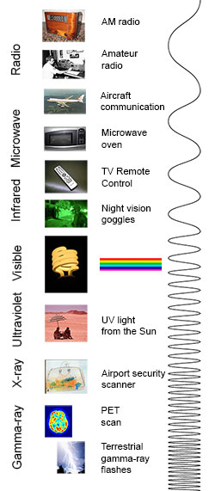
The electromagnetic spectrum from lowest energy/longest wavelength (at the top) to highest energy/shortest wavelength (at the bottom). (Click image for a larger version.)
Radio: Your radio captures radio waves emitted by radio stations, bringing your favorite tunes. Radio waves are also emitted by stars and gases in space.
Microwave: Microwave radiation will cook your popcorn in just a few minutes, but is also used byastronomers to learn about the structure of nearby galaxies.
Infrared: Night vision goggles pick up the infrared light emitted by our skin and objects with heat. In space, infrared light helps us map the dust between stars.
Visible: Our eyes detect visible light. Fireflies, light bulbs, and stars all emit visible light.
Ultraviolet: Ultraviolet radiation is emitted by the Sun and are the reason skin tans and burns. "Hot" objects in space emit UV radiation as well.
X-ray: A dentist uses X-rays to image your teeth, and airport security uses them to see through your bag. Hot gases in the Universe also emit X-rays.
Gamma ray: Doctors use gamma-ray imaging to see inside your body. The biggest gamma-ray generator of all is the Universe.
Is a radio wave the same as a gamma ray?
Are radio waves completely different physical objects than gamma-rays? They are produced in different processes and are detected in different ways, but they are not fundamentally different. Radio waves, gamma-rays, visible light, and all the other parts of the electromagnetic spectrum are electromagnetic radiation.
Electromagnetic radiation can be described in terms of a stream of mass-less particles, called photons, each traveling in a wave-like pattern at the speed of light. Each photon contains a certain amount of energy. The different types of radiation are defined by the the amount of energy found in the photons. Radio waves have photons with low energies, microwave photons have a little more energy than radio waves, infrared photons have still more, then visible, ultraviolet, X-rays, and, the most energetic of all, gamma-rays.

