Evaluate the validity and reliability of claims in published materials of the effects that different frequencies of electromagnetic radiation have when absorbed by matter. [Clarification Statement: Emphasis is on the idea that photons associated with different frequencies of light have different energies, and the damage to living tissue from electromagnetic radiation depends on the energy of the radiation. Examples of published materials could include trade books, magazines, web resources, videos, and other passages that may reflect bias.] [Assessment Boundary: Assessment is limited to qualitative descriptions.]
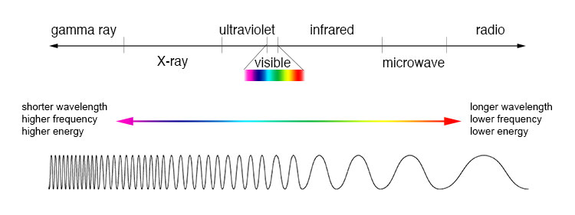
http://imagine.gsfc.nasa.gov/Images/science/EM_spectrum_compare_level1_lg.jpg

http://imagine.gsfc.nasa.gov/docs/science/know_l1/emspectrum.html

Questions:
- Can using a cell phone cause cancer?
http://www.cancer.gov/cancertopics/factsheet/Risk/cellphones

- Will living near high voltage power lines cause cancer?
http://www.csicop.org/si/show/power_lines_and_cancer_distant_healing_and_health_care_magnetism_misreprese/

- Will your laptop make you sterile?
http://www.snopes.com/medical/toxins/laptop.asp

- Is all radiation dangerous to humans?
(printed handout)
http://www.discovery.com/tv-shows/curiosity/topics/10-everyday-sources-radiation.htm

