GK-12 Bioenergy Sustainability Project Weekly Meetings
(ZOL 895, Section 401)
Fall 2013 - Fridays 1:15 to 3:15pm – Stack Hall 145

10/31/2014
Business

- 2 minute round-up
- Video Biography updates?
- Classroom observations
- Workshop session titles/abstracts – by Monday, please!

Activity

A. Biomass collection at the LTER plots
B. Workshop workday!

Future:
Next week is another workshop work day – November 12 is coming up fast!

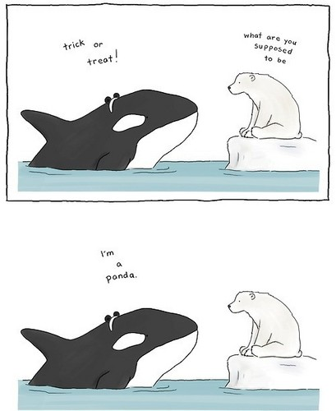Happy Halloween!

