KARENMIKE

Plants gain most of their weight from materials that came from nutrients in the soil.
Plants gain most of their weight from materials that came from the air.
Karen
Mike

“We are interested in how people use evidence to support their ideas. We’re going to talk about two students who disagree with each other about how plants gain weight when they grow. One student Karen said: “The plant gains most of its weight from materials that came from the air.’
“Another student, Mike said: ‘The plant gains most of its weight from materials that came from nutrients in the soil.’
- “Who do you think is right?”

“Now let’s talk about the quality of their arguments that support their idea.” [Start with the argument that the student agrees with; either Karen or Mike could be first. Show the card associated with Karen or Mike one at a time.]
Karen who you _____ [agree/disagree] with, explains, ‘You can grow a big plant in a little pot without a lot of soil.’ Karen adds some evidence to her argument and explains ‘A seed weighing 1 g was planted in 80 g of soil. After two years the plant weighted 50 g and the soil weighed 78 g.’
- “Can you explain Karen’s argument?”
- “How does Karen’s argument support her idea that the plant gains weight from materials that came from the air?”
- “Are their some weaknesses in Karen’s argument? Explain what they are.”
- What evidence would strengthen Karen’s argument? How would it strengthen the argument?
- Are there any other explanations for Karen’s evidence that Karen hasn’t considered?

Mike who you ____[agree/disagree] with explains, ‘Plants have roots to take up nutrients from the soil to grow.’ Mike adds some evidence to his argument and explains ‘A plant grown with no fertilizer weighed 50 g, and a plant grown with 3 g of fertilizer weighed 65 g.’”
- “Can you explain Mike’s argument?”
- “How does Mike’s argument support his idea that plant gains weight from materials that came from the soil?”
- “Are their some weaknesses in Mike’s argument? Explain what they are.”
- What evidence would strengthen Mike’s argument? How would it strengthen the argument?
- Are there any other explanations for Mike’s evidence that Mike hasn’t considered?

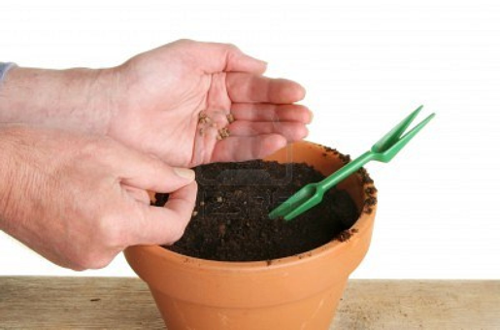
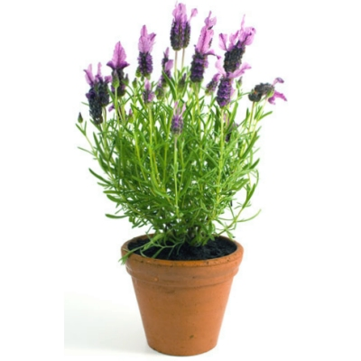
Seed planting
One year later
You can grow a big plant in a little pot without a lot of soil.
Karen
Soil = 80 g
Seed = 1 g
Soil = 78 g
Plant = 50 g
Plant grown with fertilizer
Plant grown without fertilizer
Plants have roots to take up nutrients from the soil to grow.
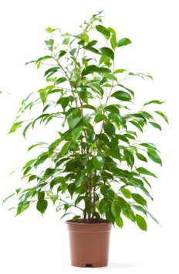

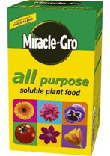
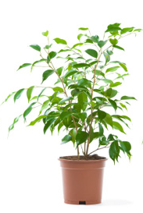
Plant = 65 g
Plant = 50 g
Mike
Fertilizer = 3 g

