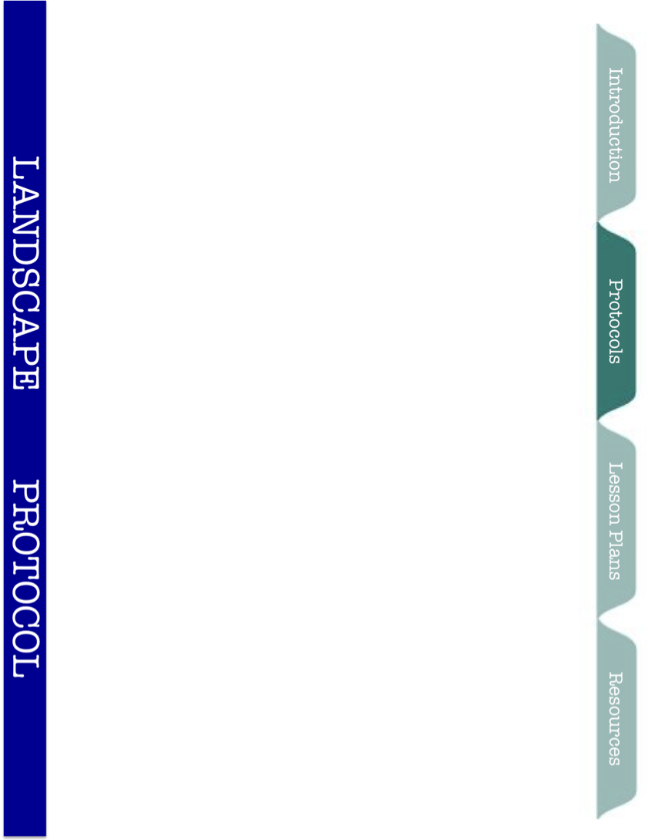



Landscape Protocol

Background information
Each school will have the same treatments and the same seed mix to start, but we will see dramatic differences in the plant and animal communities that develop over time at the different locations. What will make our bioenergy blocks differ between districts?
The data collected for this protocol can be used to help us determine how local and regional landscape processes contribute to differences between blocks. Using small scale (local) and large scale (regional) techniques we will characterize surrounding vegetation types and land cover around plots to examine what factors are important. Why do some of our planted species do better in some locations while others do better in other locations? Why do some blocks have higher biomass production? Do we see different invading plants (“volunteers”) depending on surrounding land cover? The data collected for this protocol can be used to address these questions as well as many others.
Timeline/Frequency
This protocol should be completed once a year.
Materials
Large Scale
- Map of your district plot (provided)
- Grid paper with 100 cells (provided)
- Datasheet and protocol (provided)
- 8 dry erase markers of different colors
- Ruler (preferably transparent)
- Calculator
Small Scale
- Datasheet and protocol (provided)
- Water level (provided)
- At least 2 meter sticks
- 50 m tape measure
- 0.5m x 0.5m quadrat
- Clipboard
Supplemental Documents
- Key to identify the land use categories on a satellite image
- Satellite images of all other school districts and KBS
- Instructions on how to use a GPS to collect landscape variables

Definitions

Elevation - A location’s height above sea level. Mountains have a high elevation; ocean beaches have a low elevation.

Slope - How the land changes in elevation over distance (rising or falling).

Land Cover - Physical material at the surface of the earth. Land covers include grass, asphalt, trees, bare ground, water, etc. There are two primary methods for capturing information on land cover: field survey and analysis of remotely sensed imagery (like satellite images of your school).

Land Use – Typically refers to types of land cover constructed by humans (buildings, pavement).

Latitude - A measurement used to identify how far north or south a location is from the equator.

Longitude - A measurement used to identify where a location is on the Earth’s east-west axis.

Remote Sensing - Uses devices (satellites, aerial photography) to collect data on a location without physically being on the land. You will be doing this using satellite imagery of your school.

Transect - A path along which one records data

Waypoint - A reference point in physical space used for navigation (latitudes and longitudes)

Quadrat - An enclosed shape (0.5m x 0.5m square) that allows ecologists to sample portions of the land by identifying what lies within the shape. Direct comparisons can then be made between different quadrats in areas with different land cover.

Instructions

Land Cover Categories
- Farm- annual and perennial crops, harvested
- Residential- mowed lawns, landscaped, housing developments
- Pavement- walkway, parking lot, road
- Building- man-made structure
- Soil- bare ground, gravel, sand, wood chips
- Prairie- Field, land used for grazing, not mowed or landscaped
- Woods- Trees (deciduous and conifer), not landscaped
- Water- River, lake, wetland, marsh, estuary, ponds, pools

Large Scale Methods
- Using the map and grid paper provided, measure percent land cover of the land cover categories surrounding the plots at your school. Each map is 1000 m X1000 m. Review the Key to land cover categories and examples (supplemental documents) before starting.
  - Place transparent grid paper over map, lining up edges.
  - For each grid cell, classify which land cover category it falls into. Use the KEY TO LAND COVER CATEGORIES to help you identify each cell. If the cell only contains one category, list that one. If more than one category falls within a cell, choose the one that occupies largest proportion of the cell.
  - Assign a color to each land cover category by filling in the squares under the “land cover category and corresponding color key” section on the data sheet.
  - Fill in each grid cell with the appropriate color. Only one color should be used per cell!
  - Calculate the percent land cover based on number of cells that fall into each category and fill in the data sheet at you go.
- Using the map and a ruler, measure the distance in millimeters from the center of the bioenergy block to the closest edge of each land cover type. You may find it easier to remove the grid sheet before taking these measurements. (It will be easier to see the edges of each land cover type.
- When each group is done filling out their worksheets, compile all the class’s data and AVERAGE land cover category percents obtained from all groups. Also average distances to the closest land use type from all groups in the class. These averages will be more representative of true landscape variable estimates than values from a single group.
- If you have more than one class completing this exercise, average all your classes’ data together and then submit it to the GK-12 website using the google docs web form.

Small Scale Methods:
At least 5 students, split among two teams, are required to assess each block: 2 students to measure land cover along a transect (A); 3 students to measure slope along the same transect (B).
- Characterizing land cover:
The transect will be measured from the centerpoint of each EDGE of the block (NOT the middle of the plot!). One group of students will be data collectors, and one will be in charge of the meter tape and recording data.
- Have a data collector hold one end of the meter tape and a student in charge of the meter tapes walk the meter tape out perpendicular from the plot. Place the other end of the meter tape on the ground- 50 meters from the block.
- A student should then center the quadrat on the ground around the tape just outside the edge of the block (i.e., half the quadrat will be to the left of the tape, half to the right). Estimate the dominant land cover category that is within the quadrat. The potential types of land cover categories are described above.
- The data collectors and recorders should then walk 10m on the tape, stopping at the 10m mark. At the 10m mark, center the quadrat on the ground around the tape and estimate the dominant land cover type.
- Repeat Step 3 at 20m, 30m, 40m, and 50m. If a 50m transect brings you outside the school grounds or onto property where you cannot go, then make a note of that, and use your best judgment to estimate what kind of land cover characterizes the various locations all the way up to 50m. If you cannot estimate, then make a note of that.
- Make sure the slope team is done with your transect, and then move on to the next edge of the block. Repeat steps 1-4.
- Count up the number of locations in each land cover category, and divide by the total number of locations (which will be 24 if you were able to go 50 m in all four directions). This will give the percent cover for each land cover category. For example, if sixteen of the sampled locations are mostly covered by pavement, woods cover six locations, and residential covers 2, then you will report that land cover at this scale is 67% pavement, 25% woods, and 8% residential.

Pavement 16 16/24*100=67%
Woods 6 6/24 *100=25%
Residential 2 2/24 *100=8%
Total 24 Total= 100%

Prep Work: Fill the Water Level ahead of time, fill the vial slowly, allow water to flow out the opposite end to flush out bubbles. Once filled, hold the two vials side by side and tip out water to bring their water level near the midpoint on each vial. Put on caps and make sure the air valves (holes) are closed.

- Characterizing Slope:
The slope team will characterize the change in elevation (vertical distance) over a length of the transect (horizontal distance). The vertical divided by the horizontal distance is the slope (e.g., “rise over run”).
- The slope team consists of 3 students, 2 water levelers and 1 recorder.
- Levelers will need to carry their level and meter stick. If more students are available, each student will benefit from having an assistant.
- Slope Team takes the initial reading from the water level. With air valves open, hold the two vials side-by-side, with the zeros right next to each other, until the water in each vial is level (rests at same number). This requires patience and holding still. Record the number where water in both vials come to rest. This is the “initial match reading.”
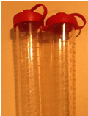
- After the initial matching reading is recorded, reclose the air valves, so water does not spill out.
- One team member walks away from the edge of the plot along the 50m transect already placed by the ground cover team.
- At the maximum distance the Water Level will reach, record the distance the two vials are apart using the 50 m tape.
- Before re-opening the air valves, it is wise to have the two levels attempt to visually hold the vials at about same level. The upslope individual (higher ground) lowering their vial, while the downslope individual (lower ground) raises their vial. If water is going to escape through the air valve, cap the air valve with a thumb to prevent water loss.
- Now the two levelers will move the vials up or down until the water level in both vials as at the same number. At this point, they are level.
- One leveler should hold their vial still, calling out their numbers and whether the water is changing or still. The other leveler makes small changes listening to their partner call out readings. (the leveling tool has a slow response to changes, so large movements can cause surprises)
- Once the initial reading is re-achieved then both students close the air valves, but the vials should remain at the same height.
- Using meter sticks, measure the distance from the ground up to the water line on each vial. This difference is
- Caution: BOTH vial’s distance measure must be completed before either student can lower their vial.
Calculating the Slope:
- Divide the change in elevation (difference between meter sticks) by the distance between the water level vials. This will be the slope of the land for that direction. Don’t forget to use same units (if you recorded centimeters from the meter stick, change to meters).
- Note that slopes may be either positive (uphill away from block), negative (downhill away from block) or have little or no slope (close to zero).

(Example)
Start Elevation (Beside Plot) 10 cm
End Elevation (Away from plot) 98 cm Conform to same units (meters)
Change in Elevation -88 cm = -0.88m

Slope -0.88 m/
18.5 m = -0.05m

