# 

# *Soil Sampling Protocol*

# Background information

# Soil quality differences across the BEST Plot research network will have big

# effects on which plant species thrive, and the overall diversity and biomass

# productivity in the experimental plots. In addition, our harvest and fertilization

# treatments should alter some of the initial soil qualities over time. In this protocol,

# you will sample soils to measure variation in important soil properties. These

# properties are described in the Soil Texture Protocol, Soil Moisture Protocol, and

# the Soil Nitrogen and pH Protocol below.

## You will collect three soil cores per plot and place them in one sample bag. Three cores will better capture the variability that exists within a plot. There are eight different plots in each block of plots (see the schematic below), so you will collect a total of eight sample bags per block. The position of the different experimental treatments (plots) within each block varies from school district to school district to “randomize away” any consistent position effects, such as always having one particular treatment in a sunny southwest corner. The plot treatment layout for each block is indicated by the block layout-sticker at the bottom of the sign at one corner of each block.

**Timeline/Frequency**

This protocol for soil sampling should be completed at least once a year in early

to mid October in every plot. An optional spring sampling may also be

Blockcompleted. This protocol includes the following yearly tests:

* **Soil Moisture**
* **Soil Nitrogen and pH**
* **Soil texture** (can be examined at any time using soil collected outside of the plot.)

**Materials**

## Site maps labeled with block and plot numbers

## Soil Sampling Data Sheet

* Clipboards (one per group)
* Pencils and sharpies
* Mailing labels and clear mailing tape
* Meter stick or metric tape measure
* Soil corer (one per group)
* Butter knife (one per group)
* Zip locks (one per plot)
* Randomization Protocol and supplies therein

### Instructions

### As you read through and follow these instructions, remember that a plot is a 3 x 3 m2 square and that there are 8 plots in one block. Each block in the whole BEST experiment has a unique code. Look at the maps of your school’s blocks or on the list in a BEST plots binder to find the unique codes of the plots you’ll be sampling (e.g.LHS), so that you will know how to label your

### samples.

### Prior Preparation

### Label one plastic bag for each of the 8 plots that you will collect from the block using address labels or labeling tape. On each plastic bag, label with: your district and school or location name (ex: Lawton High School), the three-letter location code (e.g.LHS; there is a table of these location codes in the binder), the block layout number on the sign on the corner of the block (e.g. 4), the plot treatment name (e.g switchgrass; unfertilized; harvested), and the date the sample was collected (e.g. October 3, 2012)

1. Cover labels with clear mailing tape to secure label to bag and to protect against moisture

**Sampling Soil at the BEST Experimental Plots**

1. Before you start, read through the following steps.
2. Each person who will be sampling should take at least two “practice” soil cores outside of the experimental plots using the soil corer.
3. Randomly select a location within the experimental plot using the Randomization Protocol.
4. Have one person carefully walk into the plot to the area determined by the Randomization Protocol, trying not to disturb or step on growing plants.
5. When at the correct location, carefully push the plants aside and position the core on bare ground between plants as best you can. Then use the soil corer to obtain a soil sample as deep as you can, up to **15 cm** into the soil. If you hit a big rock at less than 10cm, move a few cm to the side and try again.
6. On the Soil Sampling Data Sheet, record how deep the soil corer went into the soil.
7. **Use a butter knife** to help remove soil from the corer. Avoid touching the core with your hands. Put the soil sample into the appropriately labeled bag.
8. Use your site map to double check that the block and plot label on your bag matches the block and plot that you are sampling. Soil must stay moist. Don’t let soil sit in an open bag for too long.
9. **Repeat this process two more times on your plot. 3 cores will be collected and put into the same labeled bag**. Find a new location within the plot using the Randomization Protocol for each of the subsequent cores.
10. Do the above for each of the plots on your block. Once finished, take the soil samples back to the classroom.
11. Soils must be stored in a refrigerator at 4°C. The Soil Moisture Protocol should be done within 2 days. Soil nitrogen and pH can be done one month after collection.

**When collecting the soil, the students should make the following observations:**

**Measuring Rocks and Roots:**

1. Observe the core that you collected and record if there are none, few or many rocks or rock fragments the core or soil sample. Write this on your Soil Sampling data sheet**. Note:** A few means 1-10 rocks, while many means that there are more than 10 rocks or that at least 25% of the core has rocks in it. This is qualitative, but consistency will help make the data comparable among districts.
2. Observe the core that you collected and record if there are none, few, or many roots in the sample, and record this on your Soil Sampling data sheet.

**Note:** A few means 1-10 roots, while many means that there are more than 10 roots or that the core is held together by roots. This is qualitative, but consistency will help make the data comparable among districts.

**Animals:**

While the soil is in the closed zip-lock, look carefully at the soil core to see if there are any invertebrate animals present in the core. Feel free to break up the core into smaller pieces to find the animals. The bag cannot be opened because soil water will escape.

**Cleaning Up**

1. Look around to make sure that you take all of your sampling equipment and data sheets back to the classroom.

Switchgrass = S Fertilized = F Harvested = H

Prairie = P Unfertilized = UnF Unharvested = UnH

**Soil Sampling Data Sheet**

Names:_______________________________________________________________

School District:_______________________ Instructor/Fellow:___________________

Date:________________ Time:______________ Weather:_____________________

School / Location Name: _________________________________________________

Block Code: _______ Plot Treatment Description (Ex: S F UnH): _________________

Depth of core 1____________________________________

Depth of core 2____________________________________

Depth of core 3____________________________________

Rocks: (none, few, many):____________________________

Roots: (none, few, many):____________________________

List any invertebrate animals_________________________________

# 

# *Soil Texture Protocol*

## *Background information*

## This protocol is for characterizing soils in the BEST experiment plots. After

## collecting a soil core, you will learn about various characteristics of the soil

## including the texture and color. All of these characteristics help determine how

## well plants can grow in the soil.

**Timeline/Frequency**

Soil texture is unlikely to change within a short period of time. However, soil texture can be measured by the students whenever soil is collected using the Soil Sampling Protocol. Soil can also be collected outside of the blocks. The protocol for soil sampling should be completed at least once a year in early to mid October in every plot. Soil can also be collected outside of the blocks.

## Vocabulary Words:

## *Horizon:* A specific layer in the soil that is horizontal to the soil surface and has different characteristics from the layers below or above it. The size, or depth, of a soil horizon can vary—it can be as thin as a centimeter, or meters thick, depending on the soil.

## ped*Ped:* A single unit of soil. The size of a ped can vary. Some soils are very chunky and stuck together, and can have big golf-ball size peds (see photo below). In many soils, the peds are smaller and about a centimeter or so in diameter. In some soils, like pure sand, the particles do not stick together at all and there are no soil peds.

horizon

**Materials**

* Soil collected from near the plots (about 2 teaspoons per student).
* Water bottle: Plastic squirt bottle filled with water
* Nitrile or rubber gloves
* Acid bottle: Plastic squirt bottle filled with vinegar (one per class)
* Digital camera (optional)
* Sieve (4mm)

### Instructions

### There are two tests you can perform to examine soil texture: the Feel Test and the Sedimentation test (see below). Soil texture should be completed only after measuring soil moisture and soil nutrients and pH if using soil collected by soil protocol. However, soil can be collected outside of the blocks for this procedure. It is acceptable to use soil from outside of the blocks because soil texture does not change over small areas and does not change in a short time period. Do your observations of soil color and soil carbonates.

**Looking at Soil Horizons:**

We will not be able to dig a deep enough hole to look at soil horizons. A lesson plan will be created in the future to discuss soil horizons.

**I. Soil Texture: Feel Test**

Follow the chart below for the procedure.

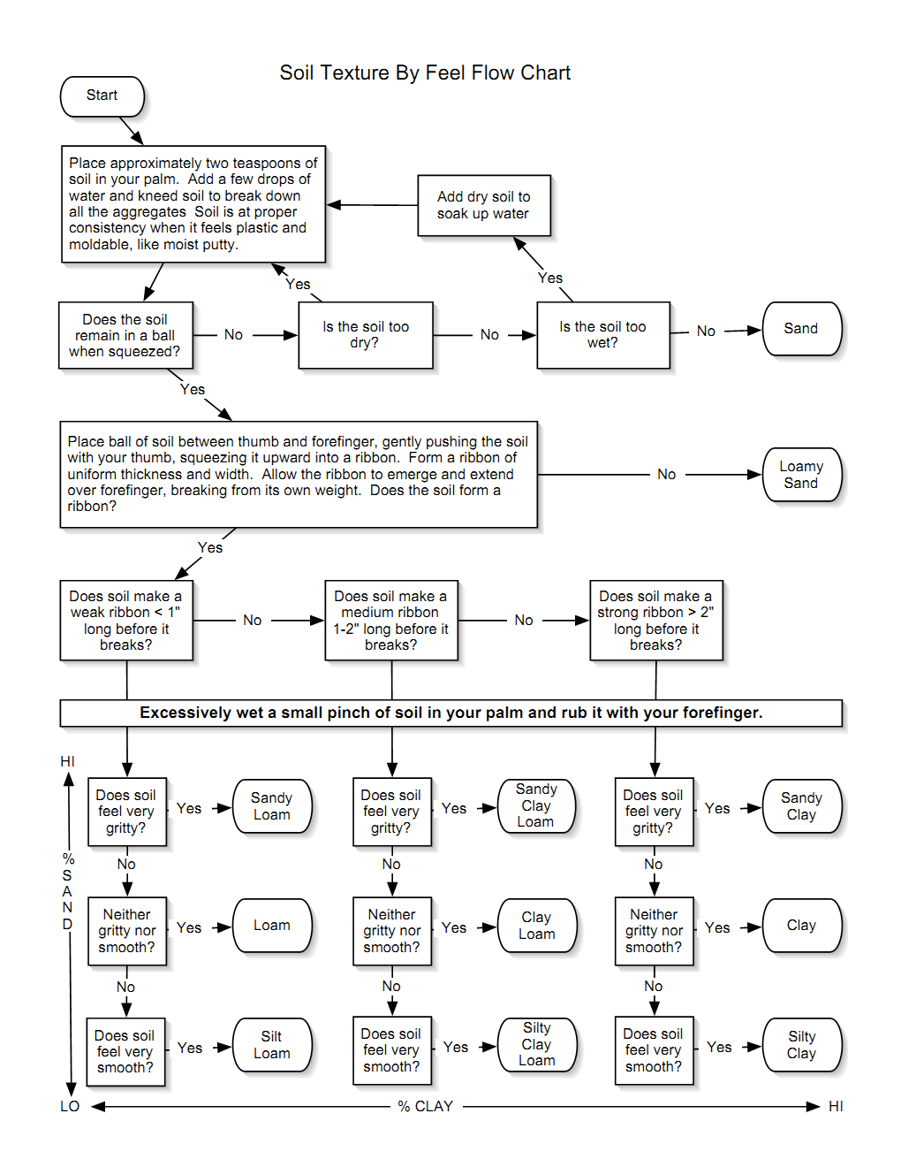

Source:http://watermonitoring.uwex.edu/pdf/level3/WEPP/soiltexturebyfeelchart.pdf

**A YouTube search for “soil texture” turns up several illustrations of this test. One excellent source is: <http://www.youtube.com/watch?v=GWZwbVJCNec>**

**II. Soil Texture: Sedimentation Text**

1. Sieve soil through a 4mm screen.
2. Select a straight-sided bottle and fill approximately 1/3 full of sieved soil.
3. Add water until the bottle is 3/4 full. Cap the bottle, and shake bottle vigorously for **10 minutes** to mix everything thoroughly. Check to be sure no soil is clinging to the bottom of the bottle. Set the bottle on a level desk or table.
4. 1-2 minutes after you stop shaking the bottle, measure the height of sediments settled at the bottom (**A**). Wait **2 hours** and take a second measurement (B). Wait **24 hrs** to take a third measurement (c).
5. Record your group’s data in the chart on this worksheet, as well as the data from the other groups.

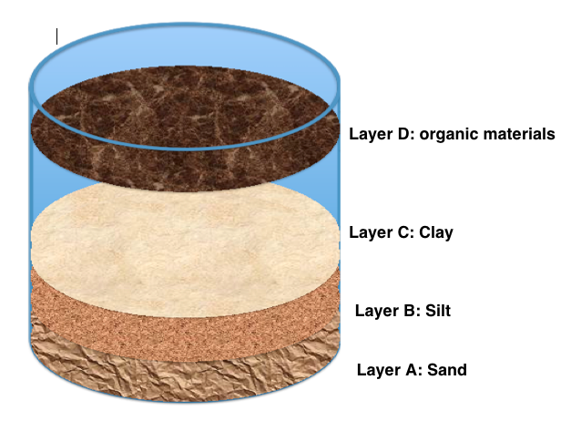

**III. Soil and Ped Color**

1. Look at the soil. Is the soil the same color throughout? Are there peds present? Take a **ped** (a hunk of soil, see “vocabulary” section above) of soil.
2. If it is dry, moisten it slightly with water from your water bottle.
3. Break the ped and look at its color.
4. Is the soil or ped mostly brown? Grey? Red? Use the soil color chart below to assign a number to the soil or ped color. If there is more than one color present, record all the color numbers you see. Record this on the soil sampling datasheet.

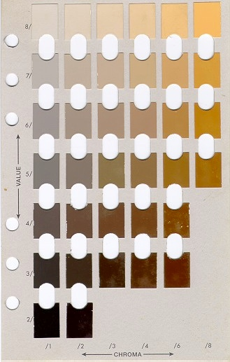To this chart, take the soil or the ped and match the soil to the color on the chart based on your observation. Once you feel you have matched the soil color well, find the number for CHROMA and VALUE. Record the CHROMA (/1-/8) and VALUE (2/-8/) of the closest match.

**IV. Soil Free Carbonate Test**

1. Take two teaspoons of soil. Make sure not to touch it with your bare hands.
2. Squirt vinegar on the soil particles. Be sure to use caution and point the bottle directly at the soil, not toward other students, especially not toward eyes. If vinegar gets into your eyes, rinse with water for 15 minutes.
3. Look carefully for the presence of **effervescence,** or bubbles. The more carbonates that are present, the more bubbles (effervescence) you will observe.
4. Record on the Soil Sampling Data Sheet one of the following results:

**None**: if you observe no reaction, the soil has no free carbonates present

**Slight**: if you observe a very slight bubbling action, this indicates the

presence of some carbonates

**Strong**: if there is a strong reaction (many and/or large bubbles) this

indicates that many carbonates are present.

**Soil Texture Data Sheet**

Switchgrass = S Fertilized = F Harvested = H

Prairie = P Unfertilized = UnF Unharvested = UnH

Names:_______________________________________________________________

School District:_______________________ Instructor/Fellow:___________________

Date:________________

School / Location Name: _________________________________________________

Block Code: _______ Plot Treatment Description (Ex: S F UnH): _________________

**I. Feel Test:**

Texture:___________________________________________

**II. Sedimentation Test:**

Write the thickness of each layer in the chart below. Don’t forget the units!

|  |  |  |
| --- | --- | --- |
|  | **Thickness (mm)** | **Percentage (%)** |
| **Layer A: Sand** |  |  |
| **Layer B: Silt** |  |  |
| **Layer C: Clay** |  |  |
| **Total** |  |  |

III. **Soil and Ped Color (List as many as you find)**

______________________________________________________________________

**IV. Free Carbonates Test (circle one)**

(none, slight, strong)



# *Soil Moisture Protocol*

## Background information

Soil moisture measures the amount of water in the soil. This depends on when it rained last but it also depends on the ability of the soil to retain water following a rain. Soil has small spaces in between the particles, which can contain water and air. The ability of a soil to hold water depends on its texture and organic matter content, among other things. Since most plant nutrients are water soluble, understanding how soil holds moisture describes the ability of the soil to provide nutrients and water to plants, affecting their growth and survival.

In this protocol, soil samples will be analyzed in the lab by taking both fresh and dry mass measurements. To obtain accurate results from this protocol, it is essential that the soil sample is tested within a few days of sampling.

**Timeline/Frequency**

This protocol for soil sampling should be completed at least once a year in early

to mid October in every plot. Soil moisture should occur within 48 hours of

completing the soil sampling protocol. An optional spring sampling may also be

completed.

**Materials**

* Fresh soil samples collected by the soil sampling protocol.
* Balances
* Soil sieve with 4mm mesh size
* Weigh boat (small plastic tray to place on scale)
* Soil Moisture Data Sheet

### Instructions

### *Day 1*

1. Retrieve a soil sample collected from when the soil sampling protocol was performed. Record the sample ID information on the sample label on the Soil Moisture Data Sheet.
2. Take all of the soil from the zip lock bag and press it through a sieve with 4 mm mesh.

Be sure to keep roots and rocks on the sieve and out of the soil. Label your weigh boat with the correct label.

1. Weigh the **empty weigh boat**. Record the mass of your empty weigh boat in the Soil Moisture Data Sheet.
2. Add 30 to 40 grams of sieved soil to the weigh boat. Avoid using any large rocks or roots. Record the mass of the **weigh boat + soil**.
3. Subtract the mass of the **empty weigh boat** from the mass of the **weigh boat + soil** to get the **mass of the wet soil sample**. Record this value on your data sheet.

Wet soil (g) = (total mass) – (empty weigh boat)

1. If ovens are not available, lay the sample in a warm dry place for at least 48 hours to dry.

***Day 2***

1. Remove your soil sample from the oven or from the counter.
2. Weigh and record the **total mass** (weigh boat + dry soil).
3. Subtract **the mass of the empty weigh boat** from the **mass of the weigh boat+ dry soil** to get the **mass of the dry soil sample**. Record this value.

Dry soil (g) = (total mass) – (empty weigh boat)

1. To obtain the % soil moisture value use the following equation:



**Soil Moisture Data Sheet**

Switchgrass = S Fertilized = F Harvested = H

Prairie = P Unfertilized = UnF Unharvested = UnH

Names:_______________________________________________________________

School District:_______________________ Instructor/Fellow:___________________

Date:________________ Time:______________ Weather:_____________________

School / Location Name: _________________________________________________

Block Code: _______ Plot Treatment Description (Ex: S F UnH): _________________

***Day 1***

1. Mass of weigh boat: ______________ (g)

2.Total mass (mass of boat + wet soil sample): ______________ (g)

3. Mass of wet soil (Answer 1 - Answer 2): ______________(g)

***Day 2***

4. Total mass (mass of dry soil sample + weigh boat): _____________(g)

5. Mass of dry soil sample (Answer 4 - Answer 1): ________________(g)

**Percent soil moisture: __________________%**

# 

# *Soil Nitrogen and pH Protocols*

**Yearly Sampling**

In this protocol, we will measure nutrients and pH from soil by placing soil in water and measuring them in the water solution.

## Nitrogen Background information

Nitrogen (N) is essential for the biochemistry of all living cells. It is important for plant growth. N is used to build proteins and chloroplasts (the machinery for photosynthesis). Measuring N in the BEST plots will give an opportunity to study the N cycle in soil!

The common forms of inorganic nitrogen in soils are ammonium (NH4+) and nitrate (NO3-).

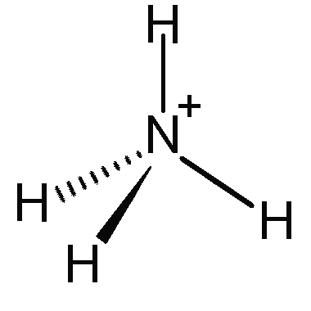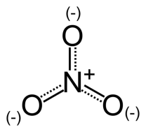

Notice the figures above: To the left is nitrate and to the right is ammonium. How are they similar? How are they different? Notice the charge sign on the two molecular formulas—ammonium is positively charged (a cation) and nitrate is negative charged (an anion).

Because of these charges, ammonium and nitrate interact with soil differently. Soil also has particles have a slight negative charge so ammonium can stick to them (opposites attract!) whereas nitrate is repelled by soil particles.

The negative charge of nitrate causes it to move in water through the soil and contaminate ground and surface water. Have you heard about high nitrate in drinking water?

Plants also prefer to take up ammonium because it is easier for them to incorporate into cell materials, but they can use nitrate as well. Microorganisms release N from dead plants, animals and other microbes through decomposition. Plants can take up this nitrogen (either as ammonium or nitrate).

## pH background information

Soil pH is important for the growth of plants. Solutions with a pH from 1-6 are acidic and solutions with 8-14 are basic. A solution with a pH of 7 is neutral. This is a measure of the concentration of hydrogen ions. Soil acidity is important because it impacts the extent to which nutrients are available to plants. Soil pH is measured by extracting soil in water. The ratio of water to soil can influence soil pH. It is important to use the same amount of soil and water among the school districts.

# How to Measure Soil N and pH

Soil nutrients and hydrogen ions are bound in the soil. We cannot measure them when they are bound to soil. Scientists extract nutrients by placing the soil in a very concentrated potassium chloride (KCl) solution. The ammonium and nitrate dissolve into the solution.

**Teacher Note:** We can use KCl solution. KCl should extract more nutrients, but some aquarium nutrient test kits can be negatively affected by high salt solution and give low results. If we wish to use a KCl solution, we will need to be sure we have the correct test kits.

There are many ways to measure the concentration of ammonium and nitrate. Most involve using a spectrophotometer and several reagents. We are going to keep it simple by using water quality test kits.

Scientists use fresh soil to measure nutrients. They would run analyses within a few days (48 hours) of collecting soil. We will be using wet soil. Be sure to run nutrients on your soil within a few days (48 hours) of completing the soil sampling protocol.

This must be done for all plots. If there are more plots than students, then each group will have to run more than one sample. Test tubes and specimen cups can be reused, but should be rinsed at least three times with water followed by distilled water. Shake out the extra water before performing the second sample.

**Materials**

* Soil sieve with 4mm mesh size
* Freshwater Master Test Kit (Aquarium Pharmaceuticals, Inc.) (one per class)
* Insta-test nitrite-nitrate test strips
* pH test kit (Aquarium Pharmaceuticals, Inc.) and/or pH paper
* 2 specimen cups (one per group)
* Spoon to measure soil (one per plot)
* Balance (accurate to 0.1 g) (3 per class)
* 100 mL graduated cylinders (one per group)
* Funnels (one per group)
* Whatman filter paper with a medium or slow filter speed
* tape & markers
* distilled water
* I M KCl solution
* gloves (nitrile)
* goggles (one per student)
* Data Sheet
* Additional test tubes with a 5 mL mark (2 per group- one for ammonium and one for pH)

**Instructions**

Gloves and safety glasses MUST be worn while performing this lab. Test solutions contain bleach, sodium hydroxide and hydrochloric acid. Gloves will protect the sample from being contaminated. Responsible and mature lab behavior is required.

### I. Measuring Ammonium and Nitrate

### Step 1: Label your cups with your sample identification, as below!

Using tape and Sharpie marker, label the cups with sample identification.

Cup A will be labeled as: **Block ___ Plot______ soil + KCl solution**

Cup B will be labeled as: **Block ___ Plot______ Filtered solution**

### Step 2: Extract N

1. Sieve soil through a 4mm screen.

2. Weigh 5 g of soil into a specimen cup.

3. Using a graduated cylinder, measure 50 mL of KCl and add it to your sample cup (Cup A).

4. Carefully screw the lid onto the cup and shake by hand for 10 minutes.

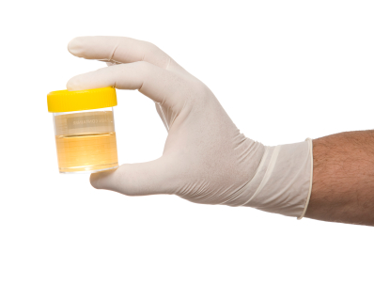

5. Set down the cup for a few minutes so that some of the sediment settles to the bottom.

6. Take a Whatman filter and fold it in half and then fold it into a quarter. Open the filter to make a cone and place the filter inside the funnel.

7. Pour the soil + KCl solution (Cup A) through the filter/funnel into the second labelled specimen cup (Cup B). Be sure that you do not pour the contents over the sides of the filter. The heavier material such as sand does not have to be poured through the filter. The solution that comes through the filter should be fairly clear. A small amount of sediment should not impact the test, but too much will make it difficult to read the results. Note: you only need 15 mL of filtered solution for these tests.

Step 3: Testing for Ammonium and Nitrate

### Ammonium water test kitAmmonium

1. Fill a clean test tube with 5 mL (the test tube line) of filtered solution from Cup B
2. Add 8 drops from the Ammonia Test Solution Bottle #1, holding the dropper bottle upside down in a completely vertical position to assure uniform drops.
3. Add 8 drops from the Ammonia Test Solution Bottle #2, holding the dropper bottle upside down in a completely vertical position to assure uniform drops.
4. Cap the test tube and shake vigorously for 5 seconds. (Do not hold your finger over the test tube to mix!)
5. Wait 5 minutes for the color to develop.
6. Read the test results by comparing the color of the water solution to the appropriate Ammonia Color Card. The tube should be viewed in a well – lit area against the white area of the card. The closest match indicates the (mg/L) of ammonia in the water sample. Rinse the test tube with clean water after each use.
7. Record the amount of ammonium in the **Nutrient data sheet**.

**Nitrate**

Be sure to have **dry hands** when getting a test strip! Wet hands will ruin the test strips in the vial.

1. 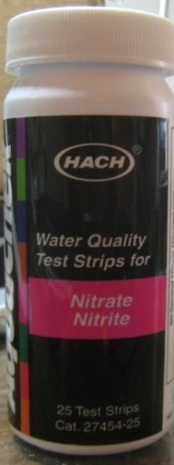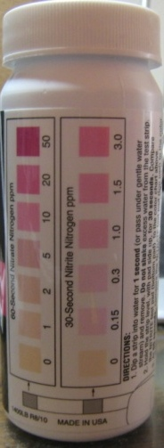Pour some of the filtered solution from cup B over a

nitrate test strip

1. Let strip sit in water for two seconds
2. DO NOT shake off extra water
3. Read after 1 minute. It is important that nitrate is read

at 1 minute- do not let it sit longer!

1. Read the test results by comparing the color of the

test strip to the appropriate concentration on the vial.

The test strip should be viewed in a well-lit area.

The closest match indicates the ppm (mg/L) of

nitrate in the water sample.

1. Record the amount of nitrate in each sample

in the **Nutrient data sheet**.

**II Measuring soil pH**

### Step 1: Label your cups with your sample identification, as below!

Using tape and Sharpie marker, label the cups with sample identification.

Cup A will be labeled as: **Block ___ Plot______ soil + distilled water**

Cup B will be labeled as: **Block ___ Plot______ Filtered solution**

### Step 2: Extract N

1. Sieve soil through a 4mm screen.

2. Weigh 5 g of soil into a specimen cup.

3. Using a graduated cylinder, measure 50 mL of distilled water and add it to your sample cup (Cup A).

4. Carefully screw the lid onto the cup and shake by hand for 10 minutes.



5. Set down the cup for a few minutes so that some of the sediment settles to the bottom.

6. Take a Whatman filter and fold it in half and then fold it into a quarter. Open the filter to make a cone and place the filter inside the funnel.

7. Pour the soil + distilled water solution (Cup A) through the filter/funnel into the Cup B (Filter solution). Be sure that you do not pour the contents over the sides of the filter. The heavier material such as sand does not have to be poured through the filter. The solution that comes through the filter should be fairly clear. A small amount of sediment should not impact the test, but too much will make it difficult to read the results. Note: you only need 15 mL of filtered solution for these tests.

**When you are finished- do not pour sediment down the drain!!! Pour any soil solution into the garbage.**

Step 3: pH Test

*Option A: Using a* pH Test Kit

1. Fill a clean test tube with 5 mL (the test tube line) of filtered solution from Cup B
2. Add 3 drops from the Test Solution, holding the dropper bottle upside down in a completely vertical position to assure uniform drops.
3. Cap the test tube and invert the test tube several times to mix solution. (Do not hold your finger over the test tube to mix! It could affect the results)
4. Read the test results by comparing the color of the water solution to the appropriate pH Color Card. The tube should be viewed in a well – lit area against the white area of the card. The closest match indicates the ppm (mg/L) of nitrate in the water sample. Rinse the test tube with clean water after each use.

This test kit only measures soil pH between 6.0 and 7.6. Soils with a pH outside of this range cannot be measured with this test kit.

***Option B: Using a pH paper***

1. Measure the pH of the filtered solution using the pH paper. Dip the pH paper in the filtered solution (Cup B).
2. Read the test results by comparing the color of the test strip to the appropriate concentration on the vial. The closest match indicates the pH. Record the pH value on the Data Sheet.

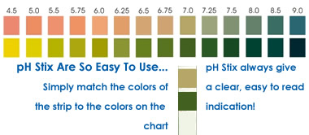

### Calculate the amount of N (NH4+ or NO3-) per gram of wet soil

As soil scientists (or farmers or gardeners), it isn’t particularly useful for us to know the concentration of nitrates or ammonia in the water solution. We want to know how much N is in the soil. So we must relate our measurement back to our starting soil. Here, you will have to pay close attention to units to do the calculation correctly. You have measured concentration (ppm or mg of N/L) and you know the volume of water you used (50 mL = 0.05 L) and the dry mass of soil you used [5g*(1-%soil moisture)].



Calculate the mg of N of nitrate and ammonium in a gram of soil. Put this number on the data sheet.

**Soil Nitrogen and pH Data Sheet**

Switchgrass = S Fertilized = F Harvested = H

Prairie = P Unfertilized = UnF Unharvested = UnH

Names:_______________________________________________________________

School District:_______________________ Instructor/Fellow:___________________

Date:________________ Time:______________

School / Location Name: _________________________________________________

Block Code: _______ Plot Treatment Description (Ex: S F UnH): _________________

1. Grams of soil used__________(g)
2. Mass of dry soil _________________ (g)

([Answer 1*(1-%soil moisture)].

*% soil moisture was calculated in Soil Moisture Protocol

1. Volume of KCl solution used___________ (mL)
2. Volume of KCl solution used in liters _______________ (L)

(Answer 2 divided by 1000)

**Nitrate Test**

1. How would you describe the color of the result for nitrate?_________________
2. Concentration of nitrates ___________________(ppm) mg/L in KCl solution

(Compare the color of test strip to the vial)

1. Amount nitrates extracted in the solution ___________________________

Concentration of nitrates (Answer 6) * Volume of KCl solution in L (Answer 3)

1. Amount of nitrate-nitrogen per gram of soil - Answer 6 divided by answer 1

Results are mg of N-Nitrate per gram ________________________ (mg/g soil)

**Ammonium Test**

1. How would you describe the color of the result for ammonium?_____________
2. Concentration of ammonium ___________________(ppm) mg/L in KCl solution

(Compare the color of solution to the color card)

1. Amount ammonium extracted in the solution=_______________________

Concentration of ammonium (Answer 9) * Volume of KCl solution in L (Answer 3)

1. Amount of ammonium-nitrogen per gram of soil - Answer 10 divided by answer 1

Results are mg of N-ammonium per gram______________________ (mg/g soil)

**Ph Test**

1. pH of water solution (cup B) _______