
Dangerously Bold
Data provided by and written by GK-12 Fellow Melissa Kjelvik

Background Information:

Differences in how animals behave in their natural environments can have a big impact on growth and survival. Sometimes there are advantages and disadvantages to acting risky (bold) AND advantages and disadvantages to acting timidly (shy). When there are costs and benefits for two different strategies, we call this a tradeoff. For example, when bluegill are young, they have to grow big enough so that they don’t fit into their predator’s (largemouth bass) mouth. The best habitat for young bluegill to get lots of food to grow is the pelagic (open water) zone. But, the pelagic zone has very little vegetation for bluegill to hide from predators, so it’s not safe when bluegill are small! Once a bluegill grows long enough to not fit in its predator’s mouth, it can forage (get food) in the pelagic zone without the risk of being eaten.

Scientists at the Kellogg Biological Station wanted to know whether acting bold or acting shy was better for bluegill growth and survival. They brought young bluegill into an aquarium lab to determine whether each individual was bold or shy. Boldness was determined by watching whether or not bluegill ate food while there was a predator behind a mesh during a trial (Figure 2). They then marked them (by clipping a right fin for bold or a left fin for shy) and placed 100 bold and 100 shy young bluegill into a pond with one largemouth bass. After two months, they drained the experimental pond and collected all remaining young bluegill.

Pelagic zone
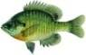
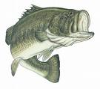
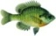

Figure 1. Pond environment. The pelagic zone is riskier Figure 2. Set-up of lab trials to identify
for young bluegill to use because predators can see them whether bluegill are bold or shy. If a bluegill eats the food near the predator (behind mesh), it is considered bold.

(A) Look at the data below. See if you identify some potential patterns. Then, proceed to (B).

DATA

At the end of the experiment, 66 bold bluegill survived and 74 shy bluegill survived.

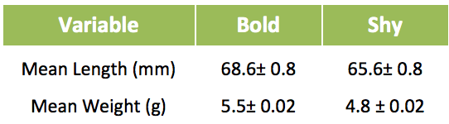

(B) Use the data given above collected by MSU scientists to answer the following question:

Scientific Question: How did behavior affect growth and survival? Was one strategy better than the other?

Evidence: What scientific evidence supports your claim? Refer to specific data, and use graphs to illustrate your point.

Use the data given above collected by MSU scientists to draw a graph of the relationship between behavior (boldness and shyness) and fish mean weight or fish mean length (Draw your graph below).

Claim: Write a conclusion that answers the above question.

Reasoning: How does this evidence support your claim?

