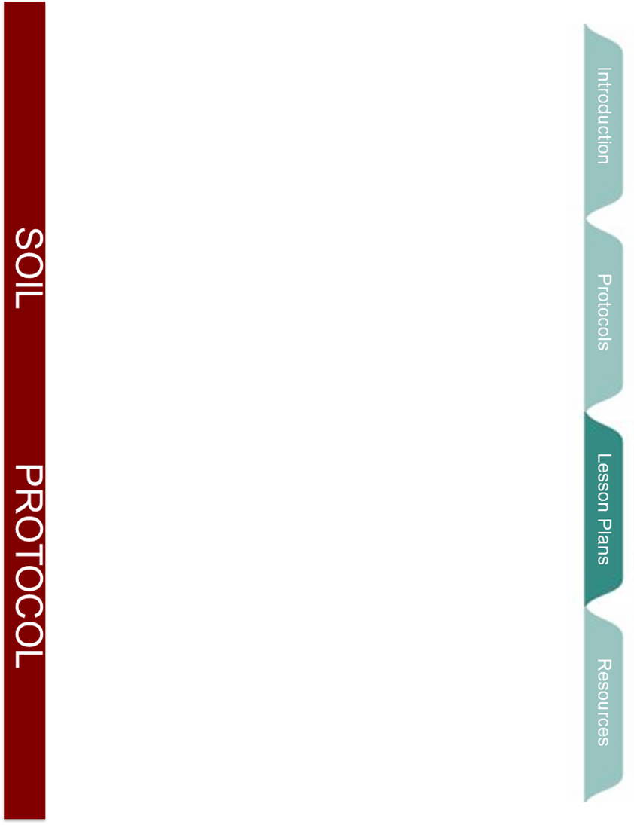



Getting to the root of plant growth

How soil composition impacts the amount of water retained in soil for plants to use

Overview
Understanding what impacts plant productivity is vital when it comes to producing biofuels and food crops. Plant growth is impacted by several soil properties, one of which is soil water retention. In this lesson students will be given the opportunity to understand how soils are formed and how soil composition is related to soil water retention and plant growth. Students will observe how soil composition impacts soil water retention and they will collect data on the composition of soil at their school. These experiences will help each student improve their inquiry skills and develop a better understanding of what is in soil and why it matters.
Objectives
At the conclusion of the lesson, students will be able to:
- Understand why soil composition varies in different places
- Be able to recognize and describe different types of earth materials
- Comprehend that soil composition impacts other soil properties, such as water retention
- Understand that plants get water by taking it up from the soil with their roots
- Understand that soil composition can impact plant growth because of the effect it has on soil water retention
Length of Lesson
This lesson can be completed in approximately 75 minutes.
Grade Levels
K - 7
Standards covered
Kindergarten through 4th Grade
INQUIRY
K-7 Standard S.IP: Develop an understanding that scientific inquiry and reasoning involves observing, questioning, investigating, recording, and developing solutions to problems
S.IP.E.1 Inquiry involves generating questions, conducting investigations, and developing solutions to problems through reasoning and observation.
S.IP.00.11 Make purposeful observation of the natural world using the appropriate senses.
S.IP.00.12 Generate questions based on observations.
S.IP.00.13 Plan and conduct simple investigations.
S.IP.00.14 Manipulate simple tools (for example: hand lens, pencils, balances, non-standard objects for measurement) that aid observation and data collection.
S.IP.00.15 Make accurate measurements with appropriate (non-standard) units for the measurement tool.
S.IA.E.1 Inquiry includes an analysis and presentation of findings that lead to future questions, research, and investigations.
S.IA.00.12 Share ideas about science through purposeful conversation.
S.IA.00.13 Communicate and present findings of observations.
S.IA.00.14 Develop strategies for information gathering (ask an expert, use a book, make observations, conduct simple investigations, and watch a video).

CONTENT
L.OL.E.1 Life Requirements- Organisms have basic needs. Animals and plants need air, water, and food. Plants also require light. Plants and animals use food as a source of energy and as a source of building material for growth and repair.
L.OL.00.11 Identify that living things have basic needs.
L.OL.02.14 Identify the needs of plants.
E.SE.E.1 Earth Materials- Earth materials that occur in nature include rocks, minerals, soils, water, and the gases of the atmosphere. Some Earth materials have properties which sustain plant and animal life.
E.SE.00.11 Identify Earth materials that occur in nature (sand, rocks, soil, water).
E.SE.00.12 Describe how Earth materials contribute to the growth of plant and animal life.
E.SE.E.2 Surface Changes- The surface of Earth changes. Some changes are due to slow processes, such as erosion and weathering; and some changes are due to rapid processes, such as landslides, volcanic eruptions, and earthquakes.
E.SE.02.21 Describe the major landforms of the surface of the Earth (mountains, plains, plateaus, valleys, hills).
E.SE.03.13 Recognize and describe different types of Earth materials (mineral, rock, clay, boulder, gravel, sand, soil, water, and air).
E.SE.03.14 Recognize that rocks are made up of minerals.
E.SE.03.22 Identify and describe natural causes of change in the Earth’s surface (erosion, glaciers, volcanoes, landslides, and earthquakes).

5th Grade through 7th grade
INQUIRY
S.IP.M.1 Inquiry involves generating questions, conducting investigations, and developing solutions to problems through reasoning and observation.
S.IP.05.11 Generate scientific questions based on observations, investigations, and research.
S.IP.05.12 Design and conduct scientific investigations.
S.IP.05.13 Use tools and equipment (spring scales, stop watches, meter sticks and tapes, models, hand lens) appropriate to scientific investigations.
S.IP.05.14 Use metric measurement devices in an investigation.
S.IP.05.15 Construct charts and graphs from data and observations.
S.IP.05.16 Identify patterns in data.
S.IA.M.1 Inquiry includes an analysis and presentation of findings that lead to future questions, research, and investigations.
S.IA.05.11 Analyze information from data tables and graphs to answer scientific questions.
S.IA.05.12 Evaluate data, claims, and personal knowledge through collaborative science discourse.
S.IA.05.13 Communicate and defend findings of observations and investigations using evidence.
S.IA.05.14 Draw conclusions from sets of data from multiple trials of a scientific investigation.
S.IA.05.15 Use multiple sources of information to evaluate strengths and weaknesses of claims, arguments, or data.

CONTENT
L.EV.05.11 Explain how behavioral characteristics (adaptation, instinct, learning, habit) of animals help
them to survive in their environment.
L.EV.05.12 Describe the physical characteristics (traits) of organisms that help them survive in their environment.
L.EC.M.3 Biotic and Abiotic Factors- The number of organisms and populations an ecosystem can support depends on the biotic (living) resources available and abiotic (nonliving) factors, such as quality of light and water, range of temperatures, and soil composition.
L.EC.06.31 Identify the living (biotic) and nonliving (abiotic) components of an ecosystem.
Materials
- Soil composition PowerPoint that provides background information and lead up questions
- BEST plots Soil Protocol: Soil Texture
- Soil texture worksheet
- Video on YouTube that demonstrates soil texture protocol
- Two soil samples with different compositions to use for water retention demo
- Soil collected from near the plots (about 2 teaspoons per student)
- Spade to dig into soil
- Water bottle: plastic squirt bottle filled with water
- Nitrile or rubber gloves
- Acid bottle: plastic squirt bottle filled with vinegar (one per class)
- Digital camera (optional)
Background
This lesson follows a guided inquiry format. The purpose of taking this approach is to encourage students to think more critically about the material instead of just listening to a lecture and remembering what was said. This lesson is designed so that things take place in the following order:
Student engagement with the material: This is achieved by discussing why plant growth matters and what students already know about plants needing to grow.
Explanation of new material: Students are introduced to biofuels and what things are important to consider when trying deciding which plants to use for biofuels. This material is introduced in the context of the GK-12 biofuel plots to make the information relevant to them.
Exploration of new concepts: Students make predictions about water retention ability of different soils and try and come up with reasons to explain why some soils can hold more water than others.
Explanation of new concepts: Students are introduced to the substances that make up soils and that they are what impacts how much water the soil can hold.
Elaboration: Students use the new information they have to investigate their soil and make predictions about if they think it would hold a good amount of water and support good plant growth.

The rest of this background section contains all the information required to go over the powerpoint with your students. Each paragraph of information corresponds with a set of slides from the powerpoint.

Some people care more about plant growth than others but in the end everyone needs plants to grow. Plant productivity matters to everyone because plants take carbon dioxide out of the atmosphere and put oxygen in, because we harvest plants for food, and because plants can be used for biofuels. (Information for slides 1-3)

Biofuels are an alternative fuel source to the fossil fuels we traditionally have used. Whereas fossil fuels are taken from the ground and are not readily renewable, biofuels are created using plants and thus are renewable. Additionally, using biofuels instead of fossil fuels is better for the environment. Plants are harvested and then taken to a processing plant where they are converted to fuel. Scientists have figured out a way to turn basically any plant into a biofuel but the question they want to know which plants are best to grow for use as biofuels. There are several factors that must be addressed to answer this question but one of the key issues relates to plant growth. Scientists want to know what plants they should grow to produce the most biofuels. (Information for slide 4)

The GK-12 biofuel study has been undertaken to try and figure out which plants produce the most biofuels. Biofuel plots have been planted at several school districts throughout southwestern Michigan. Each plot contains areas that have been planted with just switchgrass (a quick growing grass) and areas that have been planted with an assortment of natural prairie plants (16 different types of plants in fact). (Information for slides 5-7)

In order for plants to grow they need carbon dioxide from the atmosphere, sunlight, nutrients, and water. Plants use their roots to take water up from the soil. The amount of water that soil can hold is dependent on the soil composition. Soil is composed of sand, silt, clay and organic material. Sand, silt, and clay are formed by the erosion of parent materials and by weathering. (Information for slides 8-15)

The soils found on beaches are obviously almost all sand. The soils found on beaches tend to be poor soils for plant growth. The soil found on a corn fields depend on how the soil is cared for by the farmer but they should be a good combination of silt, sand, clay, and high in organic material. The soils found near rivers tend to be silty and high in organic material. Soils near rivers tend to be very good for plant growth. (Information for slide 16)

Sandy soils can’t hold much water which makes it hard for plants that grow in sandy soils to get all the water that they need. Silty soils are better for water retention and they still drain at a quick enough rate so that they don’t hold too much water. Clay soils are difficult for water to penetrate and once water does get in the soil it drains poorly. Soils that have a good combination of silt (~35%), clay (~20%), and sand (45%) hold a good amount of water without becoming water logged like peat soils. These facts are evident when comparing the soil and resulting plant growth on plots in Plainwell to plots at Gull Lake. Plainwell’s soil is too sandy and thus they have little plant growth on their plot. Gull Lake has loam soil which has allowed the plants in their plots to grow well. (Information for slides 19-21)

Activities of the session
- Go through the PowerPoint up to slide 11 (soil water retention slide). (~10 minutes)
In this part of the PowerPoint we will discuss why people need plants, discuss biofuels and introduce the GK-12 biofuel plots, and we will review what plants need to grow.

- Perform the soil water retention demonstration. (~10 minutes)
A). In this activity the initial mass of a sample of dry sandy soil (~50 mL) and a sample of dry loam soil (~50 mL) will be taken.
B). The samples will then be placed on separate pieces of filter paper and each sample will be suspended above a collecting jar.
C). 50 mL of water will then be poured over each soil sample.
D). After all the water that is going to drain through the soil has drained, take the final mass of each soil sample.
E). Subtract the initial mass from the final mass of each sample to calculate the mass of water that each soil sample held.

- Continue the PowerPoint up to and including slide 17. (~10 minutes)
In this part of the PowerPoint we will discuss soil composition, how soil is formed, and how soils can vary from place to place. We will then discuss what types of soils hold the right amount of water for plant growth and what type of soil the students think they have at their school.

- Perform the soil texture protocol. (~30 minutes)
Discuss the BEST plot soil texture protocol and then click the link on slide 18 to show the YoutTube video that demonstrates the protocol. Take the students to the block of plots and then dig a small hole just outside of the block. Use the soil from this hole to perform the BEST plot soil texture protocol. When back in the classroom, answer the questions on the soil texture worksheet.

- Summarize major points and answer questions on slide 22. (~15 minutes)
Discuss the results obtained from performing the BEST plot soil texture protocol and if the soil in your plots would be good for plant growth. Then summarize the main points of the lesson and answer the questions on slide 22.

Resources
- Link to YouTube video that demonstrates soil protocol: http://www.youtube.com/watch?v=GWZwbVJCNec

- Link to website that discusses the water retention for different types of soils: http://www.ehow.com/list_7468724_moisture-content-different-soil-types.html

Extensions and Modifications
- If the plots are too far away to walk to and still be able complete the activity then soil could be collected from near the block of plots before class and the soil texture protocol could be conducted in the classroom.

- The “Determining soil composition in jars” lesson plan can be done to reinforce many of the concepts in this lesson. To do this activity all you need is a jar with a lid, some soil, and water. Fill the jar about half way with soil and then pour water into the jar until it is nearly full. Cap the jar and sake vigorously for 1 minute. Then set the jar down a leave undisturbed for 48 hours. By this time you should be able to clearly see the layers of sand, silt, clay, and organic matter that have formed.

- The soil moisture protocol could tie nicely into this lesson and could be performed at the conclusion of this lesson.

