Dispersal – How seeds get around
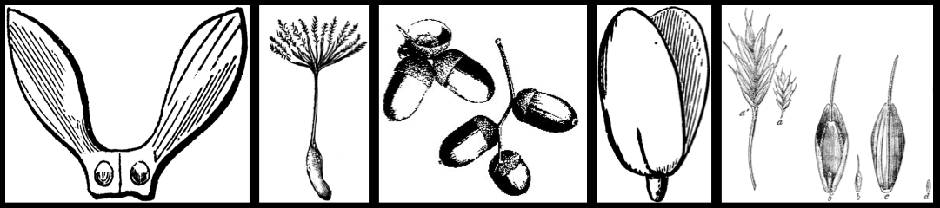

Define dispersal:

List some ways that plants and animals disperse:

Dispersal Activity:

- Collecting seeds
  - Take three seeds from each of three different types of seeds. Keep the seeds in separate piles by type.

- Predict how your seeds will disperse.
  - Describe what each seed type seeds look like, predict how each seed type will disperse, explain your prediction using the seed’s physical characteristics.

 | What do these seeds look like? | I predict these seeds will disperse by . . . | I made this prediction because . . .
Seed type 1
Seed type 2
Seed type 3

- Experiment!
  - For each seed type, test whether it can disperse by as many methods as possible (wind, air, animal fur, eaten, water).
  - Test all three seeds from each of your seed types.

How to test your seeds’ dispersal:

Wind
1) Start three seeds of one type by edge of table in a pile.
2) Blow on seeds through a straw, using just one breath.
3) Measure how far each seed moved away from the edge of the table.
4) Repeat steps 1-3 for the other seed types.

Air
1) Stand a meter stick upright.
2) Drop three seeds of one type from the top of the meter stick.
3) Use the second meter stick to measure how far each of the seeds traveled from the upright meter stick.
4) Repeat steps 1-3 for the other seed types.

Animal fur
1) Lay three seeds of one type out on the table.
2) Press animal fur down onto the seeds once.
3) Count how many seeds stick to the fur.
4) Repeat steps 1-3 for the other seed types.

Eaten
1) Observe three seeds of one type.
2) Do the seeds have brightly colored fruit surrounding them?
3) Do the seeds have a hard shell that might protect them from being eaten?
4) Repeat steps 1-3 for the other seed types.

Water
1) Take three seeds of one type and place them in a cup of water.
2) Do the seeds float or sink?
3) Repeat steps 1 and 2 for the other seed types.

Dispersal Activity Data Table:

 | DISPERSAL METHOD
 | Wind | Air | Animal Fur | Eaten | Water
Seed type | How far did each seed travel? | How far did each seed travel? | How many seeds were stuck to fur? | Are seeds brightly colored?  Do they have hard shells? | Did seeds sink or float?
1 | Seed 1: | Seed 1:
 | Seed 2: | Seed 2:
 | Seed 3: | Seed 3:
2 | Seed 1: | Seed 1:
 | Seed 2: | Seed 2:
 | Seed 3: | Seed 3:
3 | Seed 1: | Seed 1:
 | Seed 2: | Seed 2:
 | Seed 3: | Seed 3:

Summarize your data:

- For seed type 1, which dispersal method is the best? Why?
_______________________________________________________
_______________________________________________________
_______________________________________________________
- For seed type 2, which dispersal method is the best? Why?
_______________________________________________________
_______________________________________________________
_______________________________________________________
- For seed type 3, which dispersal method is the best? Why?
_______________________________________________________
_______________________________________________________
_______________________________________________________

