Climate Change: Global Warming Claims

Background information (from Intergovernmental Panel on Climate Change):
The climate system is a complex, interactive system consisting of the atmosphere, land surface, snow and ice, oceans and other bodies of water. The atmospheric component of the climate system most obviously characterizes climate; climate is often defined as ‘average weather’. Climate is usually described in terms of the mean and variability of temperature, precipitation and wind over a period of time, ranging from months to millions of years (the classical period is 30 years).
Solar radiation powers the climate system. There are three fundamental ways to change the radiation balance of the Earth: 1) by changing the incoming solar radiation (changes in Earth’s orbit or in the Sun itself), 2) by changing the fraction of solar radiation that is reflected (changes in cloud cover or atmospheric particles), and 3) by altering the longwave radiation from Earth back towards space (changing greenhouse gas concentrations). Climate, in turn, responds directly to such changes, as well as indirectly, through a variety of feedback mechanisms. The climate system evolves in time due to changes in external factors that alter the radiation balance of earth (called ‘external forcings’ and described above) and its own internal dynamics. External forcings include natural phenomena such as volcanic eruptions and solar variations, as well as human-induced changes in atmospheric composition.
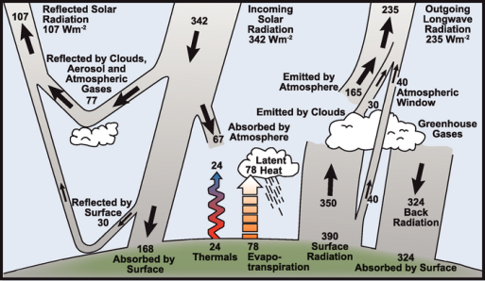

Estimate of the Earth’s annual and global mean energy balance. Over the long term, the amount of incoming solar radiation absorbed by the Earth and atmosphere is balanced by the Earth and atmosphere releasing the same amount of outgoing longwave radiation. About half of the incoming solar radiation is absorbed by the Earth’s surface. This energy is transferred to the atmosphere by warming the air in contact with the surface (thermals), by evapotranspiration and by longwave radiation that is absorbed by clouds and greenhouse gases. The atmosphere in turn radiates longwave energy back to Earth as well as out to space. Source: Kiehl and Trenberth (1997).﻿

Background continued:
The amount of energy reaching the top of Earth’s atmosphere each second on a surface area of one square meter facing the Sun during daytime is about 1,370 Watts, and the amount of energy per square meter per second averaged over the entire planet is one-quarter of this (see Figure 1). About 30% of the sunlight that reaches the top of the atmosphere is reflected back to space. Roughly two-thirds of this reflectivity is due to clouds and small particles in the atmosphere known as ‘aerosols’. Light-colored areas of Earth’s surface – mainly snow, ice and deserts – reflect the remaining one-third of the sunlight. The most dramatic change in aerosol-produced reflectivity comes when major volcanic eruptions eject material very high into the atmosphere. Rain typically clears aerosols out of the atmosphere in a week or two, but when material from a violent volcanic eruption is projected far above the highest cloud, these aerosols typically influence the climate for about a year or two before falling into the troposphere and being carried to the surface by precipitation.
The energy that is not reflected back to space is absorbed by the Earth’s surface and atmosphere. This amount is approximately 240 Watts per square meter (W m–2). To balance the incoming energy, the Earth itself must radiate, on average, the same amount of energy back to space. The Earth does this by emitting outgoing longwave radiation. Everything on Earth emits longwave radiation continuously. That is the heat energy one feels radiating out from a fire; the warmer an object, the more heat energy it radiates. To emit 240 W m–2, a surface would have to have a temperature of around –19°C. This is much colder than the conditions that actually exist at the Earth’s surface (the global mean surface temperature is about 14°C). Instead, the necessary –19°C is found at an altitude about 5 km above the surface.
The reason the Earth’s surface is this warm is the presence of greenhouse gases, which act as a partial blanket for the longwave radiation coming from the surface. This blanketing is known as the natural greenhouse effect. The most important greenhouse gases are water vapor and carbon dioxide. The two most abundant constituents of the atmosphere – nitrogen and oxygen – have no such effect. Clouds, on the other hand, do exert a blanketing effect similar to that of the greenhouse gases; however, this effect is offset by their reflectivity, such that on average, clouds tend to have a cooling effect on climate (although locally one can feel the warming effect: cloudy nights tend to remain warmer than clear nights because the clouds radiate longwave energy back down to the surface).
There are many feedback mechanisms in the climate system that can either amplify (‘positive feedback’) or diminish (‘negative feedback’) the effects of a change in climate forcing. For example, as the earth warms from some external forcing, snow and ice would begin to melt. This melting would reveal darker land and water surfaces that were beneath the snow and ice, and these darker surfaces would absorb more of the Sun’s heat, causing more warming, which would cause more melting, and so on, in a self-reinforcing cycle.

Claims:
- Global warming has not occurred since the time of the industrial revolution.
- The main cause of global warming from the time of the industrial revolution to the present has been natural changes in the amount of solar radiance from solar flares.
- The main cause of global warming from the industrial revolution to the present has been an increase in greenhouse gases in the atmosphere during that time.

Task - Working either individually or in groups up to 4:
- Examine the information presented below as it relates to the claims above
  - Interpret and analyze the information
  - Evaluate the relevancy and reliability of the information

- Decide which claim you support based on the given information.
  - Justify your position by summarizing your evaluation of each piece of evidence as it relates to each claim.
  - Explain what additional information you would need (if any) to convince you to believe the claim you supported.

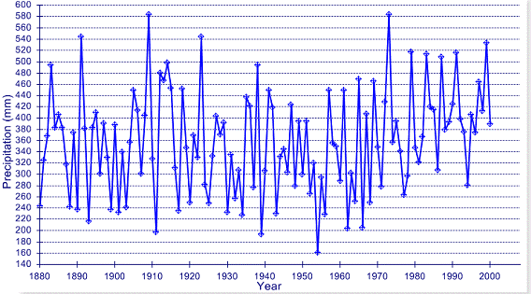
Information to interpret and evaluate as it relates to each claim:

Figure 1: Precipitation for the Denver area from 1880-2000. Data from the NOAA GHCN database
- Explain your interpretation and analysis of Figure 1: Is it relevant to the claims that were made? Is it reliable/do you believe the information that it conveys? Explain why or why not?

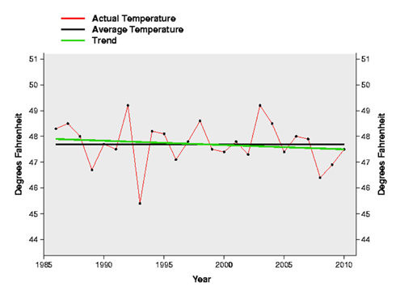

Figure 2: Pacific Northwest average annual temperatures from 1986 through 2010 with trend line. Data courtesy National Climatic Data Center
- Explain your interpretation and analysis of Figure 2: Is it relevant to the claims that were made? Is it reliable/do you believe the information that it conveys? Explain why or why not?

Figure 3: Global annual combined land-surface air temperature and SST anomalies (°C) (red) for 1850 to 2006 relative to the 1961 to 1990 mean, along with 5 to 95% error bar ranges. Figure from Intergovernmental Panel on Climate Change (IPCC)
- Explain your interpretation and analysis of Figure 3: Is it relevant to the claims that were made? Is it reliable/do you believe the information that it conveys? Explain why or why not?
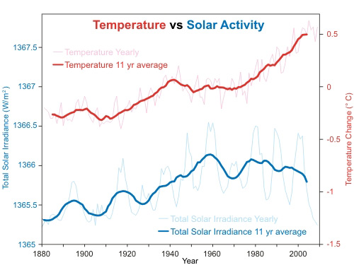

Figure 4: Global temperature anomaly comes from NASA GISS. The thin light red is the annual temperature anomaly with the thick red line showing the 11 year moving average. Total Solar Irradiance (TSI) comes from satellite measurements from PMOD. The thin light blue is the annual average with the thick dark blue line showing the 11 year moving average of TSI.
- Explain your interpretation and analysis of Figure 4: Is it relevant to the claims that were made? Is it reliable/do you believe the information that it conveys? Explain why or why not?

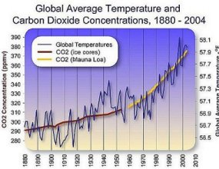

Figure 5: Graph of global temperature and atmospheric carbon dioxide. Temperature data from National Climatic Data Center and carbon dioxide data from ice cores an Mauna Loa recording station.
- Explain your interpretation and analysis of Figure 5: Is it relevant to the claims that were made? Is it reliable/do you believe the information that it conveys? Explain why or why not?

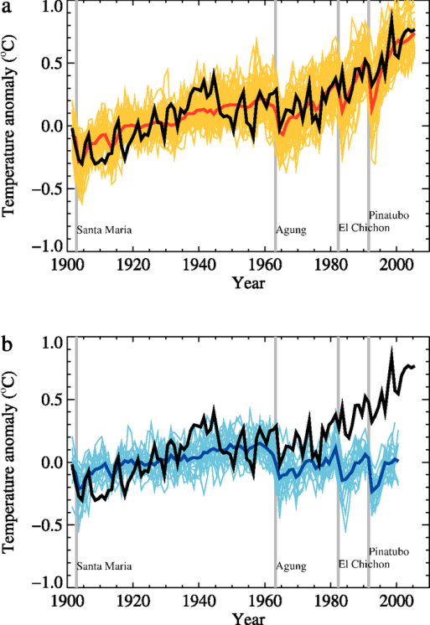

Figure 6: Comparison between global mean surface temperature anomalies (°C) from observations (black) and AOGCM simulations forced with (a) both anthropogenic and natural forcings and (b) natural forcings only. All data are shown as global mean temperature anomalies relative to the period 1901 to 1950, as observed (black, Hadley Centre/Climatic Research Unit) and, in (a) as obtained from 58 simulations produced by 14 models with both anthropogenic and natural forcings. The multi-model ensemble mean is shown as a thick red curve and individual simulations are shown as thin yellow curves. Vertical grey lines indicate the timing of major volcanic events. The simulated global mean temperature anomalies in (b) are from 19 simulations produced by five models with natural forcings only. The multi-model ensemble mean is shown as a thick blue curve and individual simulations are shown as thin blue curves. . Figure from Intergovernmental Panel on Climate Change (IPCC)
- Explain your interpretation and analysis of Figure 1: Is it relevant to the claims that were made? Is it reliable/do you believe the information that it conveys? Explain why or why not?

Claims (for reference):
- Global warming has not occurred since the time of the industrial revolution.
- The main cause of global warming from the time of the industrial revolution to the present has been natural changes in the amount of solar radiance from solar flares.
- The main cause of global warming from the industrial revolution to the present has been an increase in greenhouse gases in the atmosphere during that time.

Wrap up questions:
- Which claim do you support (base your position solely on the figures presented in this worksheet)? Justify your position by explaining why the figures best support this claim over the others.

- Explain what additional information you need (if any) to convince you to believe the claim you supported? Explain.

- Explain what additional information you need to convince you to support one of the other claims presented? Explain.

