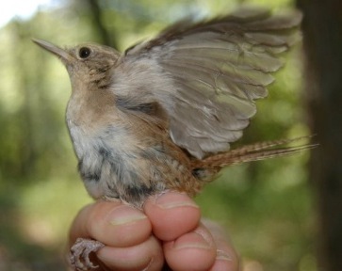
089

Strategy:
High Aggression

Rule: Replace medium and low birds. Rock-paper-scissors with high birds.

Part A Final Score: Final territory is:
…high quality = 8 offspring
…low quality = 5 offspring
… no territory = 0 offspring

Part B Final Score: Same as phase 1, minus 2 x # of fights you had.

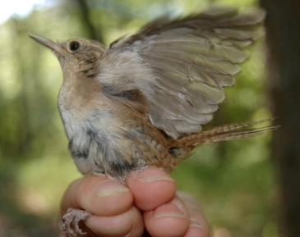

Strategy:
High Aggression

Rule: Replace medium and low birds. Rock-paper-scissors with high birds.

Part A Final Score: Final territory is:
…high quality = 8 offspring
…low quality = 5 offspring
… no territory = 0 offspring

Part B Final Score: Same as phase 1, minus 2 x # of fights you had.

Strategy:
High Aggression

Rule: Replace medium and low birds. Rock-paper-scissors with high birds.

Part A Final Score: Final territory is:
…high quality = 8 offspring
…low quality = 5 offspring
… no territory = 0 offspring

Part B Final Score: Same as phase 1, minus 2 x # of fights you had.

Strategy:
High Aggression

Rule: Replace medium and low birds. Rock-paper-scissors with high birds.

Part A Final Score: Final territory is:
…high quality = 8 offspring
…low quality = 5 offspring
… no territory = 0 offspring

Part B Final Score: Same as phase 1, minus 2 x # of fights you had.

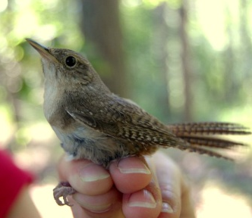

Strategy:
Medium Aggression

Rule: Replace low and lose to high birds. Rock-paper-scissors with medium birds.

Part A Final Score: Final territory is:
…high quality = 8 offspring
…low quality = 5 offspring
… no territory = 0 offspring

Part B Final Score: Same as phase 1, minus 1 x # of fights you had.

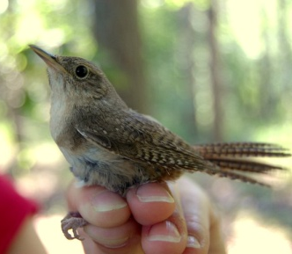

Strategy:
Medium Aggression

Rule: Replace low and lose to high birds. Rock-paper-scissors with medium birds.

Part A Final Score: Final territory is:
…high quality = 8 offspring
…low quality = 5 offspring
… no territory = 0 offspring

Part B Final Score: Same as phase 1, minus 1 x # of fights you had.

Strategy:
Medium Aggression

Rule: Replace low and lose to high birds. Rock-paper-scissors with medium birds.

Part A Final Score: Final territory is:
…high quality = 8 offspring
…low quality = 5 offspring
… no territory = 0 offspring

Part B Final Score: Same as phase 1, minus 1 x # of fights you had.

Strategy:
Medium Aggression

Rule: Replace low and lose to high birds. Rock-paper-scissors with medium birds.

Part A Final Score: Final territory is:
…high quality = 8 offspring
…low quality = 5 offspring
… no territory = 0 offspring

Part B Final Score: Same as phase 1, minus 1 x # of fights you had.
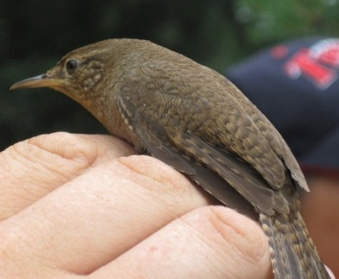

Strategy:
Low Aggression

Rule: Lose to high and medium birds. Rock-paper-scissors with low birds.

Part A Final Score: Final territory is:
…high quality = 8 offspring
…low quality = 5 offspring
… no territory = 0 offspring

Part B Final Score: Same as phase 1.

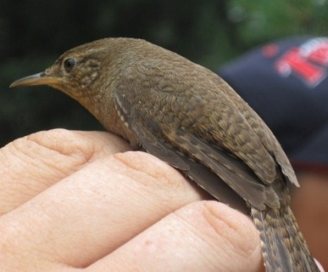

Strategy:
Low Aggression

Rule: Lose to high and medium birds. Rock-paper-scissors with low birds.

Part A Final Score: Final territory is:
…high quality = 8 offspring
…low quality = 5 offspring
… no territory = 0 offspring

Part B Final Score: Same as phase 1.

Strategy:
Low Aggression

Rule: Lose to high and medium birds. Rock-paper-scissors with low birds.

Part A Final Score: Final territory is:
…high quality = 8 offspring
…low quality = 5 offspring
… no territory = 0 offspring

Part B Final Score: Same as phase 1.

Strategy:
Low Aggression

Rule: Lose to high and medium birds. Rock-paper-scissors with low birds.

Part A Final Score: Final territory is:
…high quality = 8 offspring
…low quality = 5 offspring
… no territory = 0 offspring

Part B Offspring: Same as phase 1.

