Name: ______________________ Bird Beak Game Worksheet
Date: _______________________ Weather Scenario 3
. . . . . . . . . . . . . . . . . . . . . . . . . . . . . . . . . . . . . . . . . . . . . . . . . . . . . . . . . . . . . . .
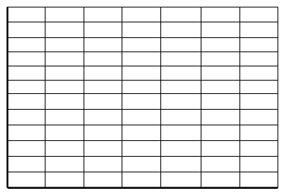
12
11
10
9
8
7
6
5
4
3
2
1
Draw your starting population:

Number of Birds

1 2 3 4 5 6 7
Beak Size
12
11
10
9
8
7
6
5
4
3
2
1
Draw your population after Year 1:

Number of Birds

1 2 3 4 5 6 7

Beak Size

What is the weather in Year 1? ________________
Which beak sizes did well? ____________________
Which beak sizes did poorly? __________________
Draw your population after Year 2:

Number of Birds

Beak Size

What is the weather in Year 2? ________________
Which beak sizes did well? ____________________
Which beak sizes did poorly? __________________

Draw your population after Year 3:

What is the weather in Year 3? ________________
Which beak sizes did well? ____________________
Which beak sizes did poorly? __________________
Draw your population after Year 4:

What is the weather in Year 4? ________________
Which beak sizes did well? ____________________
Which beak sizes did poorly? __________________

Look back at the graphs for the starting population and Years 1, 2, 3, and 4.

Describe the change over time.
Which beak sizes became more common in the population? _________________
Which beak sizes no longer exist in the population? ________________________

Why did these changes occur? Use the weather and available seed sizes to explain your answer.
______________________________________________________________________________
______________________________________________________________________________
______________________________________________________________________________

Imagine the weather continued to change back and forth each year over the next few years just like it did in Years 1 through 4.
Draw your prediction of the population in the future:

Explain what you drew in the graph in words.
______________________________________________________________________________
______________________________________________________________________________
______________________________________________________________________________

