Name: ______________________ Bird Beak Game Worksheet
Date: _______________________ Weather Dial
. . . . . . . . . . . . . . . . . . . . . . . . . . . . . . . . . . . . . . . . . . . . . . . . . . . . . . . . . . . . . . .
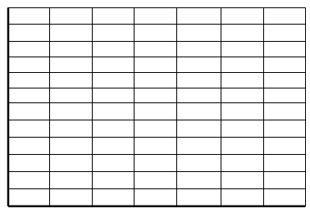
12
11
10
9
8
7
6
5
4
3
2
1
Draw your starting population:

Number of Birds

1 2 3 4 5 6 7
Beak Size
12
11
10
9
8
7
6
5
4
3
2
1
Draw your population after Year 1:

Number of Birds

1 2 3 4 5 6 7

Beak Size
What is the weather in Year 1? ________________
Which beak sizes did well? ____________________
Which beak sizes did poorly? __________________
Draw your population after Year 2:

Number of Birds

Beak Size

What is the weather in Year 2? ________________
Which beak sizes did well? ____________________
Which beak sizes did poorly? __________________

Draw your population after Year 3:

What is the weather in Year 3? ________________
Which beak sizes did well? ____________________
Which beak sizes did poorly? __________________
Look back at the graphs for the starting population and Years 1, 2, and 3.

Describe the change over time.
Which beak sizes became more common in the population? _________________
Which beak sizes no longer exist in the population? ________________________

Why did these changes occur? Use the weather and available seed sizes to explain your answer.
______________________________________________________________________________
______________________________________________________________________________
______________________________________________________________________________

Imagine the weather stayed the same as Year 3 over the next few years.
Draw your prediction of the population in the future:

Explain what you drew in the graph in words.
______________________________________________________________________________
______________________________________________________________________________
______________________________________________________________________________

