Name_______________________

**It’s Gettin’ Hot In Here: Data Interpretation Worksheet**

**Range shifts in birds**

Below is a figure showing the wintering grounds for a variety of different bird species and how they have changed over time.

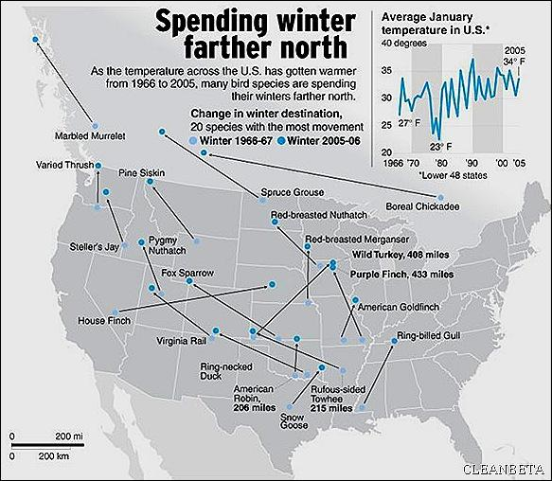

1. This map of the United States shows where bird populations spent the winter in 1966 and 2005. What is the overall trend for these species as time has progressed? What do you believe the main contributing factor is for the observed change?
2. Describe in a sentence or two what the small graph in the top right corner of the picture is telling us. Why was this graph included?
3. Which species of bird that once lived in the United States is now living in Canada?

**Nematodes and Muskoxen** (Kutz et al. 2005)

Muskoxen in the Canadian arctic are parasitized by a lung-dwelling nematode. These nematodes cause respiratory problems and weaken the muskoxen to predator attack. Before infecting muskoxen, the nematode lives and develops inside an intermediate host (a slug). Historically it took two years of development inside slugs before the nematodes could infect muskoxen, but warming temperatures may change that. Below is a graph of the accumulated degree days (the total number of days out of the year that reached a minimum temperature) in the Canadian arctic over time. The horizontal line represents the minimum number of degree days in a year for the nematodes to fully develop in one year instead of two.

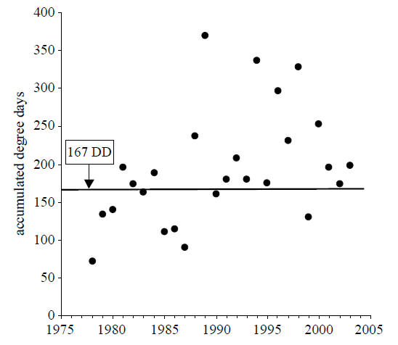

1) Describe the trend you see in this figure. What is happening to the nematode life cycle as time progresses?

2) How might having a more rapid life cycle affect nematode abundance? (Hint: think about what might happen to the nematodes if they are stuck in slugs over winter)

3) How might your answer to question 2 affect muskox populations?

**Ocean acidification and clownfish anti-predator behavior** (Munday et al., 2010)

As atmospheric CO2 increases the oceans absorb more and more CO2 from the atmosphere. Higher levels of CO2 in the ocean lead to ocean acidification which can have a number of negative effects on marine life. For example, ocean acidification is thought to interfere with the senses of clownfish. Below is a graph of juvenile clownfish response to the scent of a predator when raised in water with different concentrations of CO2. Researchers placed juvenile clownfish into a device that allowed them to choose between spending time in water that was exposed to a predator’s scent, and water that was unexposed.

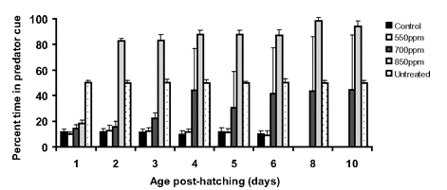

1) Describe the pattern you see in this graph. What effect does CO2 concentration have on predator avoidance? (Note: bars labeled as Untreated describe tests where no predator scent was added)

2) How might your answer to question 1 affect clownfish populations?

**Vegetation shift to exotic species**

One of the consequences of climate change is that it can make habitats more susceptible to colonization by exotic species. Below is a graph showing the relationship between the number of days with frost and the number of exotic species present in southern Switzerland



Note: The “Number of Frost Days” is illustrated by the darker line, the “Number of Exotic Species” is illustrated by the lighter grey line. The study took place in the southern portion of Switzerland.

1. What has happened to the number of frost days throughout the recorded time period? What is the length of time that this study looked at?
2. “Exotic” species have the possibility of becoming “invasive” species depending on how they interact with the habitat. Judging from your previous knowledge of invasive species, and what the graph is showing, what do you think the impact of these exotic species is?
3. This study stopped recording data at the year 2000. If this graph were to extend into present time (year 2012), what do you think the graph would look like? What will happen to temperature? Exotic species?