Name:_____________

The Best Genes for the Job: Student Worksheet

In this activity you get to become a bird searching for food. You can play the part of a bird with a genotype for a long skinny beak or a genotype for a spoon-shaped beak. You will search for food in two different environments; a smooth, open environment, and a rough environment. What type of beak will be the best and will it depend on the environment?

In the table below record the number of beans you successfully picked up in each trial:

 | Smooth Environment | Rough Environment
Spoon Beak
Tweezers Beak

Use the axes below to graph your data. Make sure to include labels.

Thought Questions:

1) Does your data show an interaction between genes and the environment? How?

2) Why do you think these two different genotypes are able to persist?

3) Imagine for a moment that you live in a world where unicorns exist. In this world unicorn horns are a highly valuable and the longest horns are the most prized. As a result poachers will hunt unicorns for their horns, and they greatly prefer to hunt unicorns with long horns over those with short horns. Below is a graph showing the survival rates of long horn and short horn unicorns in two different environments, an environment where poachers are present, and an environment where poachers are absent. Look at the graph, do you see an interaction between genotype and environment? Describe this interaction. (what type of unicorn does best in each environment?)

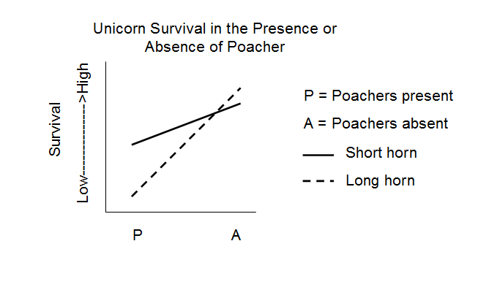

4) Now imagine that dragons also exist in this world. Dragons prey upon unicorns but only in areas where poachers are absent (dragons are very afraid of poachers). Long horn unicorns are much better at defending themselves against dragons than short horn unicorns. With this in mind, draw how you think adding dragons will change the above graph (please use the blank graph below).

