How can we grow our fuel with plants?
Data provided by NSF GK-12 BEST project and
Written by GK-12 Fellow Tomomi Suwa, Cara Krieg and Alycia Lackey

Background Information:
Everyday we consume a large amount of energy to drive our cars, to heat or cool our homes, and to use electronic devices. Most of this energy is produced by burning fossil fuels. However, burning fossil fuels creates carbon dioxide, the number one greenhouse gas contributor to climate change. Scientists are trying to figure out alternative ways to produce energy. For example, biofuel is a type of a fuel produced from plant matter. Using plants as fuel can help reduce human impact on climate change because plants take up carbon dioxide as they grow. Plants do release carbon dioxide when we burn them to make fuel, just as fossil fuels release carbon dioxide when they are burned. However, the net carbon emission of plants is lower because plants also take up carbon dioxide when they grow (i.e., photosynthesis).
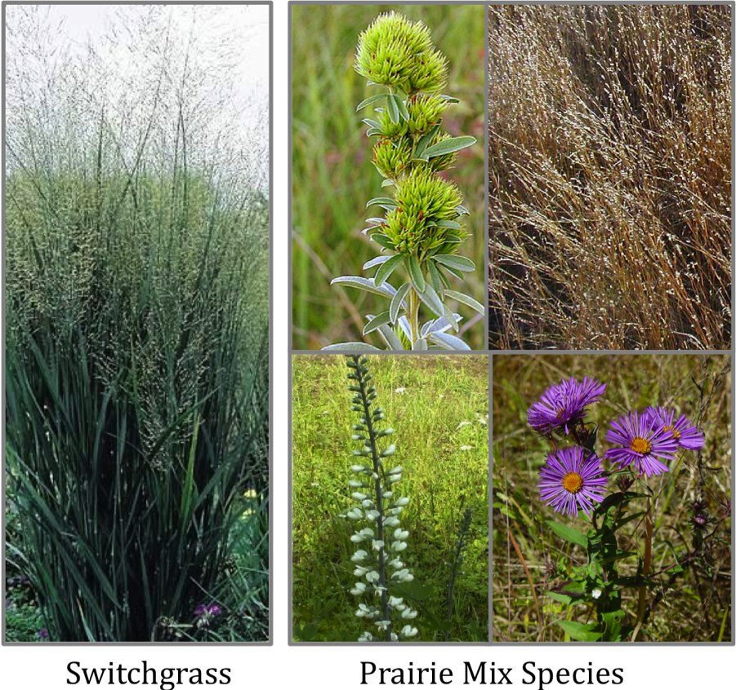
To examine how to use plants to grow fuel, young scientists from Michigan set up two types plots in ten schoolyards. They either planted switchgrass or a mixture of 16 prairie species. They wanted to know how to maximize biofuel production using plant materials. They harvested plant materials from Switchgrass plots and Prairie Mix plots. Then they dried the plant material for a week and measured the mass (known as biomass). Measuring biomass can help scientists to estimate how much biofuel can be produced.

Scientific Question: Which plot type produces the most biomass (Prairie Mix or Switchgrass)?

(A) What is your prediction? Why do you predict this?

(B) Look at the data below.

Calculate the average biomass for each plot treatment (Prairie Mix and Switchgrass).
Do you notice any patterns in the data related to your prediction?

School | Prairie Mix  Biomass (g) | Switchgrass Biomass (g) | Overall Average (g)
Plainwell | 7.6 | 9.8 | 8.7
Harper | 84.0 | 65.5 | 74.8
KBS | 81.2 | 72.9 | 77.0
Gull Lake | 70.9 | 91.3 | 81.1
Lawton | 58.7 | 113.0 | 85.8
KBS | 76.2 | 101.5 | 88.8
Comstock | 101.3 | 90.5 | 95.9
Lawton | 101.8 | 155.5 | 128.7
Delton | 148.6 | 203.1 | 172.0
Gobles | 157.9 | 209.4 | 183.7
AVERAGE

(C) What parts of the data will you use to answer the question?

Identify independent and dependent variables.
Independent (what did we set up?): ____________________
Dependent variable (what did we measure?): _____________ ( )units

Circle numbers you will plot on your graph.

(D) Use the data you circled to draw a graph showing the independent variable on the x-axis and the dependent variable on the y-axis. Plot a graph of the relationship between type of plot (Prairie Mix or Switchgrass) and average biomass.



(E) Claim: Using the information from your graph, write a statement that answers the scientific question: “Which plot type produces the most biomass (Prairie Mix or Switchgrass)?”

(F) Evidence: What data from the table or graph allows you to make the claim above?

(G) Reasoning: Now use your evidence to support your claim. Answer the scientific question including the data as evidence in your statement.

