Does soil moisture affect plant performance?
Data provided by NSF GK-12 BEST project and
Written by GK-12 Fellow Tomomi Suwa, Cara Krieg and Alycia Lackey

Background Information:
Many factors can affect how well plants grow. In order to grow, plants need water, light, and carbon dioxide. Other organisms, such as plant pests, pollinators, and diseases, can also affect plant growth. How do scientists test whether these factors affect plants growth?
To address this question, a group of young scientists in Michigan decided to focus on how soil moisture (amount of water soil holds) affects plant growth. They planted seeds in a 2m x 2m plot at each schoolyard and measured soil moisture once plants began to grow. They also collected plant growth above ground, not including roots, and dried it for at least one week. This is called biomass, and it is a measure of how much plants grew excluding the mass of water in the plants. The data they collected are summarized below and can be used to test whether soil moisture affect how well plants grow.

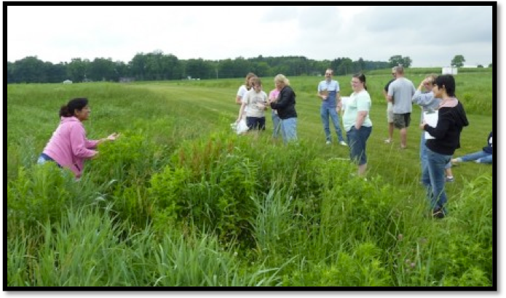
Scientists collecting biomass

Scientific Question: How does soil moisture affects plant performance?

A) What is your prediction? Why do you predict this?

(B) Look at the data below. Do you see any patterns related to your prediction?

School | Biomass (g) | Soil Moisture (%)
Harper Creek 1 | 85.7 | 13.7
Harper Creek 2 | 153.5 | 11.0
Harper Creek 3 | 50.8 | 15.6
Olivet | 22.2 | 14.1
Plainwell | 46.2 | 7.5
Comstock | 95.9 | 11.6
Delton Kellogg 1 | 223.9 | 16.6
Delton Kellogg 2 | 84.8 | 13.4
Gull Lake 1 | 81.1 | 22.3
Gull Lake 2 | 87.9 | 15.1
Lawton 1 | 128.7 | 9.7
Lawton 2 | 85.8 | 18.7
Plainwell 1 | 8.7 | 7.1
Plainwell 2 | 9.9 | 9.8

(C) What parts of the data will you use to answer the scientific question?

Identify independent and dependent variables.
Independent (what did we set up?): ______________( ) units
Dependent variable (what did we measure?): __________( ) units

Circle numbers you will plot on your graph.
(D) Use the data you circled to plot a graph showing
independent variable (x-axis) versus dependent variable (y-axis).


(E) Claim: Using the information from your graph, write a statement that answers the scientific question: “How does soil moisture affects plant performance?”

(F) Evidence: What data from the table or graph allows you to make the claim above?

(G) Reasoning: How does the data in your graph support your statement? Draw arrows and/or circle the parts of the graph that you used to make your statement.

