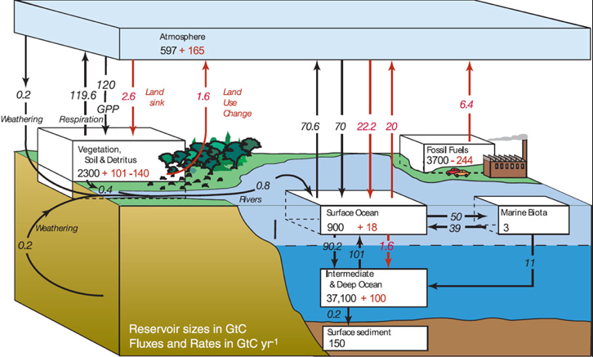

Credit: Intergovernmental Panel on Climate Change

