 | How they look | Size (µm) | Abundance (tons/hectare) | Reproduction | Habitat characteristics | Preferred ecosystem | Lifestyle
Fungi | 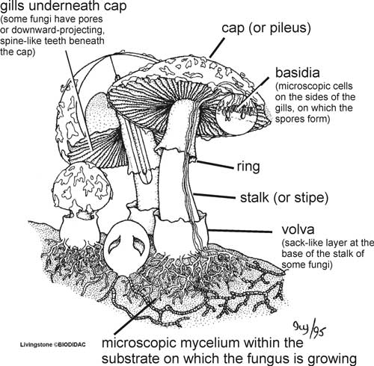
Bacteria | 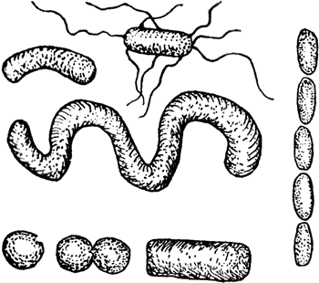
Protozoans | 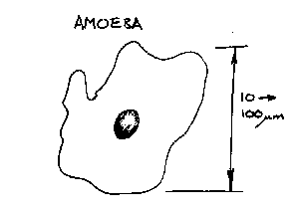
Nematodes | 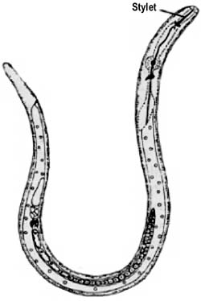

Images Courtesy of: Ivy Livingstone, Biodidac Project (fungus); Educational Technology Clearinghouse, University of South Florida (bacteria); National Science Foundation “simscience” (Amoeba), United Nations Food and Agriculture Organization (Nematode)

