K-12 Partnership Lesson Plan

Groundwater Conceptions and Processes

Overview
This lesson about groundwater includes an overview of three important ideas: the scarcity of freshwater reservoirs available to us, what water looks like and how it flows in the ground, and how our land-use choices impact the availability of groundwater. First is a demonstration of what percentage of the Earth’s water is available to us. Incorrect conceptions of groundwater are very common, so we will use student drawings to understand where our students are starting when we introduce the idea of groundwater. Finally we will demonstrate groundwater movement and storage using small groundwater models that teachers can use in their classrooms.
Objectives
At the conclusion of the lesson, students will be able to:
- Demonstrate the relative amounts of water on the Earth that is in various reservoirs
- Pre-assess and anticipate student’s conceptions of ground water
- Model the water table and its relationship to surface water
- Model how groundwater contamination flows through the ground depending on the subsurface characteristics
- Define and explain key terms related to groundwater processes: infiltration, porosity, permeability, aquifer
Length of Lesson
1-3 class periods
Grade Levels
Middle school
Standards covered (NGSS)
Disciplinary Core Ideas:

- MS-ESS2-4: develop a model to describe the cycling of water through Earth’s systems driven by energy from the sun and the force of gravity
- MS-ESS3-1: construct a scientific explanation based on evidence for how the uneven distributions of Earth’s mineral, energy, and groundwater resources are the result of past and current geosciences processes

Cross Cutting Concepts:

- Scale, proportion, and quantity
- Systems and system models
- Energy and matter in systems

Science and Engineering Practices

- Developing and using models
Materials
Activity 1
- 1 liter graduated cylinder
- 1 small plastic pipette
- 1 small graduated cylinder
- 6 small clear glasses
- Blue food coloring
Activity 2
- Small groundwater model
  - Gravel
  - Non-hardening molding clay
  - Pump and plastic tubes
- Cups or small beakers
- Food coloring
- Transfer pipet
- Bucket or sink
Background

When most students think about fresh water they picture lakes and rivers. However, a large portion of the Earth’s fresh water exists as water below the ground. Groundwater is in important step of the water cycle. It can also be influenced by human activity on the surface.
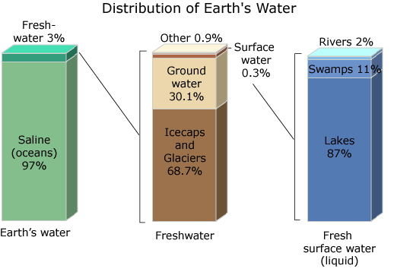
http://ga.water.usgs.gov/edu/watercyclefreshstorage.html

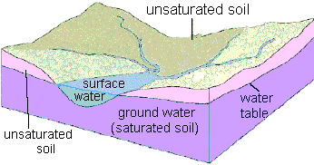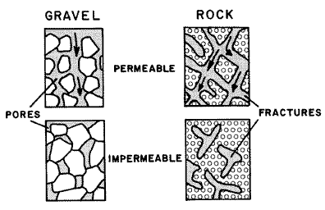

In this lesson, students will learn about the following scientific terms:
- Pore space: spaces between soil particles that can be filled with either water or air
- Infiltration: the process of water on the surface entering the soil
- Porosity: the amount of pore space in the soil. A porous soil has many spaces
- Water table: the level at which soil is permanently saturated with water
- Permeability: how well connected the pore spaces are within the soil. Water will flow easily through a highly permeable soil
- Impermeable: a material is impermeable when pores are not connected and ground water cannot pass between spaces
- Aquifer: underground soil or rock that ground water can move through easily. This depends on soil porosity and permeability
- Confined aquifer: when an aquifer is surrounded by less porous rock. This confines the water and its pressure. If wells are drilled into a confined aquifers, the pressure can sometimes be enough to push the water up without the aid of a pump

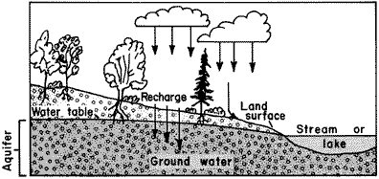

Activities of the session

Activity 1: Why does groundwater matter?
- Of the water on Earth, 97% is saline (salty ocean water), leaving only 3% freshwater that is potentially available for humans to drink. Of that 3%, the percentages stored in the following reservoirs can be found in Table 1.

- Using 1000 ml of water with a small amount of blue food coloring, pour volumes of water proportional to the percentage of freshwater available in each reservoir.
Water Reservoir | Percentage of Freshwater (%) | Volume of Water (of 1000ml)
Ice caps, Glaciers, Permanent Snow | 68.7% | 687ml
Fresh Groundwater | 30.1% | 301ml
Ground Ice & Permafrost | 0.8% | 8ml
Surface Water: Lakes, Rivers & Swamps | 0.3% | 3ml
Soil Moisture, Atmospheric Moisture,  & Biological Moisture | 0.1% | 1ml
Total Freshwater: | 100.0% | 1000ml
Source: Gleick, P. H., 1996: Water resources. In Encyclopedia of Climate and Weather, ed. by S. H. Schneider, Oxford University Press, New York, vol. 2, pp.817-823. *Rounded to tenth place.

- Summary questions
  - Which freshwater reservoirs supply most of the water we drink?
  - How much of the freshwater on Earth is available for us to drink?
  - Going further: what percentage is the freshwater we have available to drink compared to all of the water on Earth (fresh and saline)?

Activity 2: What does groundwater look like?
- We will model groundwater processes using a small table-top groundwater model. We are using models from the Colorado School of Mines because they are small, inexpensive and can model processes rapidly enough to do this activity in a typical class period. The models have been prepared to save time during this workshop. To prepare the models, use the diagram on the handout as a placement guide for the gravel, clay, and well tubes. When making the clay layer, be sure to seal the clay around the well tube and to the sides of the model. Before adding the upper layer of gravel, test the seal of the clay by pouring water along the clay layer. If water moved into the lower gravel layer anywhere but the clay gap near the stopper, use additional clay to seal the area.
- The procedure outlined below is designed as a one-hour professional development. Additional ideas are presented in the Resources section.
- Part A: Fill the groundwater model with water
  - Inquiry questions:
    - The level of the water in the ground is called the water table. How is the water table related to the level of the water in the lake?
    - Pump water out of one of the wells. What happens to the water table? What happens to the water level in the lake?
    - In the real world, what factors could impact the level of the water in the ground? How would the height of the water table change in the spring? In summer?
    - If you wanted to drill a well for your house to get water, how deep would you have to drill to get water all year round?
- Part B: “Contaminate” the lake by dropping two drops of food coloring
  - Inquiry questions
    - What will happen to the groundwater surrounding the lake?
- Part C: Pump water from Well B
  - Inquiry questions:
    - What happened to the contamination in the lake?
    - How would the flow of water change if we used sand in our model instead of gravel?
    - Pump water from Well A. Did the contamination affect Well A? Why or why not?
Resources
- Water distribution on Earth: http://ga.water.usgs.gov/edu/waterdistribution.html
- USGS Groundwater Information Page
This page will lead you to sources of real groundwater data and modeling programs. http://water.usgs.gov/ogw/

