Name: Name of other group members:

Don’t Shell Yourself Short
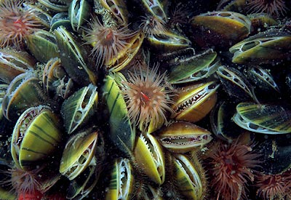
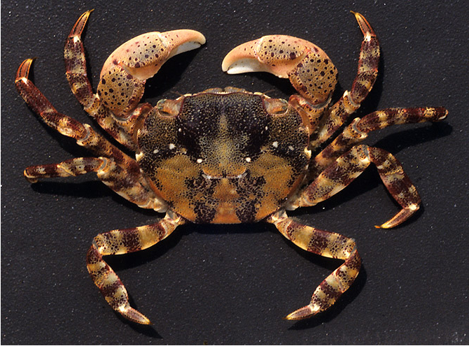
Asian shore crab (predator) Mussels (prey)

Introduction

Asian shore crabs (Hemigrapsus sanguineus) are native to the western Pacific Ocean. Since the late 1980s, they have been spreading throughout the northeast coast of the US. Crabs are tiny (about the size of a penny), but populations are growing very quickly. They are generalist predators (eat lots of different prey). Blue mussels (Mytilus edulis) in the northeast US are becoming more resistant to predation by crabs. How is this happening?

In this session, we will play a game with nuts simulating crab-mussel interactions. We will gather data from the game, analyze it, and draw conclusions about how an introduced predator could cause quick evolutionary change in only a few generations of the prey species.

Definitions

Evolution:

Natural selection:

Phenotype:

Genotype:

Inherited:

Fitness:
Methods

- Divide into groups of 4. Each person in the group gets 9 peanuts in the shell and 1 almond. Everybody dumps their nuts into a pile in the middle of the table. This pile is your group’s population. All the mussels (nuts) are the same species, but some have a different phenotype. (Alternate version exploring the importance of variation: in two groups, each person starts with 10 peanuts in the shell and no almonds).
- Data collection: fill out the table below for your population.
- Generation 1:
  - Selection: Everybody removes one nut, shells and eats it, and goes back for more nuts, one at a time. If you can’t shell the nut, return it to the table and take another. Selection continues for 60 seconds.
  - Count the number of each type of nut left and write to the left of the x2 in the appropriate box in the data table below.
  - Reproduction: Next, add more nuts to double the number of each type. (Example: 5 peanuts are left and 2 almonds are left. After reproduction, you will have 10 peanuts and 4 almonds.)
  - Fill out the data table to the right of the x2 with the number of each type of nut after reproduction.
- Repeat Selection and Reproduction (steps a-d) for generations 2 and 3, filling out the data table for each generation.

 | Number of thin shells (peanuts) in the population |  |  | Number of thick shells (almonds) in the population |  |  | Total number of mussels in population  (peanuts + almonds) | Percent peanuts | Percent almonds
Starting population
After generation 1 |  | x2 |  |  | x2
After generation 2 |  | x2 |  |  | x2
After generation 3 |  | x2 |  |  | x2

Results

- Compile all the groups’ data after 3 generations
Peanuts | Group 1 | Group 2 | Group 3 | Group 4 | Group 5 | Group 6 | Group 7
Starting population
After generation 1
After generation 2
After generation 3

Almonds | Group 1 | Group 2 | Group 3 | Group 4 | Group 5 | Group 6 | Group 7
Starting population
After generation 1
After generation 2
After generation 3

Total population size | Group 1 | Group 2 | Group 3 | Group 4 | Group 5 | Group 6 | Group 7
Starting population
After generation 1
After generation 2
After generation 3

- Line graphs: Plot the class data over time, using the graph paper provided by your teacher.

Discussion

- Did the percent almonds (hard shells) change over time? Why?

- Which phenotype had a higher fitness? Why?

- What three things are necessary for evolution to occur? What part of the game each?
 | Condition necessary for evolution | Rule of the game representing this condition
1 | There are different phenotypes in a population
2 | The phenotype is inherited
3 | Some phenotypes have a higher fitness than others (selection)

- Did evolution occur? How do you know?

- How quickly did evolution occur?

- Did population sizes respond to predation by the crab?

- Did any of the populations go extinct? Why?

- The introduction of a new species (in this example, the crabs) can cause new selection pressures. What else could cause new selection pressures? Give an example of each.

- In our game, what would have happened if natural selection was different in some groups? If some populations could ONLY eat almonds and not peanuts, what would have happened?

- In real life, do you think natural selection is the same in all environments? Why?

- Explain how natural selection can lead to biodiversity.

