Cheat Sheet for Herbicide Exposure Scenarios

Suit | Identity of Frog
Female
No exposure to herbicide
Female
Exposed to herbicide
Male
No exposure to herbicide
Male
Exposed to herbicide

Reproduction: |  | Female is…
Male is… |  | 2  offspring | 1  offspring
 |  | 1  offspring | 0  offspring

 | Generation 1  Population | Generation 2  Population | Generation 3  Population | Generation 4  Population
40% Female  No herbicide | 10
90% Female  No herbicide | 10
40% Female  Herbicide | 10
90% Female  Herbicide | 10

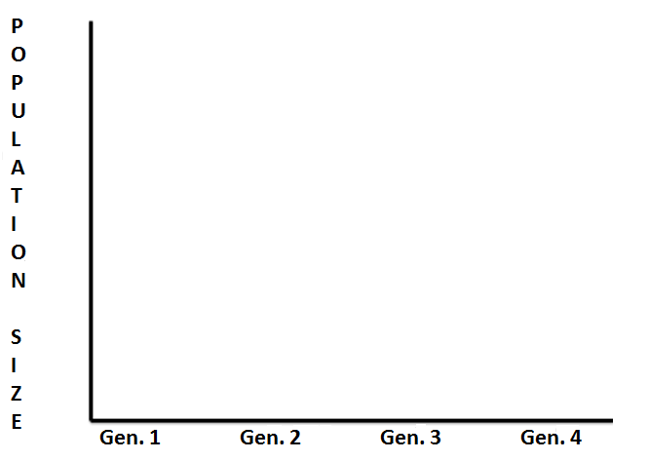

What population trends do you see? What differences do you see between scenarios?

Does herbicide appear to affect population dynamics before introduction of chytrid?

Do there seem to be differences between scenarios in the proportion of frogs reproducing? What consequences could this have?

