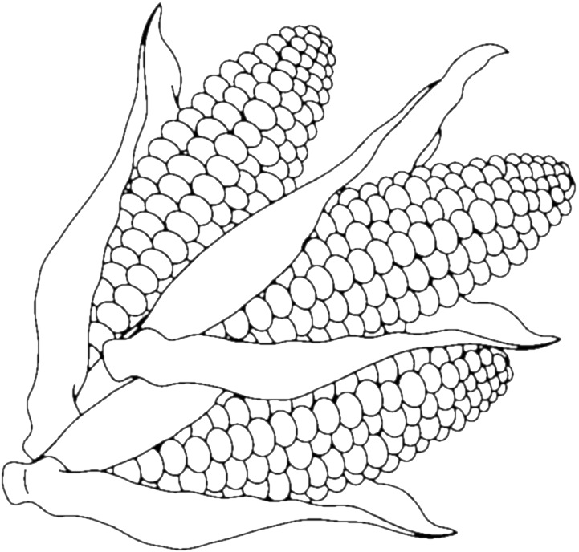Title:

**Legend**

☐= Prediction

☐= Data

Title:



**Legend**

☐= Prediction

☐= Data