INSECT CARDS (FRONT)

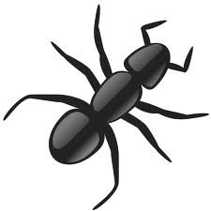  INSECTS | INSECTS
INSECTS | INSECTS
INSECTS | INSECTS

INSECT CARDS (BACK)

Bees Pollinate  All plants gain 1 seed | Bees Pollinate / Ants defend territory  Plants without Ants: gain 1 seed  Plants with Ants: lose 1 seed
Aphid infestation!  Plants with Ants: gain 1 seed  Plants without Ants: lose 1 seed | Grasshopper infestation!  Plants with Ants: gain 1 seed  Plants without Ants: lose 1 seed
Slug infestation!  Plants with Ants: gain 1 seed  Plants without Ants: lose 1 seed | Wasps eat nectar  Plants without Ants but with rhizobia: lose 1 seed  Plants without Ants and rhizobia: lose 2 seeds

ANIMAL CARDS (FRONT)

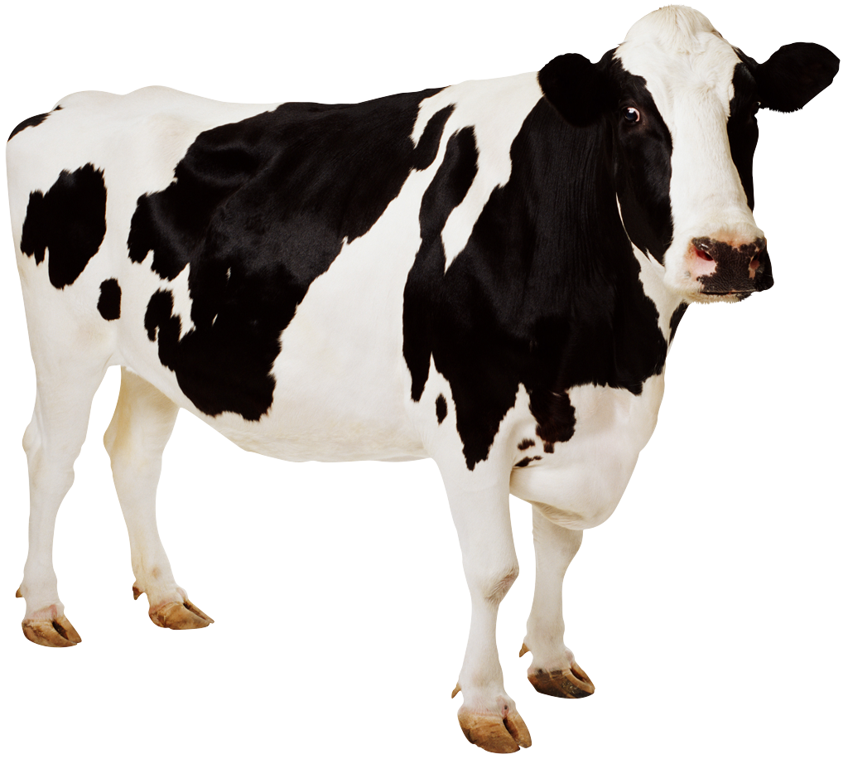  ANIMALS | ANIMALS
ANIMALS | ANIMALS
ANIMALS | ANIMALS

ANIMAL CARDS (BACK)

Deer eats plant with rhizobia!  Plants with rhizobia: lose 1 seed | Frogs eat ants!  Plants with ants: lose 1 seed  Plants without ants: gain 1 seed
Snake finds shelter from sun  All plants stay the same | Dog urinates on plant!  Plants without rhizobia: gain 1 seed  Plants with rhizobia: lose 1 seed
Birds swoop in and eat insects!  Plants without Ants: gain 1 seed  Plants with Ants: lose 1 seed | Fox eats plant with rhizobia!  Plants with rhizobia: lose 1 seed

WEATHER AND ENVIRONMENT CARD (FRONT)
Weather  &  Environment | Weather  &  Environment
Weather  &  Environment | Weather  &  Environment
Weather  &  Environment | Weather  &  Environment

WEATHER AND ENVIRONMENT CARDS (BACK)

Farmer fertilizes field!  Plants without rhizobia: gain 1 seed  Plants with rhizobia: lose 1 seed | Drought!!!  Plants with rhizobia: gain 1 seed  Plants without rhizobia: lose 1 seed
Unexpected frost hits area!  All plants lose 4 seeds | Mother’s Day plants picked!  Plants without ants, but with rhizobia: lose all but one seed
Beautiful day!  All plants earn 2 seeds | Beautiful day!  All plants earn 2 seeds

OTHER PLANT CARD (FRONT)

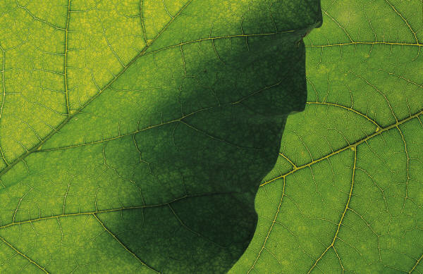  OTHER  PLANTS | 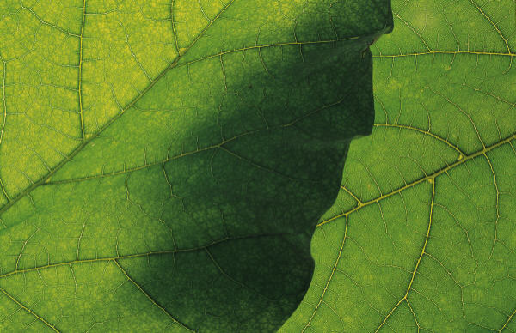  OTHER  PLANTS
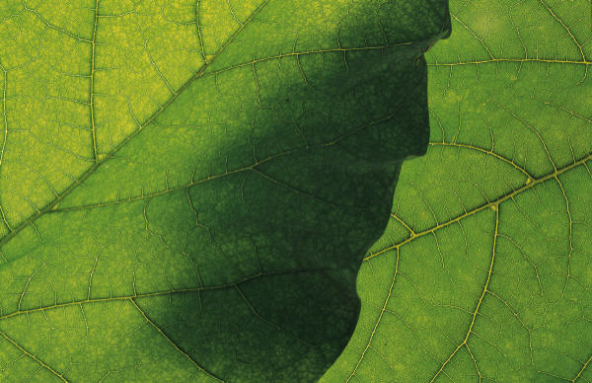  OTHER  PLANTS | 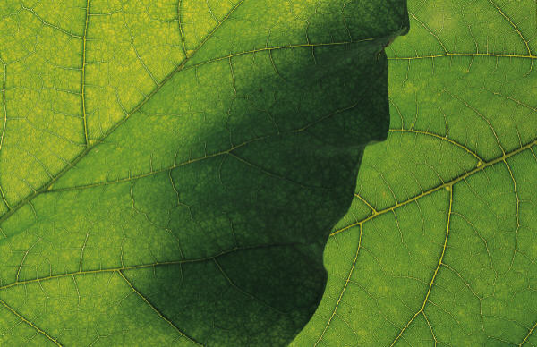  OTHER  PLANTS
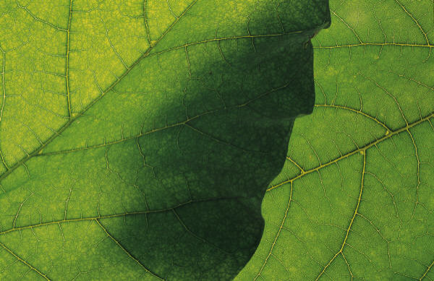  OTHER  PLANTS | 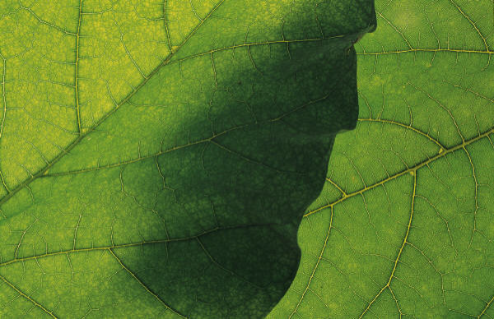  OTHER  PLANTS

OTHER PLANT CARDS (BACK)

COMPETITION  Plants with rhizobia: gain 2 seeds  Plants without rhizobia: lose 2 seeds | COMPETITION  Plants with rhizobia: gain 2 seeds  Plants without rhizobia: lose 2 seeds
COMPETITION  Plants with rhizobia: gain 2 seeds  Plants without rhizobia: lose 2 seeds | Neighbor plants tree creating shade for plants  All plants lose 2 seeds
Prairie grass introduced!  All plants lose 2 seeds | Plants paired with alfalfa!  Plants without rhizobia gain 1 seed

