# Hard Drive:Users:eschultheis:Desktop:KBS Logo.png

# K-12 Partnership Lesson Plan

# Andy Booms, Jamie Bowman, Shaun Davis

# *Running the Gauntlet*

# *Finding the Least-Cost Path*

## Overview

Animals move across the landscape for many reasons – such as migration, dispersal, or simply to find enough food. These movements often force animals to move through less-than-ideal habitat where they’re more exposed to predators or dangers associated with human activity (think of a deer moving out of a forest to cross a highway). Because not all habitats making up a landscape are the same, there are often more- and less-costly paths an animal can take as it moves from one point to another. In this lesson students will explore the costs of moving across a complex landscape. The students’ goal is to find the least-cost (i.e. safest) path for a particular animal given knowledge of that animal’s habitat needs and preferences and the dangers associated with different habitats.

**Objectives**

At the conclusion of the lesson, students will be able to:

* Explain how habitats, humans, and other wildlife can affect an animal’s ability to move across a landscape.
* Describe negative impacts that human land-use practices have on wildlife and predict the consequences of future land-use change.
* Discuss and compare the habitat requirements of some East African wildlife.

**Length of Lesson**

2-3 50-minute class periods (less if students do not draw their own maps)

**Grade Levels**

4-9

**Standards covered (NGSS)**

Disciplinary Core Ideas:

* **MS-LS2-1:** analyze and interpret data to provide evidence for the effects of resource availability on organisms and populations of organisms in an ecosystem
* **MS-LS2-4**: construct an argument supported by empirical evidence that changes to physical or biological components of an ecosystem affect populations

Cross Cutting Concepts:

* Patterns
* Cause and effect
* Scale, proportion and quantity
* Stability and change of systems

Science and Engineering Practices

* Developing and using models
* Analyzing and interpreting data
* Constructing explanation and designing solutions

***Previous Michigan Standards Met:***

* **S.IP.06.11**: generate scientific questions based on observations, investigations, and research
* **S.IA.06.12**: evaluate data, claims, and personal knowledge through collaborative science discourse.
* **S.IA.06.13**: communicate and defend findings of observations and investigations using evidence.
* **S.RS.06.15**: demonstrate scientific concepts through various illustrations, performances, models, exhibits, and activities.
* **S.RS.06.17**: describe the effect humans and other organisms have on the balance of the natural world.
* **L.EV.05.11**: explain how behavioral characteristics (adaptation, instinct, learning, habit) of animals help them to survive in their environment.
* **L.EV.05.12**: describe the physical characteristics (traits) of organisms that help them survive in their environment.
* **L.EC.06.21**: describe common patterns of relationships between and among populations (competition, parasitism, symbiosis, predator/prey).
* **L.EC.06.32**: identify the factors in an ecosystem that influence changes in population size.
* **L.EC.06.41**: describe how human beings are part of the ecosystem of the Earth and that human activity can purposefully, or accidentally, alter the balance in ecosystems
* **B3.4C**: examine the negative impact of human activities
* **B3.5E**: recognize that and describe how the physical or chemical environment may influence the rate, extent, and nature of population dynamics within ecosystems.

*Extensions (including graphing of class path data) may incorporate:*

* **S.IP.06.15**: construct charts and graphs from data and observations
* **S**.**IP.06.16**: identify patterns in data
* **S**.**IA.06.11**: analyze information from data tables and graphs to answer scientific quesions

**Materials**

* Colored pencils/crayons
* Large-grid graph paper
* Animal fact sheets (see attached)
* Habitat summaries (see attached)
* Habitat cost sheet (see attached)
* Path cost tally sheet (see attached)
* Satellite image and habitat map (see attached)
* Map/example powerpoint slides (see attached)
* Optional follow-up questions (see attached)

**Background**

The landscapes that animals live in and move across are often more complex than we realize at first glance. Landscapes are often comprised of different habitat types, each with its own set of pros and cons for a given animal. Imagine a whitetail deer living in southern Michigan: the deer likely encounters forests, agricultural fields, residential neighborhoods, and swamps on a regular basis, not to mention rivers, roads, and fences running through these various habitats. A deer’s ability to move safely through a forest or swamp is likely much greater than through agricultural fields or neighborhoods (where they risk encounters with hunters or automobiles). Nevertheless, animals often have to move across these complex landscapes in search of food, mating opportunities, unclaimed territory, etc. Therefore, it’s important that animals be able to move in a way that minimizes the risks associated with humans, predators, and harsh environments.

### Scientists have developed a number of methods for predicting and assessing how animals move across the landscape. One of these methods, called Least-Cost Path Analysis, divides the landscape into grid cells where each cell is assigned a cost (or weight) depending the dominant habitat within the cell and how dangerous it is for the animal of interest to move through that particular habitat. More dangerous cells will have higher costs and safer cells will have lower costs, so the least-cost path from one point to another might not be a shortest path (Figure 1). Approaches like Least-Cost Path Analysis are often used in conservation and management applications where scientists want to maintain healthy wildlife populations that are able to move in the most natural way possible. Such approaches can also predict the best locations for things like wildlife over-/under-passes, designed to connect populations on opposite sides of busy highways and reduce the number of vehicle-animal collisions (Figure 2).

**Figure 2** Photo evidence of wildlife (left: black bears, right: bobcats) using a wildlife underpass along US-93 in Montana.

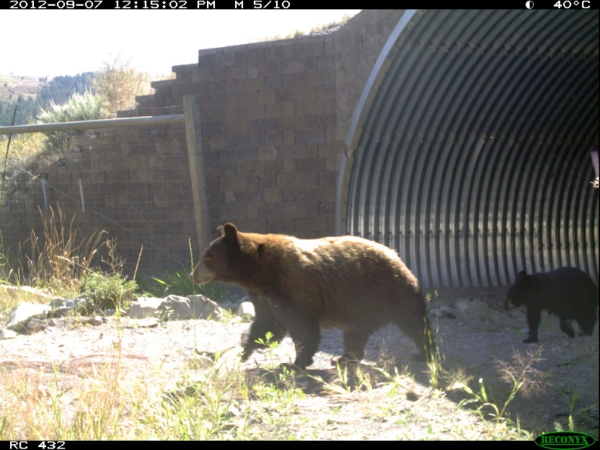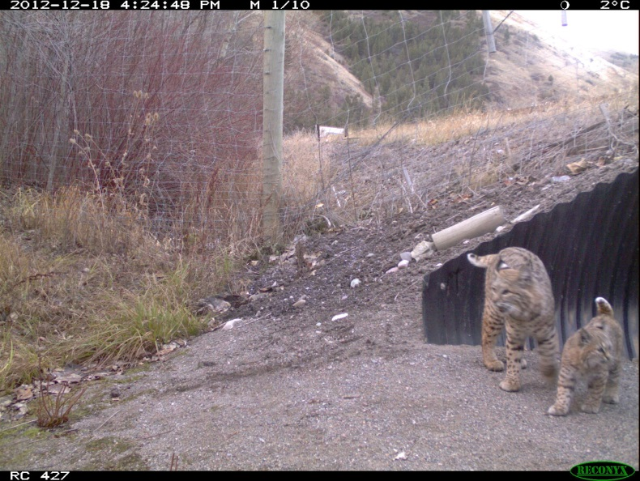

### Activities of the session

1. Research presentation on hyenas and East African habitats (optional)
2. Prior knowledge requirements on East African habitats
   * Students will need to know enough about each landscape that appears on the provided maps to assess the pros/cons of moving through each habitat from an animal’s perspective. The attached **Habitat Notes** document provides brief summaries of each habitat type that can be expanded upon as needed.
3. Students use graph paper to create a pixelated grid map based on provided satellite/habitat maps.
   * Similar to the BEST Plot Landscape Protocol – Large Scale Methods (step 1)
   * *See Figure 3 for an example of this process*
4. Students choose one of the species described in **the Animal Fact Sheets** document and design what they think is the least costly path across the landscape (A to B) for that animal.

* The path a student draws can be any route from A to B that stays within the map, but the ideal outcome will be for the student to choose the route carefully based on the information given in the Animal Fact Sheets and the Habitat notes.

1. Students calculate cost for chosen route using the provided **Tally Sheet** and **Cost of Travel** documents.

* This cost calculation will account for the fact that not all habitats on the map are equally safe or easy to cross for a given species.
* The Cost of Travel values should not be given to students until after they have drawn their least-cost path so the focus during path-drawing is the biology of their animal. The aim is for students to independently reach the same conclusions about the relative costs of travel of the different habitats during path-drawing as are reflected in the provided cost values.
* *See Figure 4 for an example using the African Elephant*



**Figure 1** An example of a landscape divided into grid cells. Each cell in the map is assigned a cost, with lighter colors representing lower costs and darker colors representing higher costs. An animal moving from A to B along the shortest path would have to cross high-cost (i.e. dangerous) habitats, while the least-cost path would likely require the animal to take a longer route around the black and gray cells.

1. Have students group according to species and compare their paths, scores, and reasons for choosing their paths (i.e. all hyenas together, all elephants together, etc.). Then, as a class, compare across all species to see how different animals have different “best” ways to move from A to B.
2. Optional discussion **Questions** and any other wrap-up needed to reinforce key concepts.

**Resources**

* Powerpoint, animal fact sheets, cost of travel sheet, habitat notes, assessment questions, cost tally sheet and maps are all located on the “Running the Gauntlet” lesson page on the GK-12 website
* BEST Plot Landscape Protocols: <http://kbsgk12project.kbs.msu.edu/blog/2011/09/14/landscape-level-protocols/>
* For satellite imagery: [www.google.com/maps](http://www.google.com/maps), <https://www.google.com/earth>

**Extensions and Modifications**

* Pixelated grid maps can be provided to students to: 1) reduce lesson time (spent coloring maps) and 2) ensure uniformity of grid maps among students to allow for better comparison of least-cost path scores.
  + It may be helpful to use laminated maps so students can use dry-erase markers to draw paths directly on maps.
* Rivers and/or roads may be added to grid maps to increase landscape complexity
  + Students would then need to consider both habitat type and their animal’s ability to cross roads/rivers along their path
* Local satellite/habitat maps can be substituted for the provided East African ones.
  + Students would already be familiar with local wildlife and habitat; a brief discussion would likely suffice to prepare students to assess the pros/cons of local wildlife moving through a local landscape.
  + Satellite images of areas around GK12 partner districts are provided in the BEST Plot Landscape Protocols – Large Scale Materials.

**Assessment**

Possible follow-up questions are provided on the lesson page on the GK-12 website to help guide student thinking and understanding of narrow to broad conclusions that can be drawn from this lesson.

**Figure 3** The mapping process, from provided habitat map (top left) to end product pixelated grid map (bottom). Students can start by imagining the grid from their graph paper overlaying the habitat map (middle). Then should then work to color in their graph paper so that the habitat areas approximately match what is seen on the habitat map, except that each cell on the graph paper can only be occupied by a single habitat type (thus creating a more pixelated version of the habitat map; bottom).

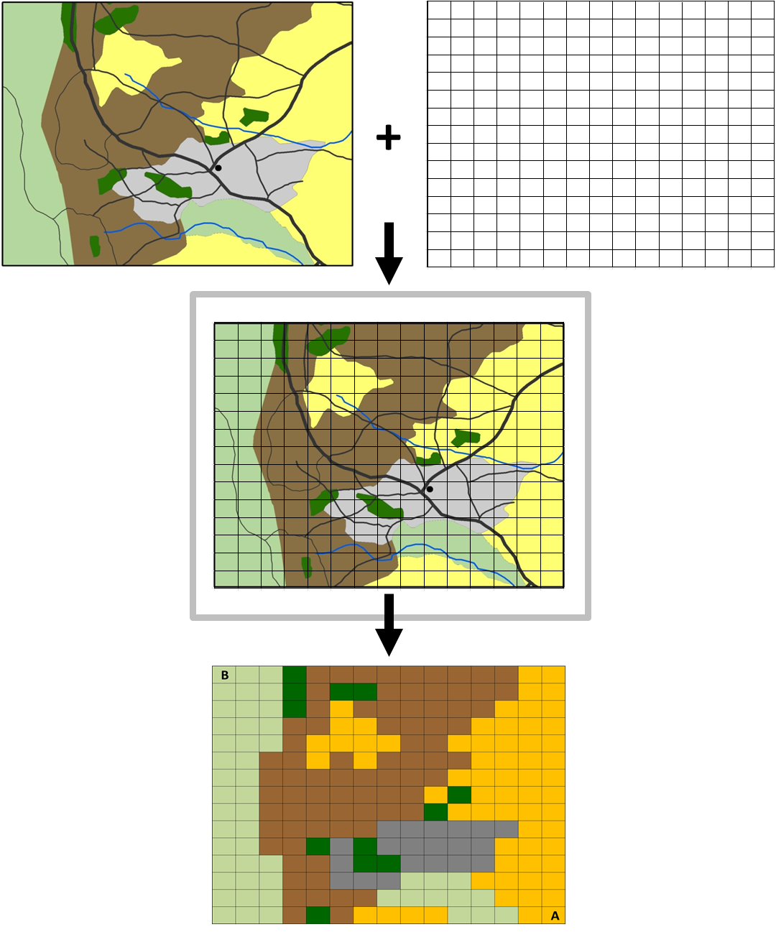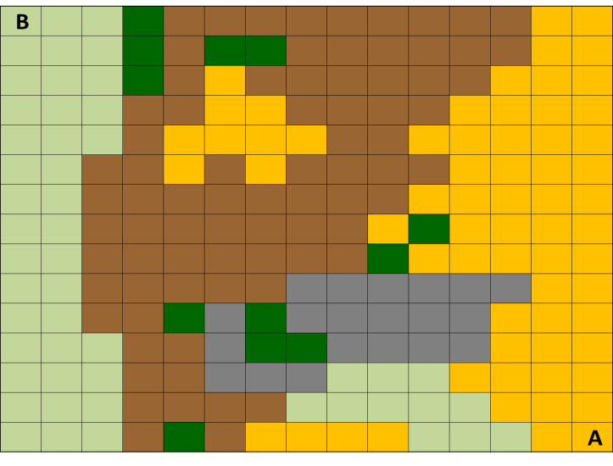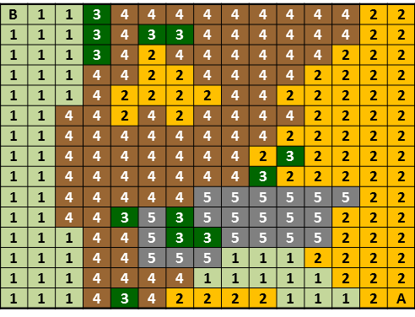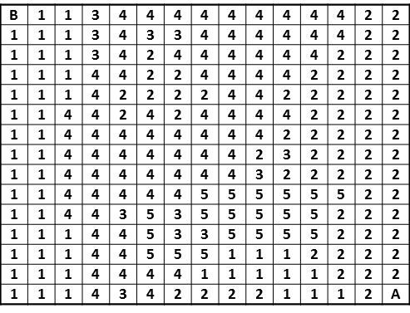

**Figure 4** An example of total cost accumulated for a given path for the African Elephant. Once a student has drawn their least-cost path (top left), they can be provided the cost values from the Cost of Travel document (top right – a visualization of the cost value associated with each cell on the map). The Tally Sheet provides for easy calculation of the total cost of the path – without putting any numbers on the map - by asking students to tally the number of cells of each habitat type, multiply those habitat sums by the habitat cost multiplier, and then calculate the overall sum. In this example, the path crosses 23 savanna (x1), 2 agriculture (x4), 3 grazing (x2), and 1 forest (x3) cells between A and B. The total cost of this path is 40.