**Extension- Data Nugget**

1. During my field season, I wanted to monitor the soil moisture in both sandstone and serpentine soils. I had two probes in the ground on each soil type, for a total of four probes. These probes gave me records of the soil moisture each day between April 18 and May 20. The results are shown below.

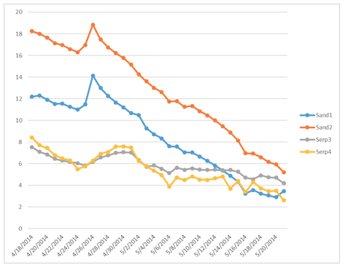

% Soil Moisture

Date

Sandstone 1

Sandstone 2

Serpentine 1

Serpentine 2

1. Overall, how does soil moisture change across the season?
2. How is soil moisture different between serpentine and sandstone soil?
3. Which soil type do you think has greater permeability?
4. Which soil type do you think has the smallest sized particles? Why?
5. Why do you think there are two readings for each soil type (instead of just one)?
6. How do you think these differences would affect plants growing in each soil type?

2. In a field experiment, I planted seedlings from both soil types on both soils in experimental plots to see if the native population did better than the foreign population. Below are the results on serpentine soil.



1.0

0.6

0.2

Serpentine Soil

Survival to Flowering

***

Serpentine Pop

Sandstone Pop

1. What is on the y-axis?
2. In one sentence, state the result shown on this graph.
3. Based on the results from the first graph, give a possible explanation for this result.