Teacher reference sheet
Concurrent Session: Decomposition – the ultimate disappearing act!
Questions
What happens during decomposition? What factors control decomposition? Why is this important?
Standards – based on NGSS engineering standards
- Asking questions (for science) and defining problems (for engineering)
- Developing and using models (food chain and carbon cycle)
- Planning and carrying out investigations (decomposition long and short term)
- Analyzing and interpreting data
- Using mathematics and computational thinking
- Constructing explanations (for science) and designing solutions (for engineering)
- Engaging in argument from evidence
- Obtaining, evaluating, and communicating information
Materials
Dissecting microscope, Berlese funnel (light, screen, funnel), Petri dish, alcohol, soil, spread sheet
Activities
Demonstration 20-25 minutes : videos, demonstration and questions.
Explore: 25 minutes. Examine soil, funnel fauna, litter, decomposition, matter transformation. Explain:10 minutes Bring together concepts. Carbon transformation. Decomposers, states of matter.
Day 2 Make experiments: 25 minutes What do you want to do? Which litter, which soil, which temp?
Make predictions: 15 minutes what will your data show? Graphing exercise and LIDET data.
Links
LIDET data: http://andrewsforest.oregonstate.edu/research/intersite/lidet.htm
Pig - https://www.youtube.com/watch?v=R1CD6gNmhr0
Fruit Bowl - https://www.youtube.com/watch?v=c0En-_BVbGc
Blue whale ashore: http://www.theguardian.com/environment/video/2014/apr/30/rotting-dead-whale-verge-exploding-canada-video
Exploding whale: http://www.youtube.com/watch?v=1_t44siFyb4
Whale Fall: https://www.youtube.com/watch?v=rdI3eFrTGs8
Decomposition I
Pig Video https://www.youtube.com/watch?v=R1CD6gNmhr0
1) What are you observing in the pig video? Is anything being measured?

2) Why are the beads moving in the video? What is moving them?

3) What happens to the biomass of the pig? What is the pig biomass made of? Where does it go?

Fruit Video https://www.youtube.com/watch?v=c0En-_BVbGc
1) What do you observe about different fruit and vegetable types? What will decompose first?

2) What are examples of physical and chemical changes. What do you think it smells like?

Your experience
1) Where do you observe decomposition at home? What factors do you observe there (chemical and physical). Where does decomposition happen in nature?

2) What if we did not have decomposition? How does it fit into other life processes that you know?

Decomposition II – Exploration through 5 activities
1Soils: sandy, farm soil, forest soil. Look closely at different soils. Run your hands through it. Smell it.
a) What materials can you identify in the soil?
Sandy -
Farm –
Forest -
b) Is there carbon in the soil? _____________________________________
Where did it come from? _______________________________________
Which soil has more carbon? _______________________________________
How do you know?

c) Do you think anything lives in these soils?

d) Will you find different organisms in each different soil type - why or why not?

2: Berlese funnel. We use this special funnel to capture soil “critters”.
a) What do you observe in the tube(s)?

b) Why would you find these invertebrates in the soil?

c) Where do they get their energy?

d) Draw a picture of how these animals fit into a food chain – what do they eat, who eats who or what?

3 Microscopes: Look in the different scopes. The scopes have organisms from different soils. What do you think came from where? Why? Scan and count how many different organisms you observe.
Draw some of the critters under the scope.
A B C

Estimate # of different species:
A _______________ B _______________ C_______________
Estimate # of total organisms:
A _______________ B _______________ C_______________

Given the dishes you saw, predict which dish of invertebrates from sandy soil, farm soil, or forest soil?
Dish A_____________ Dish B _____________ Dish C _______________

4 Raw Materials: Look at these different decomposable materials. Apple, wheat straw, banana, potato, gummi worms, cabbage, lettuce etc…
a) What elements make up these materials?

b) Where did the material come from?

c) What do you think will decompose faster? List in order fastest to slowest? Why in this order?

5 Rotting materials!: Look at these bags. Which has been in the car and which in the refrigerator?
a) One has been in the refrigerator? In the car?

b) What do you observe chemically and physically?

Decomposition III – Let’s set up a decomposition experiment!
Now we combine your different soil types and a “plant” material, and measure decomposition over time. We will do this by measuring how mass changes over time.
Dependent variable? ___________________________________________________________
Independent variable (s)? _______________________________________________________
Think about how we can use a control for this experiment. What variable(s) do we need to control:

Let’s talk about it.
Now look at your data sheets to set up your experiment:
1) Weigh your Petri dish – bottom and top and record weight.________________________(grams)

2) Pick a soil type from your bench – sandy, farm or forest. __________________________
Why did you pick this?

Weigh about 40 grams of your soil and record the total weight_________________ (grams)

3) Pick a raw material apple, gummy worm, potato, banana, wheat straw _______________________
Why did you pick this?

Place the material in the petri dish and again record the weight_________________ (grams)
This is your total weight!

4) Now what about your control?

5) Where will you keep it? Window sill? Refrigerator? Dark closet? _________________________
Why did you select this location?

Predictions
Title:______________________________________

Y variable

______________

X variable ______________

Title:______________________________________

Y variable

______________

X variable ______________
Same litter, different climate
Alaska, Mid-west, Puerto Rico

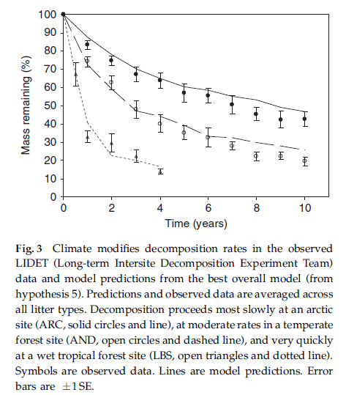
weeks

Which line represents which location?

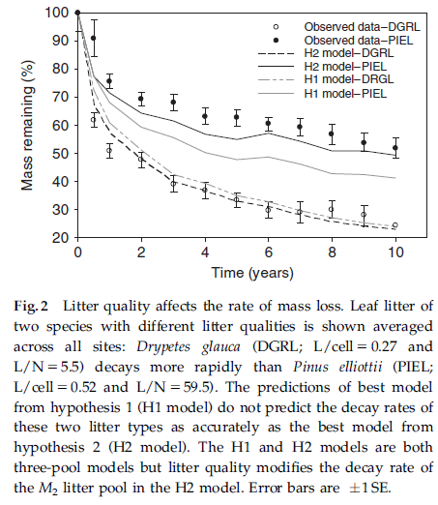
Different litter, same climate!
pine needles and fruit leaves
weeks

Which line represents which litter?

Note that both of these data come from a real series of experiments. Find the project here!

http://andrewsforest.oregonstate.edu/research/intersite/lidet.htm

