Why do species cooperate? A card-based simulation of the ant-acacia mutualism
Name: _____________________
Rules of the game:
Setup
- Each player chooses a side: Ants or Acacia
- Each player should have their two draw piles, one for Cooperate cards and one for Exploit cards of their species. Each player also needs space for a Discard pile, and a Next Generation pile.
- Each player takes 3 Cooperate Cards and 3 Exploit Cards from the pool of cards and shuffles them to make their initial population. This is Generation 1. Each partner writes down the data for this generation in his or her species table.
- Your population is hidden from your partner. Each round of play will consist of you and your partner each playing an individual from your population to interact.
Play
- To play, both players simultaneously flip over their top card and play it in the middle of the table, as in the card game War.
- Each player then determines what happens to their species using their species card:
  - If you are instructed to discard a card, the card that you just played goes into your discard pile.
  - If you are instructed to add a card(s) to your population, draw the correct number of cards from your Exploit or Cooperate pile, and add these cards, PLUS the card you just played to your Next Generation pile.

- When either you or your partner runs out of cards, the generation is over. If one partner has remaining cards, those cards are added to his or her Next Generation pile
- Count the number of Exploit and Cooperate cards in your Next Generation pile, and record the data in your tables.
- Repeat this process with your new generations of ants and acacia until you have filled your data table (4 total rounds).

Current Co-evolution
Ant evolution data
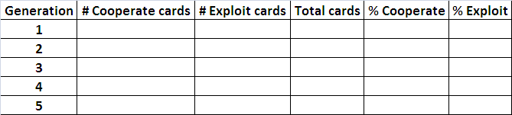
Acacia evolution data
Co-evolution without Elephants
Ant evolution data
Acacia evolution data
Make a line graph of your data:

Current cooperative evolution
Ant
Legend
Generation
% Cooperate
Acacia

Cooperative evolution without Elephants
Acacia
Legend
Generation
% Cooperate
Ant

Follow-up questions:
1) Describe what happened in your two simulations.

2) Under what circumstances is co-evolution of cooperation helpful?

3) Look at the ending populations in your Cooperative evolution without Elephants graph. What do you think might happen if humans transplanted new elephants into the area?

