1. How long ago did land plants appear?

2. Where did the ancestors of land plants live?

3. What are the benefits to a plant living on land?

4. What is challenging about living on land for a plant?

 | First found on Earth | Adaptation | Purpose
Green Algae | 1 billion years ago
Bryophytes (mosses)
Ferns
Gymnosperms
Angiosperms

Cross sections of algae versus plants. True plants have vascular stems with more complex structures for carrying food and water up and down their stems. Algae
ALGAE VASCULAR PLANT
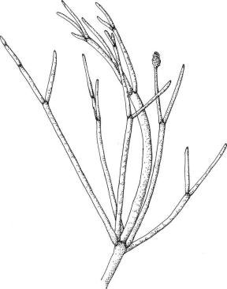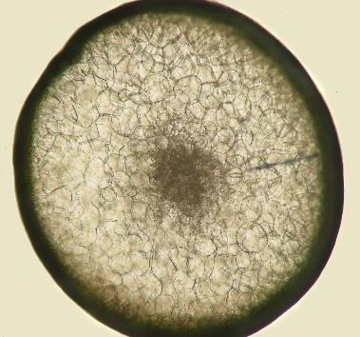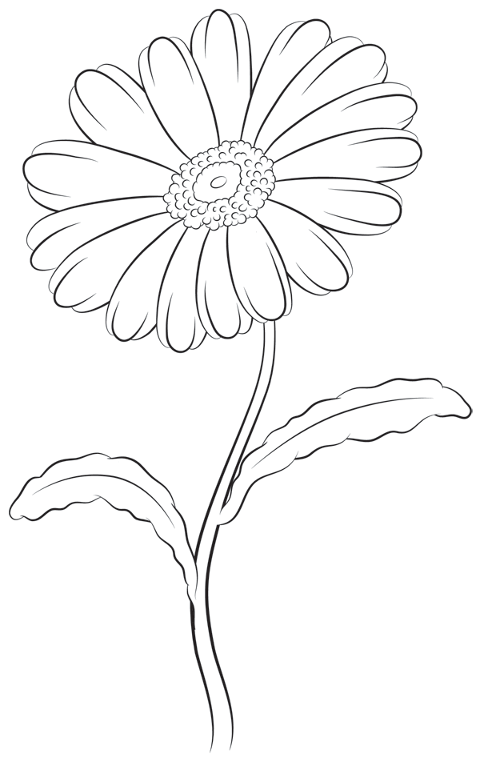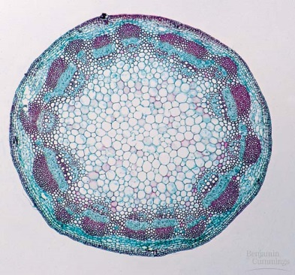
Today’s Challenge: Identify the plant group that Specimen A belongs to using its traits. Then, determine which specimen (B or C) is in the same plant group but adapted for aquatic habitats and which specimen (B or C) is an algae and not a plant at all.
In front of you are three specimens A, B, and C.
Step 1. Look at the specimens under the dissecting microscope and make observations. Find all of the characteristics we have learned about such as the cuticle, vascularity, and seeds.
Place a check mark in each box if you can observe that trait in each specimen
 | Specimen A | Specimen B | Specimen C
Cuticle
Vascular tissue
Seeds
Fruit + Flowers

Step 2. Use scissors or a scalpel to make a cross section of A, B, and C. Make slides using your cross sections put them under the compound microscope to make observations. Draw pictures for each specimen and label the magnification.

Conclusions:
1. Specimen A is a in the plant group ____________ because:

2. Specimen B is a ____________ because:

3. Specimen C is a ____________ because:

