K-12 Partnership Lesson Plan

Seeing the forest from the trees

Water and leaf size - Objectives
For this portion of the exercise, we will ask students to simulate how larger leaves require more water to sustain them. We will use food coloring in water as the source of ‘ground water’ and different sized sponges as leaves. Given the same amount of water, travelling up a tube (like the stem or trunk of a tree), a large leaf will not receive sufficient water to completely saturate. A smaller leaf requires less water and will be saturated. By squeezing the liquid out of the sponge and measuring the volume of the ground water, we can see how smaller leaves can be sustained easier than larger leaves.
Materials
- Large balloons
- Ring stand
- PVC soft tubing (approximately ¼ in outer diameter, from a hardware store or aquarium supply store)
- Gel food color
- Plastic bowls
- Cable ties
- Sponges
- Tape
- Plastic syringes
- Graduate cylinders

Preparation - (Refer to the picture below when reviewing set-up)
- Place the ring stands on a level table or bench. Raise the rings to equal heights, as high as they can extend. Place a plastic bowl or cup into the ring.
- Cut equal lengths of PVC tubing to about 30 inches - long enough to extend one end up to the cup or bowl and the other end down to below the level of the table or bench. Use tape to secure the tube at the top and bottom of the ring stand.
- Mix food coloring in about a half liter of water – pick a color(s) will contrast best with the sponges.
- Prepare (cut) three sizes of sponges – such as a full standard size washing sponge, a half and a quarter size sponges. Poke a hole in the side of the sponge using a pencil or nail so that you can insert the end of the PVC tube securely into the interior of the sponge, and place above the plastic bowl at the top of the ring stand.
- Carefully add colored water to the balloon using the plastic syringe. It may take some trial and error to find a volume that both saturates the small sponge and does not saturate the large sponge. Start with 30 milliliters and see if you need to increase or decrease the amount.
- Insert the bottom end of the tube into the balloon opening and secure the balloon opening to the end of the tube with two cable ties. Make sure they are tight.
- Force liquid up the tube from the balloon - squeeze the balloon fully so that all the liquid leaves the balloon and travels up the tube.
- Every time a different sized sponge is used, the tube must be emptied, the balloon removed and refilled and fresh cable ties fitted again.
- Use beakers or graduated cylinders to measure the amount of water absorbed in the sponges. NOTE: More liquid can be squeezed out of small leaves (they receive the water they need – often to excess) while larger sponges do not receive enough water to saturate (and are harder to sustain at the top of a tall tree).

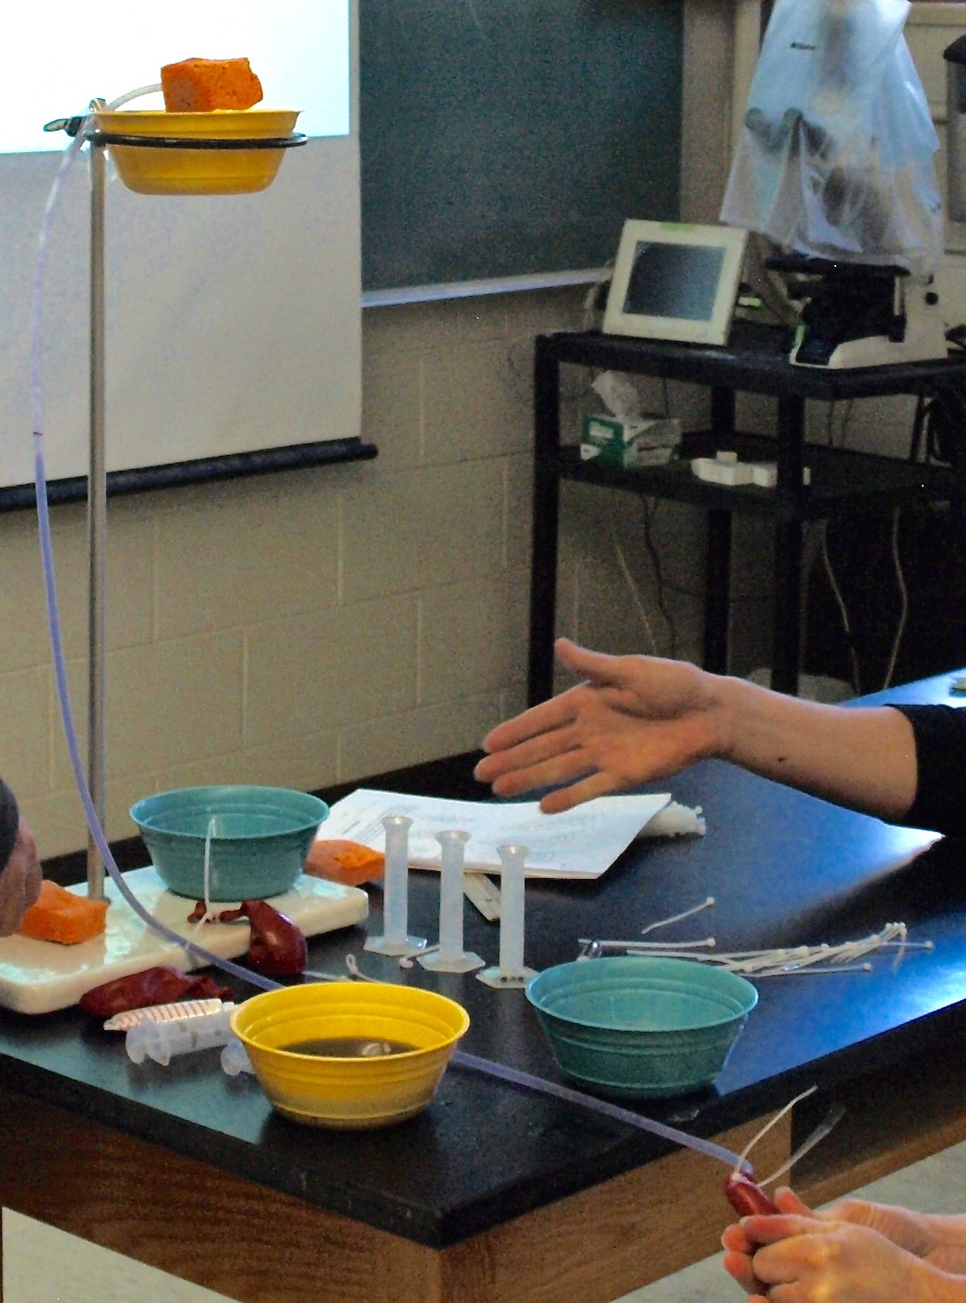
Graduated cylinder
Colored water
Syringe
PVC tubing
Ring Stand
Sponge
Balloon
Cable ties
Cup or bowl

Resources
Youtube David Attenborough video:
https://www.youtube.com/watch?v=w6f2BiFiXiM

