# Hard Drive:Users:eschultheis:Desktop:KBS Logo.png

# K-12 Partnership Lesson Plan

# Di Liang, Brendan O’Neill

# *Seeing the Forest from the Trees*

## Overview

What controls the structure of forests and the leaves within that forest?  Individual leaves have very different shapes and even colors, but together they make up the forest canopy that traps light and water. This lesson aims to help students understand how the form of leaves and trees follows from the function of how plants use light and water. At the beginning of the class, instructors will lead a discussion on what trees need to grow. Students then will work individually on certain leaf types to understand how their shape influences their function; – this may involve collecting leaves, but also cutting out the shape of leaves or tracing the outline that the leaf shadow makes. Finally, students will see how the ways plants supply water to leaves interact with the capacity to capture light to influence leaf size.

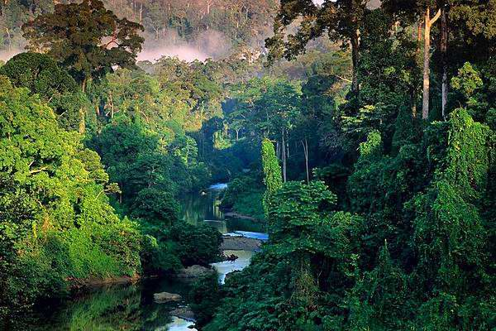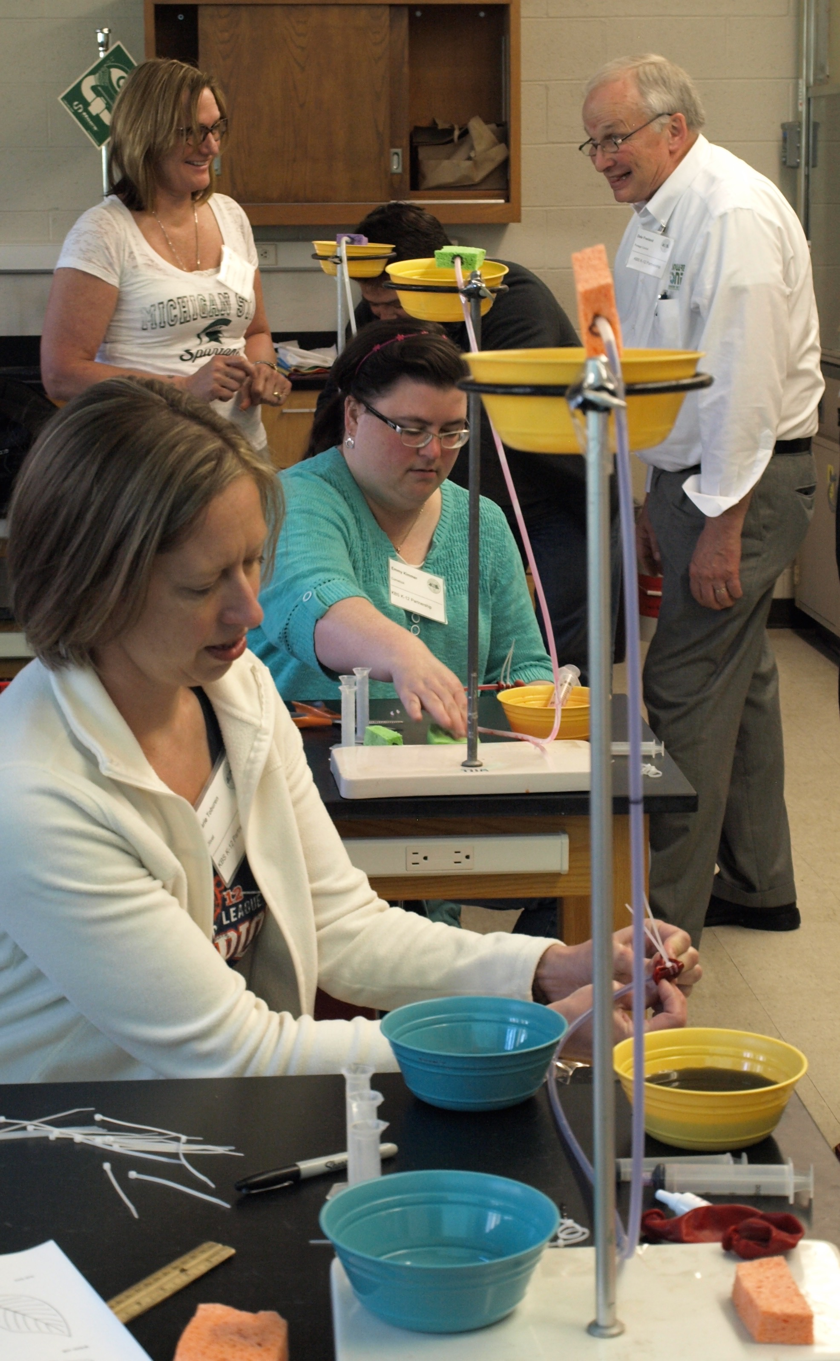

**Objectives**

At the conclusion of the lesson, students will be able to:

* Name factors affecting plant growth
* Understand plants need energy, water, and nutrients to survive
* Explain how leaf size and tree height are shaped by sunlight and soil water
* Describe the general relationship between leaf size and plant (or tree) height
* Describe different strategies plants use to adapt to certain environments

**Length of Lesson**

1 hours (if no leaf collection), 2 hours if collecting leaves is included

**Grade Levels**

Elementary school (grades 3-5)

**Standards covered (NGSS)**

Disciplinary Core Ideas:

* **K-LS1-1**: use observations to describe patterns of what plants and animals (including humans) need to survive
* **K-ESS3-1**: use a model to represent the relationship between the needs of different plants and animals (including humans) and the places they live
* **K-2-ETS1-2**: develop a simple sketch, drawing, or physical model to illustrate how the shape of an object helps it function as needed to solve a given problem
* **2-LS4-1**: make observations of plants and animals to compare the diversity of life in different habitats
* **4-LS1-1**: construct an argument that plants and animals have internal and external structures that function to support survival, growth, behavior, and reproduction
* **5-LS1-1**: support an argument that plants get the materials they need for growth chiefly from air and water

Cross Cutting Concepts:

* Patterns
* Structure and function

Science and Engineering Practices

* Developing and using models
* Planning and carrying out investigations

***Previous Michigan Standards Met:***

* **L.OL.00.11**: identify that living things have basic needs
* **L.OL.E.3**: structures and functions- organisms have different structures that serve different functions in growth, survival and reproduction
* **L.EV.03.11**: relate characteristics and functions of observable parts in a variety of plants that allow them to live in their environment (leaf shape, thorns, odors, color)
* **L.OL.04.15**: determine that plants require air, water, light, and a source of energy and building material for growth and repair
* **L.EV.05.12**: describe the physical characteristics (traits) of organisms that help them survive in their environment

**Materials**

* Powerpoint presentation (materials found on the “Seeing the Forest from the Trees” lesson page on the KBS GK-12 website)

For the sunlight challenge

* Coloring/clipping handouts (1 per student)
* Colored pencils/crayons/marker
* Scissors

For the water and leaf size activity

* Balloons
* Ring stand
* PVC soft tubing (approximately ¼ in outer diameter, from a hardware store or aquarium supply store)
* Gel food color
* Plastic bowls
* Cable ties
* Sponges
* Tape
* Plastic syringes
* Graduated cylinders

**Background**

What shapes the structure of forests and the plants within forests? What gives different leaves their shapes? Plants need a few fundamental resources to survive and thrive, among these are light, water, soil (and the nutrients within soil) and the carbon dioxide from air. Plants derive their energy from sunlight, so the more sunlight they can capture, the more energy they can use for growth. The first exercise examines how leaf size matters to a plant and quantifies the area of light they can capture. Plants need lots of light and the bigger the leaf size, the greater the opportunity to capture more light.

Why some leaves are small if bigger leaves mean the plant can capture more energy to make food? Because sustaining large plant leaves requires a lot of water. Plants constantly draw water up their stems and this water is always evaporating form the pores in the leaves. Think of plants like bananas or the giant taro or ferns – these all have large leaf areas and they all grow relatively close to the ground. It is easier to supply water (from the soil) to the leaves if the plant is lower to the ground. Conversely trees which grow large and form the canopy of a forest often have smaller leaves compared to plants in the understory. It takes a great deal of energy to supply leaves high in the canopy with water. Plant leaves need a constant supply of water and big leaves need lots of water!

### Activities of the session

Sunlight challenge

This activity is to help students to understand bigger leaves will capture more sunlight. Thus, if students clip three Kapok leaves, the least amount of sunlight will be captured. In contrast, if three Giant taro leaves are chosen, the maximum amount of sunlight will be captured. Following this activity, it will be useful to show students the table below. Students will then understand Giant taro is very short (live in the rainforest understory where sunlight is very limited) but has big leaves so they can capture more sunlight. For Kapok trees, they live in the top layers of a forest where sunlight is abundant so they have small leaves. We have a lot of cool pictures of these tree species in the presentation.

1. Choose leaves from one species on the student handout
2. Color as desired
3. Cut out the leaves
4. Place them on the grid provided and trace
5. Count how many boxes of sunlight the leaves capture
6. Repeat with a new species if desired

Water and leaf size activity

For this portion of the exercise, we will ask students to simulate how larger leaves require more water to sustain them. We will use food coloring in water as the source of ‘ground water’ and different sized sponges as leaves. Given the same amount of water, travelling up a tube (like the stem or trunk of a tree), a large leaf will not receive sufficient water to completely saturate. A smaller leaf requires less water and will be saturated. By squeezing the liquid out of the sponge and measuring the volume of the ground water, we can see how smaller leaves can be sustained easier than larger leaves.

1. Place the ring stands on a level table or bench. Raise the rings to equal heights, as high as they can extend. Place a plastic bowl or cup into the ring.
2. Cut equal lengths of PVC tubing to about 30 inches - long enough to extend one end up to the cup or bowl and the other end down to below the level of the table or bench. Use tape to secure the tube at the top and bottom of the ring stand.
3. Mix food coloring in about a half liter of water – pick a color(s) will contrast best with the sponges.
4. Prepare (cut) three sizes of sponges – such as a full standard size washing sponge, a half and a quarter size sponges. Poke a hole in the side of the sponge using a pencil or nail so that you can insert the end of the PVC tube securely into the interior of the sponge, and place above the plastic bowl at the top of the ring stand.
5. Carefully add colored water to the balloon using the plastic syringe. It may take some trial and error to find a volume that both saturates the small sponge and does not saturate the large sponge. Start with 30 milliliters and see if you need to increase or decrease the amount.
6. Insert the bottom end of the tube into the balloon opening and secure the balloon opening to the end of the tube with two cable ties. Make sure they are tight.
7. Force liquid up the tube from the balloon - squeeze the balloon fully so that all the liquid leaves the balloon and travels up the tube.
8. Every time a different sized sponge is used, the tube must be emptied, the balloon removed and refilled and fresh cable ties fitted again.
9. Use beakers or graduated cylinders to measure the amount of water absorbed in the sponges of various sizes. NOTE: More liquid can be squeezed out of small leaves (they receive the water they need – often to excess) while larger sponges do not receive enough water to saturate (and are harder to sustain at the top of a tall tree).



**Resources**

* Youtube David Attenborough video: [***https://www.youtube.com/watch?v=w6f2BiFiXiM***](https://www.youtube.com/watch?v=w6f2BiFiXiM)
  + - * Ecophysiology in natural and managed communities, Chapter 12 - Sunlight: an all pervasive source of energy, 12.1 Photosynthesis in sun and shade:<http://plantsinaction.science.uq.edu.au/edition1/?q=content/12-1-1-light-interception-and-utilisation>
* Chazdon, 1988, Sunflecks and their importance to forest understorey plants. Adv. Ecol. Res., 18 (1988), pp. 1–63

**Extensions and Modifications**

* Could have students collecting leaves of different sizes and shapes if time allows. Or organize a field trip to a Michigan forest to observe how plants adapt to certain environments (soil water, tree density, plant diversity, etc).
* Apart from leaf size, you could spend some time talking about other strategies plants adopt to regulate sunlight: change leaf angle/orientation throughout the day, wax or hairs on the surface of leaves to reflect excessive sunlight or hold in water, change chloroplast density and location within leaves, etc.
* What are other factors you think might influence leaf shape? For example, large leaves in tall trees might capture more wind and be blown off – with smaller leaves, heavy wind will more easily pass through the canopy. The importance of maintaining leaf water can be easily demonstrated with a cut flower or celery stalk.
* Think about other trades-offs that shape plant communities and their leaves. What about deserts?
* In these dry environments there is plenty of light and little water. So plants have very tiny or almost no leaves – they cannot afford to lose water through lots of leaves.
* In extreme northern latitudes in coniferous forest, the plants also need to preserve liquid water because it is so cold, so the needles of the trees are tiny (compared to a tropical forest with lots of water).
* In tropical forests, large trees are covered in *epiphytes* which are small plants which grow in the branches of trees to get closer to the sun. They can have large leaves because they are adapted to capture the abundant rain even though they roots don’t touch the soil.