Sunlight challenge!

Suppose you are in a tropical rainforest now, your task is to select three leaves and make sure they can receive enough sunlight in the rainforest understory (The understory is the shaded part of a forest near the ground. Clip three leaves and place them on the last page. Color them with your favorite colors. Then use a pencil to outline the shape of your leaves on the last page.

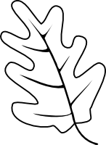

White oak

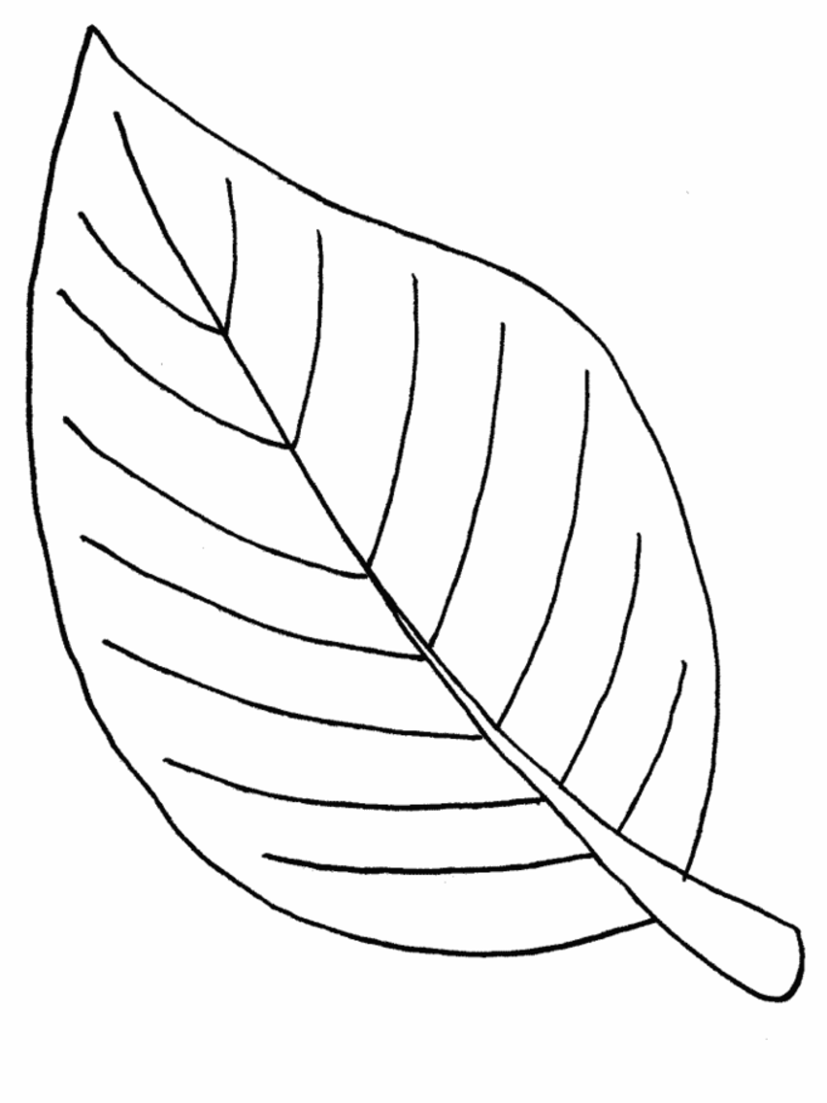
Ant tree

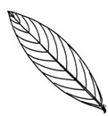

Kapok

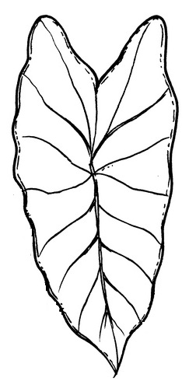

Giant taro

Count how much sunlight (number of boxes) your leaves received. If the area of a box is covered by over 50% of leaf, count as 1; if a box is covered by less than 50% of its area, count as 0.5. Calculate the total number of boxes. Share with your classmates the number of the boxes and which species of leaf you selected.

