For teacher:

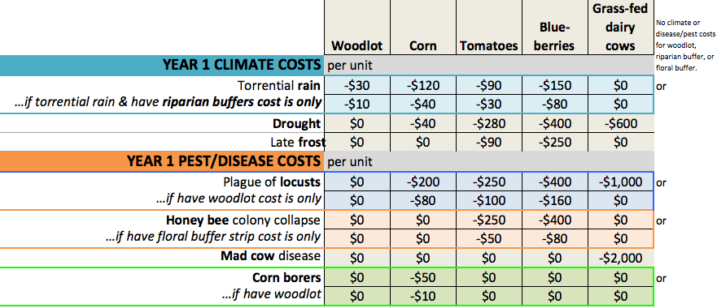
Croptions costs for climate and pest/disease cards

