K-12 Partnership Lesson Plan

Michael Kuczynski

A Game of Selection … You Win or You Die

Exploring evolution by natural selection

Overview
A strong understanding of evolution is paramount to any education in biology. In this lesson students will be introduced to the concept of evolution and natural selection using a combination of presentation, worksheet, and several outdoor games and demonstrations. These activities will emphasis how populations change over time as a result of evolution by natural selection. Students will learn how we define evolution and natural selection, as well as the key components required for natural selection to occur. Using a series of demonstrations, students will also learn about the different forms of selection (directional, stabilizing, disruptive). Finally, these activities can all be used to identify and discuss the inaccuracies of several misconceptions of evolution by natural selection.
Objectives
At the conclusion of the lesson, students will be able to:
- Explain what evolution is and how to define it
- Explain what natural selection is and understand the key components required for natural selection to occur (variation, selection, heredity)
- Understand three different types of natural selection (directional, stabilizing, disruptive)
- Construct and interpret graphs relating to evolution and natural selection
- Relate patterns to theory
- Use evidence and reason to form a conclusion
Length of Lesson
Variable, the lesson provides multiple options for games and demonstrations, these activities can be lengthened or shortened to fit time requirements. (Recommend: 2 class periods for all activities presented in the lesson plan)
Grade Levels
Grades 6-12 (or whenever the concept of evolution/natural selection is first addressed in your classroom)
Standards covered (NGSS)
Disciplinary Core Ideas:

Middle School

- MS-LS4-4: construct an explanation based on evidence that describes how genetic variations of traits in a population increase some individuals’ probability of surviving and reproducing in a specific environment
- MS-LS4-6: use mathematical representations to support explanations of how natural selection may lead to increases and decreases of specific traits in populations over time

High School

- HS-LS4-2: construct an explanation based on evidence that the process of evolution primarily results from four factors: (1) the potential for a species to increases in number, (2) the heritable genetic variation of individuals in a species due to mutation and sexual reproduction, (3) competition for limited resources, and (4) the proliferation of those organisms that are better able to survive and reproduce in the environment
- HS-LS4-4: construct an explanation based on evidence for how natural selection leads to adaptation of populations

Cross Cutting Concepts:

- Patterns
- Cause and Effect
- Structure and function
- Stability and change of systems

Science and Engineering Practices

- Planning and carrying out investigations
- Analyzing and interpreting data
- Using mathematics and computational thinking
- Engaging in argument from evidence

Previous Michigan Standards Met:
- B1.1:scientific inquiry
- B3.5x: independence of living systems and the environment: environmental factors
- B4.L4.P2: genetics: heredity and environment
- B4.4x: genetics: genetic variation
- B5.3: evolution and biodiversity: natural selection
Materials
A Game of Selection
- Items for students to forage on, ~ 2X the number of participants. These can be practically anything- poker chips, checkers, easter eggs, candy, etc.
Forms of Selection Demonstrations
Disruptive selection
- “creatures” made of cotton balls with four pipe cleaner legs. Individual creatures should vary in leg length
- Masking tape to add a tag to each creature, labeled with the creature’s size (e.g. long legs get a 10 while small legs get a 2)
Stabilizing selection
- “creatures” made of brightly colored oval construction paper. On some add two long pipe cleaners for horns and some short pipe cleaners (total 3 types of creature: no horns, short horns, long horns)
- Area with sand or dirt where creatures can burrow
Disruptive selection
- Beetle-shaped creatures made of either brown, green, or brown and green striped construction paper
- Double-sided tape attached to the back of each creature
Background
What is evolution? The most simple definition of evolution could simply be change over time. A more detailed definition would be change in average phenotype (observable characteristics or traits) of a population over time. For example, a population of cactus showing an increase in the average number of spines on an individual plant as herbivores become more abundant. Still an even more precise definition of evolution would be change in allele frequency over time. This definition incorporates the importance of genetics in how we understand evolution and it is the most commonly used definition of evolution among scientists.

Evolution can occur in a population by several different methods, but perhaps the most commonly heard of is evolution by natural selection. Natural selection is the non-random biological process by which certain traits become more or less common in a population as a result of differential reproduction. In simpler terms, if an organism has a trait that makes it a very good survivor/competitor/reproducer that organism will have more offspring and the trait will spread throughout the population over time.

Evolution by natural selection requires several key components to occur: variation, selection, and heredity. Variation simply means that individuals in a population must differ from one another in the traits and characteristics they possess. If all individuals are identical then evolution by natural selection will not occur.

The second component, selection, means that traits must influence an individual’s fitness (an organism’s ability to survive and reproduce). Some variants of a trait may help an organism survive or reproduce very well, while other variations of a trait may make an individual less likely to survive. For example, in a population of moths living amongst dark-barked trees, moths with a darker body color will be better at hiding from predators than moths with light body coloration.

The third component, heredity, means that traits must be heritable; they must be passed on from parent to offspring. Even if a trait makes an individual an extremely effective survivor and allows the individual to produce many offspring, if the trait is not heritable the trait will not be passed on to the offspring and will not spread throughout the population by natural selection.

When these three components are present a population will undergo evolution by natural selection.

There are three different forms of natural selection: directional, stabilizing and disruptive. Directional selection occurs when one extreme of a trait distribution is favored while the other extreme is selected against. For example in a population of desert mice living amongst light colored rocks, those with light colored fur will be able to hide from predators and will be favored over those with dark colored fur. This type of selection results in the average phenotype shifting in one direction or the other (e.g. shifting towards lighter fur).

Stabilizing selection occurs when the middle/intermediate values of a trait distribution are favored while both extremes are selected against. For example, if the mice were living in an area with intermediately colored rocks than mice with very dark or very light fur would be at a disadvantage, while mice with intermediate color fur would be favored. This type of selection does not change the average phenotype but it does reduce the amount of variation in the trait distribution.

Disruptive selection occurs when both extremes are favored while the intermediate trait values are selected against. For example, if the mice were living in an area that had patches of light rocks and patches of dark rocks, those individuals with light and dark fur would be able to hide, but those with intermediate fur color would stick out and will be at a disadvantage. This type of selection does not change the average phenotype but it does increase the variance in the trait distribution.

Activities of the session
- Before the lesson:
  - It may be useful to prepare all the cut-outs (see instructions below) for the selection demonstrations before class in order to save time.
- Go through the Game of Selection powerpoint presentation, introducing students to evolution by natural selection, the key components of selection, and the different types of selection.
- Go outside and play through the natural selection game (see instructions below)
- Have students complete the forms of selection demonstrations (see below)
- Have students complete the Game of Selection worksheet (see attached)
Resources
- All resources for this lesson can be found on the “A Game of Selection” lesson page on the KBS GK-12 website.

A Game of Selection Rule Sheet

In this activity participants will take on the role of a population of foraging animals. Individuals will vary in their ability to move while foraging and participants will observe how the population evolves by natural selection as the game progresses.

Steps:

1) Inform the participants that they will be taking on the role of a population of foraging animals trying to feed on tokens (for the games purposes these tokens can be practically anything, poker chips, checkers, easter eggs, etc.).

2) Participants will vary in how they are able to move while foraging for tokens. The three movement types are:
Walkers (can move normally)

Heel-Toe-Walkers (must walk with each step placing the heel of one foot directly in front of the toes of the other foot)

Hoppers (can only move by hopping with their legs together)

Divide the students into these three movement types, for best results it is recommended to start the game with only a very small number of walkers. This allows you to suggest that walkers are a new mutation in the population (and as such start out with low numbers) and the class will observe how/whether this mutation will spread through the population.

3) Have the students line up along the edge of a designated game area (the size of the area used will depend on the number of participants).

4) Randomly distribute the tokens within the game area, try to avoid large clumps of tokens. For best results the number of tokens you distribute for the game should be 2X the number of participants.

5) The game takes place over the course of 4 rounds, which can be described as 4 generations. During a round participants will have 20 seconds (the time may be adjusted depending on the size of the game area) to collect as many tokens as possible while maintaining their assigned movement type.

6) Participants that collect at least 2 tokens are able to gather enough food and survive, those who collect less than 2 die and move to the side of the game area designated as the dead zone.

7) Participants that collect 4 or more tokens are able to reproduce. To reproduce a participant brings a “dead” player from the dead zone back into the game, this revived player now becomes the same movement type as the player that reproduced. After reproduction, take a count of the different movement types (have students record this data in the Game of Selection worksheet).
8) Repeat steps 5-7 for the remaining rounds/generations. At the completion of the game take a final tally of the number of each movement type and record the data.

9) Have participants graph the change in movement types within the population over the generations of the game.

10) Optional follow-up discussion: Have participants discuss how each of the key elements of natural selection (variation, selection, heredity) was present in this game.
Forms of selection demonstrations

Below is a description of a demonstration for each of the three forms of natural selection (directional, stabilizing, disruptive). The specific materials described below can easily be substituted to better fit the specifics of your class. Each of these demonstrations follows the same general outline. Half of the students will be hiding a set of creatures with variable traits, and the other half of the students will try to collect one (and only one) of the creatures that appears the most obvious to them. The creatures will all have an assigned trait value that allow the students to calculate the average phenotype before and after half of the class has the chance to collect creatures (e.g. before and after selection).

Directional selection:

This demonstration will have half of the students hiding “creatures” that vary in body size within a grass field. The other half of the students will act as predators and will each grab (“prey upon”) one of these creatures.

To create the “creatures” use a cotton ball with four pipe cleaner legs (for added fun add googly eyes!). To create variation in body size use different lengths of pipe cleaners for the legs. You can vary the number of creatures you create for the demonstration depending on your class size.

On each creature attach a tag (e.g. small piece of masking tape) and write a trait value score for its body size, large creatures get a larger score (e.g. large creature may get a value of 10 while small creatures get a value of 2).

Before students hide the creatures calculate the average body size score for the population. While half of the students are hiding the creatures make sure the other half are not watching. When the hiding is complete have the other half of the students each collect one creature that is the most obvious for them to see.

After the collection calculate the average trait score for the “surviving” (uncollected) creatures. Discuss with your students how larger bodied creatures were easier to see/collect and how the average trait value shifted towards smaller bodies.

Stabilizing selection:

This demonstration proceeds in much the same way as the directional selection demonstration above, but the creatures and the environment are different. To create the creatures use a brightly colored oval construction paper cut-out with googly eyes. On some of the creatures attach two pipe-cleaner “horns”. These horns will either be short or very long so that in total there are three types of creature (no horns, short horns, long horns).

This demonstration needs to take place in a sandy or dirt environment. Tell the students who hide the creatures that these animals use their horns to burrow just under the surface. Students hiding creatures with horns can place a thin layer of dirt/sand over the top of the creature (they cannot bury or flatten horns however, the horns must be allowed to protrude from the ground). Creatures without horns cannot burrow under the sand/dirt and must simply hide on the surface.

As with the directional selection demonstration assign each creature a trait score related to horn length (for example, no horns = 0, short horns = 5, long horns = 10). Calculate the average trait score for the creatures before and after collection as described and discuss with students how the intermediate trait value (small horns) was the best at hiding and discuss how the average trait value remained the same.

Disruptive selection:

The creatures in this demonstration consist of beetle shaped construction paper cut-outs that are colored either brown, green, or brown and green striped. Assign each creature a trait value score based on their coloration such that solid brown has a low value, solid green has a high value, and brown and green striped has an intermediate value. On the back of each creature attach a piece of double sided tape.

Inform the students hiding the creatures that these animals like to live either on tree bark or on tree leaves. Have the students hiding the creatures stick them either to tree bark or leaves. This should create a scenario where the solid brown blends in well on the bark, the solid green blends in well on the leaves, but the brown and green striped does not blend in well on either background.

As with the other demonstrations calculate the average trait value before and after students collect the creatures. Discuss how the average phenotype remains the same with disruptive selection.

A Game of Selection Worksheet
1) A) A Game of Selection Data Table. Fill in this table as you complete the game.

Generation | Walkers | Hoppers | Heel-Toe Walkers
0
1
2
3
4

B) Using the table above plot the frequency of the three types of movement across the generations. Be sure to properly label each axis.

2) Below is a pair of graphs depicting beak size in a population of finches on the Galapagos Island of Daphne Major. Larger beaks are better at cracking open larger, harder seeds while small beaks are better at feeding on small seeds. In 1977 there was a drought that greatly reduced the abundance of small seeds on the island. Using the graphs below describe how and why beak size changed in this population as a result of the drought. What type of selection is this?
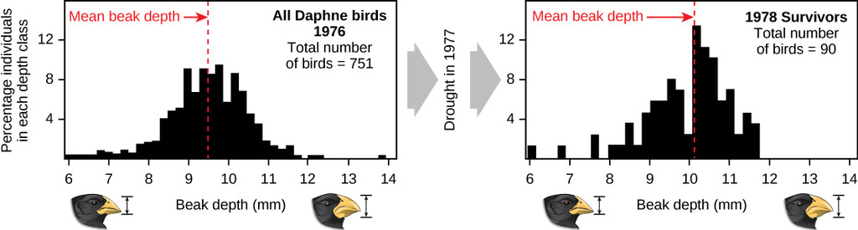

3) The larvae of certain species of flies can cause plants to grow bulbous structures known as galls in which the larvae can live. These galls face predation from both birds and parasitic wasps. Below is a data table with information on the percent survival for different sizes of gall (small, medium, and large), and a figure depicting the size distribution of a population of galls. Using this information draw a second curve on the figure illustrating what you think the population will look like after many generations.

Gall Size | Percent Survival
Small | 58 %
Medium | 83 %
Large | 63 %

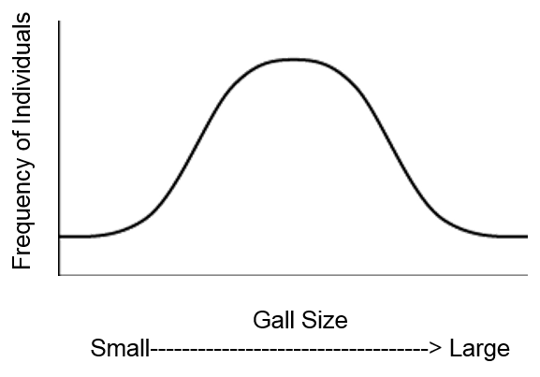
4) Imagine you are a biologist studying a species of fish that live amongst dark rocks on the ocean floor. Individual fish vary in their coloration ranging from very light to very dark. Below is a data table from a sample of ten fish. The column on the left is an individual’s color score which ranges from 0 to 1 where 0 is a very dark colored fish and 1 is a very light colored fish. The column on the right is the total number of offspring each individual was able to produce over the course of its life.
Color Score | # Offspring produced
0.4 | 15
0.8 | 19
0.1 | 3
0.2 | 5
0.8 | 22
0.9 | 26
0.2 | 11
1.0 | 28
0.3 | 10
0.6 | 19

A) Use the axes provided below to create a scatterplot of the relationship between color and offspring produced (be sure to label everything). What type of selection is acting on the coloration of these fish? How do you think the average coloration in this population will change after 100 generations?

B) Now imagine that a hurricane has deposited large patches of light colored sand among the rocks. Use the axes below to sketch how you think your graph from part A would change under these new conditions. What type of selection is acting under these new conditions?

