Part 2: Comparing trees built with physical traits vs genetic data

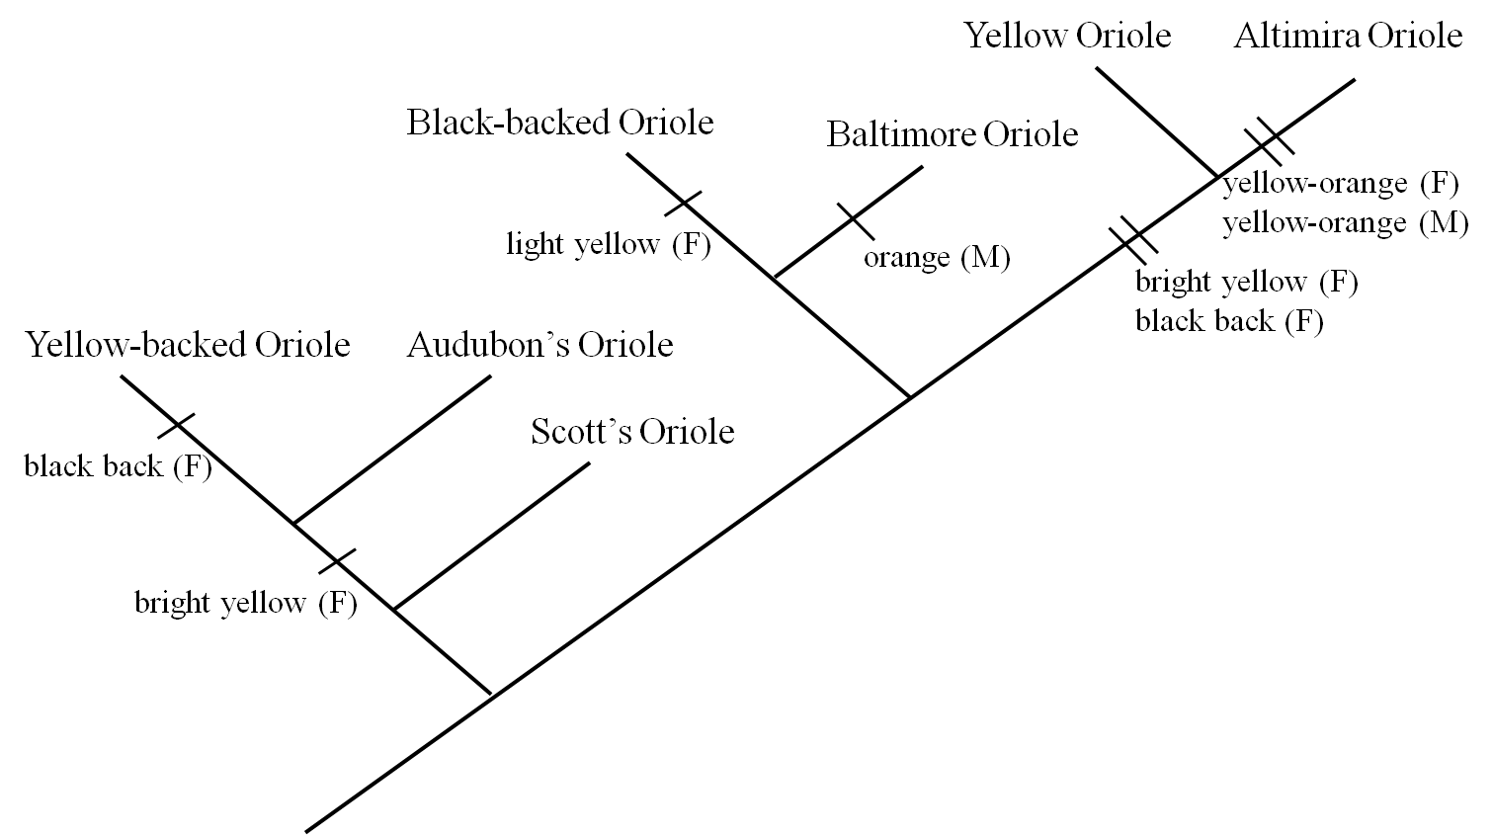

Above is the published tree that Hofmann, Cronin, and Omlin built using several different oriole genes.

Questions

- What color was the female ancestor on this new tree? How does this compare to your original prediction? _______________________________________________________
________________________________________________________________________________________________________________________________________________________________________________________________________________________________________________________________________________________________________________________________________________________________________

- How many times did color traits change on your tree? ____________________________

- How many times did coloration change on this tree built from genetic data? ___________

- Why might the published tree differ from the one your group built?__________________
________________________________________________________________________________________________________________________________________________________________________________________________________________________________________________________________________________________________________________________________________________________________________
Part 3: Using trees as tools for new hypotheses

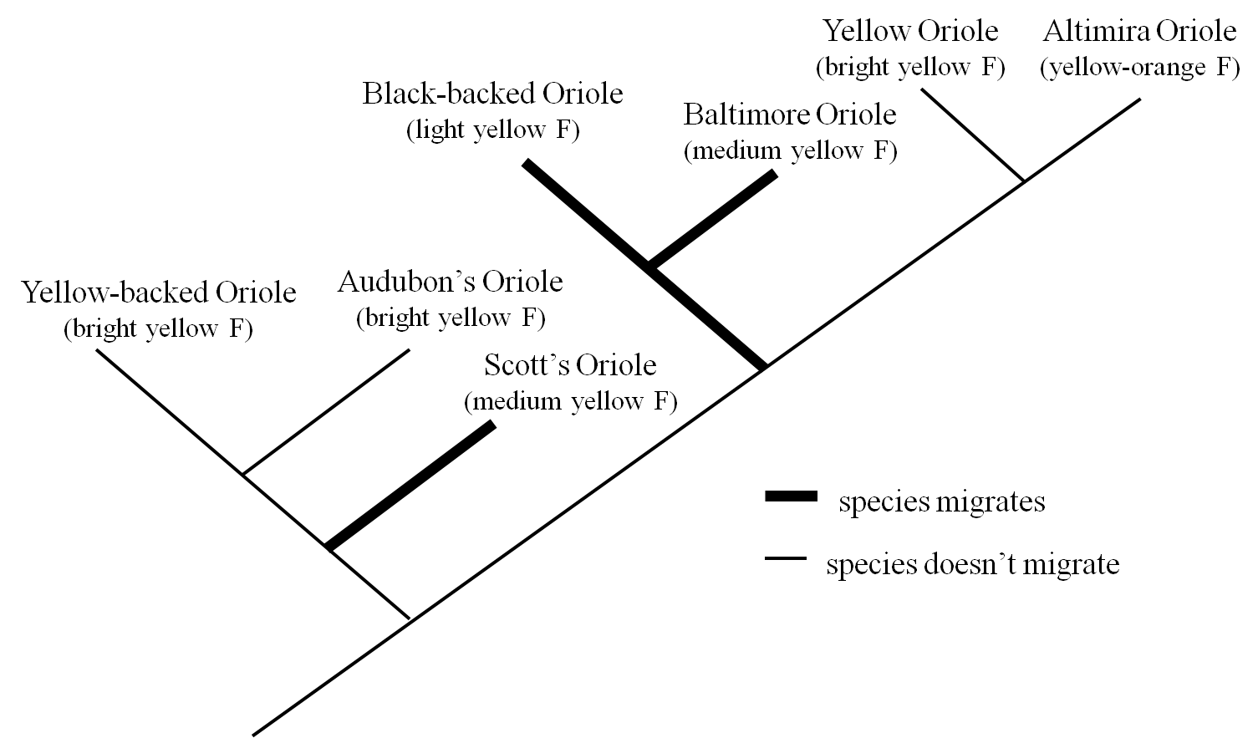

Evolutionary trees can be useful trees for figuring out if certain traits evolve more frequently in certain environments or with certain life styles than others. On the published tree above, migratory behavior is shown in black. All other species spend the whole year in the same area in warm habitats closer to the equator.

Questions

- In which lifestyle are brighter female colors more common? _______________________

- Explain one way that bright female colors could be adaptive in this lifestyle (or that dull colors could be adaptive in the opposite lifestyle)? _______________________________
________________________________________________________________________________________________________________________________________________________________________________________________________________________________________________________________________________________________________________________________________________________________________________________________________________________________________________

References: Hofmann, C.M, Cronin, T.W., Omland, K.E. 2008. Evolution of sexual dichromatism 1. Convergent losses of elaborate female coloration in New World Orioles. The Auk. 125:778-789

Friedman, N.R, Hofmann, C.M, Kondo, B., Omland, K.E. 2008. Correlated evolution of migration and sexual dichromatism in the New World Orioles (Icterus). Evolution 63:3269-3274.

