Building Evolutionary Trees:
How did the color patterns in New World Orioles evolve?

Background
The New World Orioles are a large family of birds that live throughout the tropical and temperate habitats of North America. All males are various shades of yellow and orange contrasting with black feathers. Females range from dull yellow to bright yellow-orange. Evolutionary biologists, Hofmann, Cronin, and Omlin, wanted to know how female colors evolved in this group. Below we’ll explore this question using 7 species from the New World Oriole family.

Part 1: Building a tree using physical traits

Make a prediction: Was the female ancestor brightly colored or dull? _____various answers__
_____________________________________________________________________________

Instructions

- Using the table of traits below, the species cards, and the blank tree on the next page work with your group to arrange the species in the order you think they evolved. Your goal is to minimize the number of trait changes on the tree.
- When you’ve decided on a solution, write the species names at the tips of each branch.
- Every time a trait changes, draw a dash on the tree where this happens and write the new trait next to the line (i.e. “female-gray back”). If multiple traits change in one spot, draw multiple dashes and write out all traits.

Species | Male Back | Male Color | Female Back | Female Color
Altimira Oriole | black | yellow-orange | black | yellow-orange
Audubon’s Oriole | black | bright yellow | gray | bright yellow
Baltimore Oriole | black | orange | gray | medium yellow
Black-backed Oriole | black | bright yellow | gray | light yellow
Scott’s Oriole | black | bright yellow | gray | medium yellow
Yellow Oriole | black | bright yellow | black | bright yellow
Yellow-backed Oriole | black | bright yellow | black | bright yellow
Totals | black = 7 | bright yellow = 5  yellow orange = 1  orange = 1 | black = 3  gray = 4 | yellow-orange = 1  bright yellow = 3  medium yellow = 2  light yellow = 1

Questions:

- What color was the female ancestor to the group?______various answers, but should match their tree__________________________
________________________________________________________________________________________________________________________________________________________________________________________________________________________

- Write a sentence to describe the evolutionary changes, in the order they occurred, to get from the ancestor to the Baltimore Oriole according to your tree. ______various answers, but should match their tree_____________
________________________________________________________________________________________________________________________________________________________________________________________________________________________________________________________________________________________________________________________________________________________________________

Part 2: Comparing trees built with physical traits vs genetic data

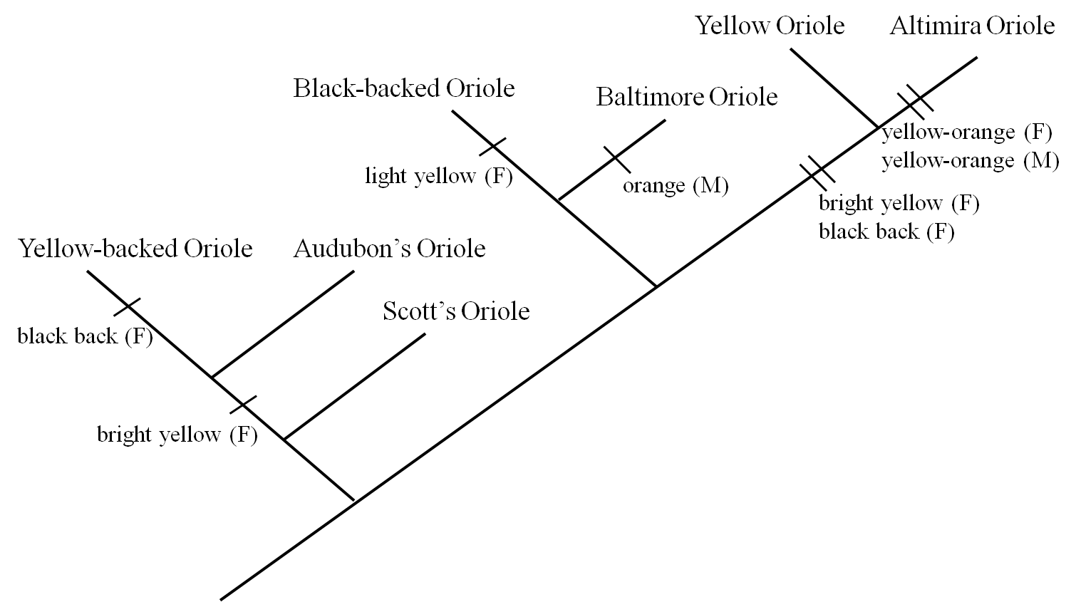

Above is the published tree that Hofmann, Cronin, and Omlin built using several different oriole genes.

Questions

- What color was the female ancestor on this new tree? How does this compare to your original prediction? ______female ancestor: medium yellow, gray back; this should be different from original tree in most groups_________________________________________________________________________________________________________________________________

- How many times did color traits change on your tree? various answers (Should match tree)________________________

- How many times did coloration change on this tree built from genetic data? ____8______

- Why might the published tree differ from the one your group built?__genetic data has much more information; contains changes you can’t always see; (more advanced nuance) evolution isn’t always parsimonious – trait may in fact be changing back and forth multiple types for adaptive reasons__________________________________________________________________
Part 3: Using trees as tools for new hypotheses

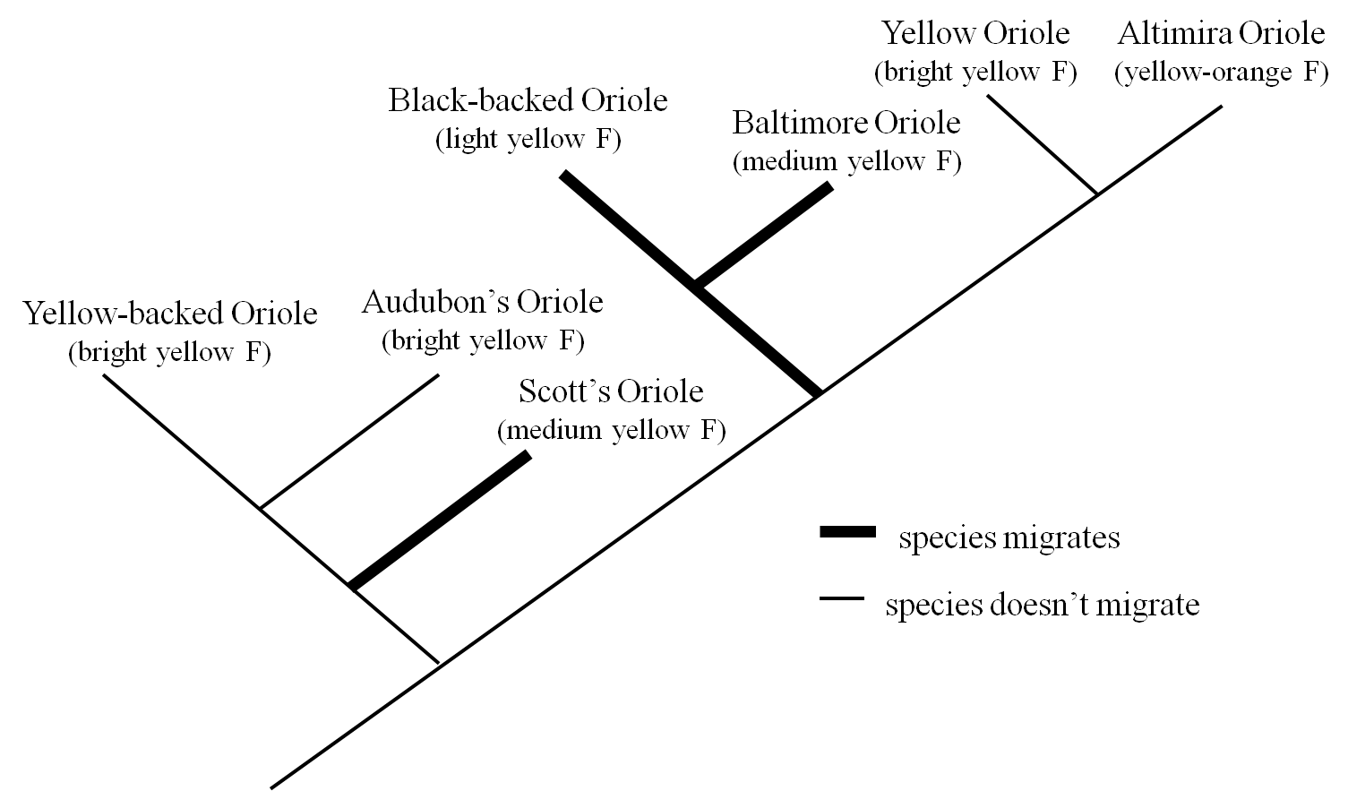

Evolutionary trees can be useful trees for figuring out if certain traits evolve more frequently in certain environments or with certain life styles than others. On the published tree above migratory behavior is shown in black. All other species spend the whole year in the same area in warm habitats closer to the equator.

Questions

- In which lifestyle are brighter female colors more common? ___no migration_________

- Explain one way that bright female colors could be adaptive in this lifestyle (or that dull colors could be adaptive in the opposite lifestyle)? ___various answers- just has to make sense__________________________________________________________________________________________________________________________________________________________________________________________________________________________________________________________________________________________________________________________________________________________________________________________________________________________________________

References: Hofmann, C.M, Cronin, T.W., Omland, A.E. 2008. Evolution of sexual dichromatism 1. Convergent losses of elaborate female coloration in New World Orioles. The Auk. 125:778-789

Friedman, N.R, Hofmann, C.M, Kondo, B., Omland, K.E. 2008. Correlated evolution of migration and sexual dichromatism in the New World Orioles (Icterus). Evolution 63:3269-3274.

