“Cricket Growth Experiment:”
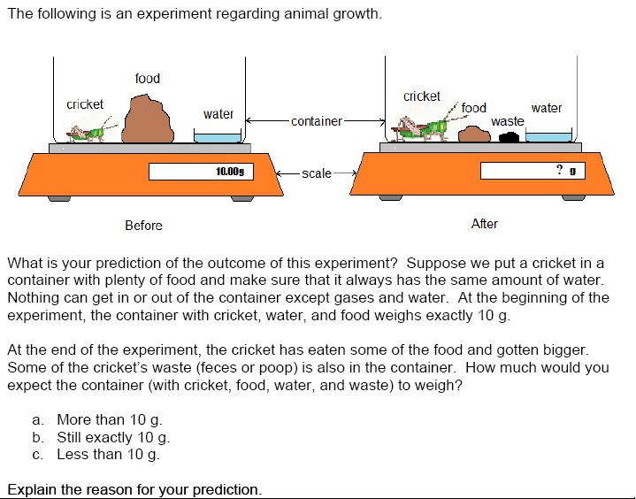

A | More than 10g; who knows in between time of the cricket pooping and easting and drinking it could have been lifting weights and have gotten more muscle and muscle wieghs more than fat |  | B | Less than 10g; when the cricket eats the food it used energy and some of the food it eats is converted into heat, because no energy transfer is 100%. You always lose some of the energy to heat. When the cricket moves around he will use up some of the energy from the food, so the container will weigh less than 10 grams
C | Still exactly 10g; it should still be the same weight because you cant create or destroy matter. the only weight lost on the scale would be the evaporation of the water. the loss of food turns into waste. |  | D | Less than 10g; I think that when the cricket eats the food it will use some of it up as energy and the rest comes out as waste.
E | Less than 10g; because CO₂ has escaped from the crickets body because the cricket changes the food into other compounds mostly CO₂ and water, which can both escape as a gas. |  | F | Still exactly 10g; What the cricket has eaten of the food he has gained in body weight and the nutrients his body doesnt use comes out in his waste. Also the only thing in and out of tyeh cage is air therefore it is the same.
G | Less than 10g; Because so of the food will loose it energy because of the heat created so it will weigh less after the cricket is doen eating. |  | H | Less than 10g; The cricket still has some of the food in it's blood stream.
I | More than 10g; If the criket at most of the food it would have gained wieght. Then the biproduct of the criket eating is the waste which also has a wieght. The water also wieghs some so the after container must way more than the before container. |  | J | Still exactly 10g; it would go down if the tank was open because Co2 was released in the atmosphere and little mass left

“Cricket Growth Experiment:”

A | More than 10g; who knows in between time of the cricket pooping and easting and drinking it could have been lifting weights and have gotten more muscle and muscle wieghs more than fat  1 |  | B | Less than 10g; when the cricket eats the food it used energy and some of the food it eats is converted into heat, because no energy transfer is 100%. You always lose some of the energy to heat. When the cricket moves around he will use up some of the energy from the food, so the container will weigh less than 10 grams 3
C | Still exactly 10g; it should still be the same weight because you cant create or destroy matter. the only weight lost on the scale would be the evaporation of the water. the loss of food turns into waste.  2 |  | D | Less than 10g; I think that when the cricket eats the food it will use some of it up as energy and the rest comes out as waste.  3
E | Less than 10g; because CO₂ has escaped from the crickets body because the cricket changes the food into other compounds mostly CO₂ and water, which can both escape as a gas.  4 |  | F | Still exactly 10g; What the cricket has eaten of the food he has gained in body weight and the nutrients his body doesnt use comes out in his waste. Also the only thing in and out of tyeh cage is air therefore it is the same.  2
G | Less than 10g; Because so of the food will loose it energy because of the heat created so it will weigh less after the cricket is doen eating.  3 |  | H | Less than 10g; The cricket still has some of the food in it's blood stream.  2
I | More than 10g; If the criket at most of the food it would have gained wieght. Then the biproduct of the criket eating is the waste which also has a wieght. The water also wieghs some so the after container must way more than the before container.  1 |  | J | Still exactly 10g; it would go down if the tank was open because Co2 was released in the atmosphere and little mass left  4

 | Specific Level Description  Practice: Mass/Gases | See cards for text of “Cricket Growth Experiment”
Level 4/4+ | Indicators:  1. Choose C (less than 10g) AND  2a. Account for mass leaving the system as gas(es) OR  2b. Explain that (cellular) respiration or other metabolic processes cause some mass loss as gas.  Do Not Need To:  1. Identify specific organic molecules as the source of the gas.  2. Specifically identify CO₂ as the main gas emitted. | C. Less than 10 g; the experiment has to follow law of conservation of mass. If the gases get out not all of that mass will be the same.
3/4 | L3 answers clearly convert at least some of the cricket’s matter to mass, while L4 answers point to gases as the cause of loss.
Level 3 | Indicators:  1. Describes some of the food being lost as energy during metabolism. OR  2. Identifies heat lost during respiration as the rationale for lost mass.  Do Not Need To:  1. Answer C (although most do).  2. Specify that respiration is the process whereby heat is produced. | C. Less than 10g; Even though the cricket is bigger, a lot of the food was used up as energy and only a little came back out.  C. Less than 10 g. It should weigh less than 10g because some of the material will be wasted on providing heat energy for the cricket and that will burn off, leaving less than 10grams in the tank.
2/3 | L2 answers tend to describe process in terms of “blocks” of matter (food, cricket, etc). L3 describes matter more in terms of molecules.
Level 2 | Indicators:  1. Choose B AND  2. Describe system as closed - food goes in, poop waste comes out, mass stays the same. OR  3. Acknowledge presence of gases (O2, CO2), but w/o describing them as having mass. OR  4. Choose C AND simply state that eating food makes mass go down. OR  5. Name a non-metabolic process as responsible for mass loss.  Do Not Need To:  1. Name cellular-level processes (respiration) or specific molecules (e.g. glucose, etc) | B. Still exactly 10 g. Because the same amount of matter is still in the container after the cricket has eaten it... none of the matter is lost because it is still present but in a different form.  B. Still exactly 10g; because the same amount of O2 and CO2 is used during cellular respiration!  C. Less than 10g; because the food was the greatest mass and the waste has been broken down but the insect has only gained partially what was there
1/2 | L1 answers focus on the process of growth, saying that accounts for increased mass. L2 responses use some transformations of matter.
Level 1 | Indicators:  1. Notes cricket looks bigger and reasons that mass must also have increased. OR  2. Describes increase in mass from unspecified sources, often simply citing the process of growth. OR  3. Describes mass as having increased because system looks visibly bigger or new things have been added (i.e. waste).  Do Not Need To:  1. Choose “A” (although most do). | A. More than 10g; The cricket waste will weigh a certain amount of grams which will add to the original weight. The cricket will also gain weight because of it's consumption of the food it was provided.  A. More than 10 g; because the cricket ate some of the food, and grew bigger. So the cricket weighs more then he did before. Yes, some of the food is gone, but there is now waste. So the cricket is twice the size he was, and there is waste.
0 | Answer does not make sense or is not related to the question
5 | Skipped or did not reach the questions
7 | Provide "I don't know" or similar responses.

“Cricket Growth Experiment:”

A |  |  | B
C |  |  | D
E |  |  | F
G |  |  | H
I |  |  | J

