Tree identification by its leaves
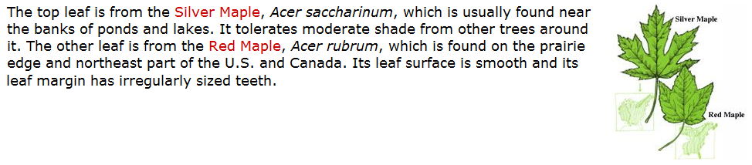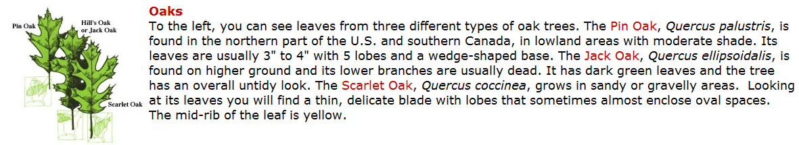

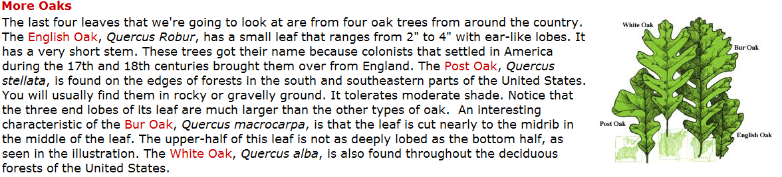

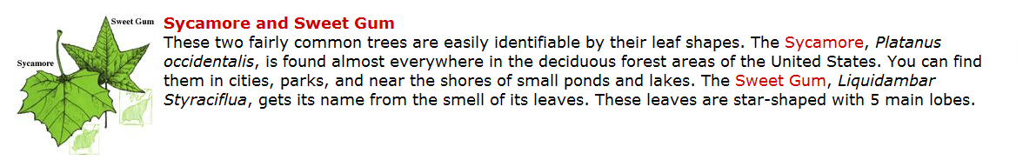

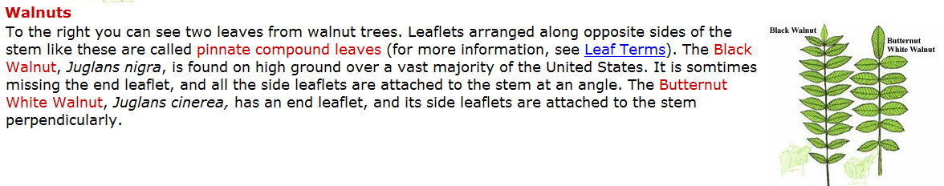
Pictures from: http://www.mbgnet.net/sets/temp/index.htm
Descriptions from: Illustrations from Tree Finder by May Theilgaard Watts (c) 1963, 1991 Nature Study Guild

